PRELIMINARY INFOMEMO

TO APPLY FOR GRANT

22th August 2003

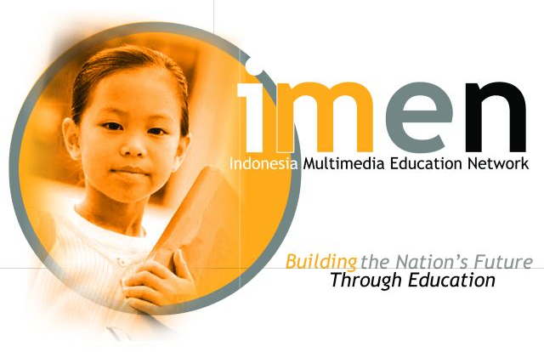

A

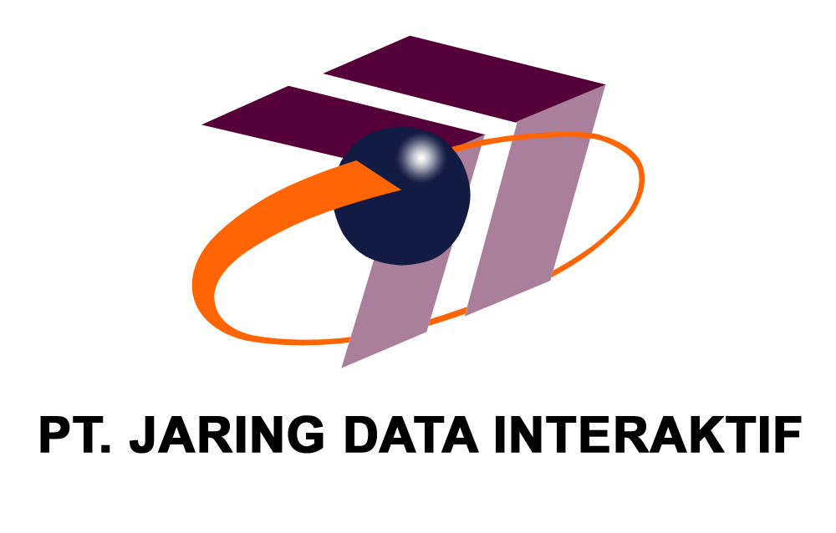
Service

Table of Content

EXECUTIVE SUMMARY | 2
Founding Partners | 3
ANNEX A – PROJECT HIGHLIGHTS | 4
1. DESCRIPTIONS | 4
1.1. Title | 4
1.2. Location 4
1.3 Summary 4
1.4 Objectives 5
1.5 Justification 6
1.6 Detailed description of activities 6
1.7. Grand Amount requested 12
1.8. Partnerships and Alliances 14
1.9. Team proposes for the implementation of the project 15
1.10. Evaluation mechanism foreseen 15
1.11. Duration and plan of action 15

2. EXPECTED RESULTS 15
2.1. Estimated impact on target groups and/or situation addressed 15
2.2. How the proposal will improve the situation of the target groups 15
2.3. Financial sustainability 16

3. BUDGET FOR THE IMPLEMENTATION OF THE PROPOSAL 17

4. THE APPLICANT 18
4.1. Identity 18
  - Description of the applicants 18

5. CAPACITY TO MANAGE AND IMPLEMENT OPERATIONS 20
  - Experience with similar grants 19

ANNEX B – PROJECT BUDGET 21

ANNEX C – DESCRIPTION OF PARTNERS 24

CONTACT DETAILS 28

Executive Summary

The Indonesia Multimedia Education Network (imen) has been established by PT Jaring Data Interaktif (JDI) working closely with several partners from the government education departments as well as the private sector who have expertise in areas of education, training, multimedia content and infrastructure.

imen aims to create a network of multimedia learning centers across the country, thereby facilitating access and opportunity to affordable high quality education for all citizens of Indonesia, going beyond the traditional geographic, social and economic barriers.

imen will help the Indonesian education sector to leap frog several years into the future and therefore plays a very important role in the development of the human resources of the nation.

imen is designed to be a revenue generating operation within four years of operations to allow for self sustenance to continue beyond the funding period. Much of the funding to establish imen has been provided by JDI. However, to take this project to its true potential, JDI invites assistance from funding agencies for grants and loans that can help imen achieve its goals.

This document serves as an initial information memorandum about the imen project, its scope and benefits, to allow us to introduce imen to various funding agencies in Indonesia who would like to be a part of this unique opportunity for…


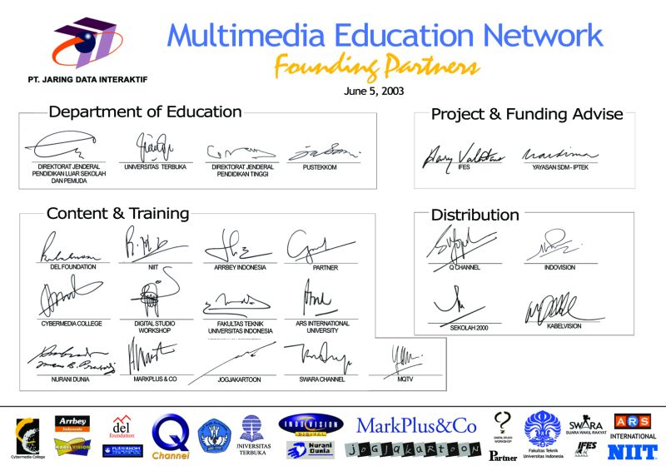

ANNEX A – PROJECT HIGHLIGHTS

- DESCRIPTIONS

  - Title : imen - Indonesian Multimedia Education Network

    - Priority Theme

Building the Nation’s Future through Education

  - Location:

Jakarta, Indonesia with correspondents and multimedia learning centers in all Indonesian provinces

  - Summary

It is a well acknowledged fact that media is a very influential means to propagate and popularize ideas and concepts. Television in particular is well known to be the most effective means to reach a mass audience and it offers high audience attention compared to any other media. Television is known to not only entertain but also to inform and educate audiences and the credibility of this media is well established. Television today has the highest media penetration in Indonesia. Approximately 83% of Indonesians watch television, accounting for 160 million persons. Due to delivery of audio and video images, it is the most effective means of mass communication today. Radio and Internet add other new dimensions to delivering content and creating an interactive interface.

This project proposes to provide regular education broadcasts on Q Channel that can be accessed by schools, universities, companies and homes. By collaborating with agencies producing education content suitable for multimedia distribution, we will set up a dedicated multimedia distribution network for education all over Indonesia using Internet, data, voice and video broadcasting technologies.

The Multimedia Education Network consists of the following media channels.

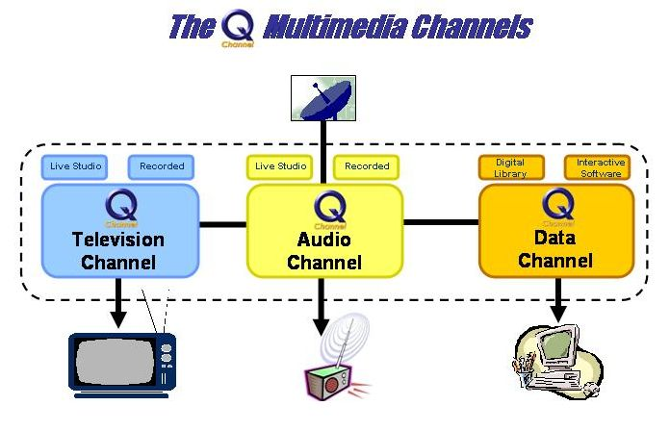

  - Objectives

The Multimedia Education Network
  - aims to transmit educational programs and materials to schools, universities, state agencies, civil society organizations, homes and businesses through direct broadcast of television, audio and data using satellite and cable transmissions.

  - opens a world of opportunities for students, teachers, parents, caregivers, public officials, businesses, universities, colleges, civil society and other organizations by offering programs of instruction, training, distance learning and participatory civic education with interactive information, communications and emerging technologies.

  - will bridge traditional geographic, institutional and ethnic boundaries through educational outreach, civic discourse and by incorporating local opportunity for direct participation.

  - Will provide a resource for Indonesia that can be used primarily to enhance reforms in education with coexistent benefits in programs of democratization, health, governance, environment, ethnic and societal issues.

  - Justification

The Education sector in Indonesia is facing many challenges today. There is a shortage of skilled teachers everywhere and schools in several remote areas only have one teacher for over 300 students. To complicate matters further, the wide geographical spread of the Indonesian archipelago has made it a difficult task to reach education opportunities to the people of Indonesia. The role multimedia can play in Indonesia is one of the best solutions that allows the nation to leapfrog several years ahead in developing education infrastructure and distribution uniformly across the country.

  - Detailed descriptions of activities
imen consists of Television, Audio and Internet Data channels that will provide educational content and a variety of interactive products and services for the Indonesian Education Sector. Educational materials will soon be available in digital formats such as TV and audio broadcasts, downloadable digital data libraries of audio/video/electronic books, as well as interactive educational and utility software. These channels will be available nationwide anywhere in Indonesia via direct digital satellite broadcast and can be accessed at community centers, schools, universities, companies, offices and homes.
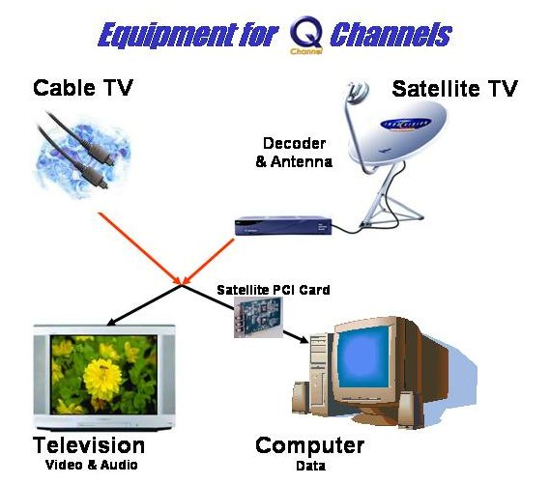
imen uses a methodology termed mLearning, a unique mix of direct and distance learning techniques using a combination of digital and traditional media and other conventional education methods. mLearning fills in the gaps left by the recent e-Learning methodology that relies heavily on Internet use, a technology that so far has limited reach in Indonesia.
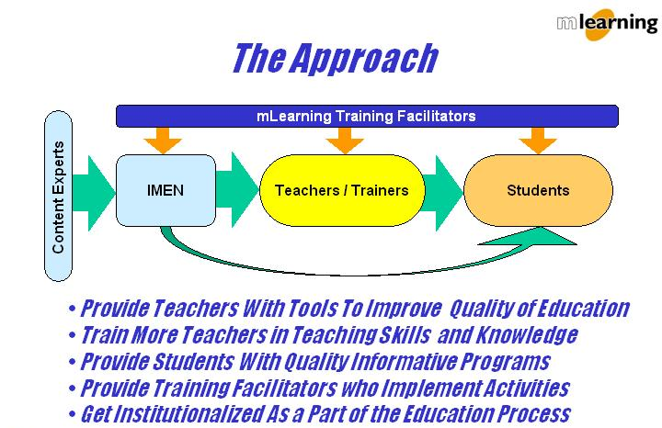

imen provides educational content to cover the complete educational life stages of Parenting, Prenatal and Infant, Preschool, Primary, Middle, Secondary, College, Graduate, Continuing, Career and Distance Learning Education. Therefore, the target segment of imen is each and every person living in Indonesia.

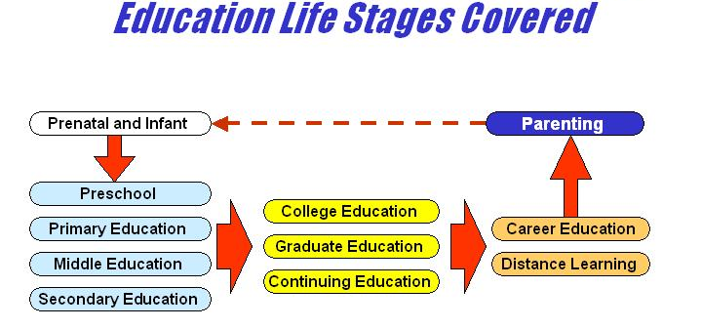

imen is being targeted to specific communities where regular educational programming can benefit the identified target segments. Unlike terrestrial television, imen creates a NEW AUDIENCE of people who would watch television and access data at educational locations where they would not normally view other television channels. Hence, with imen there is little overlap with the audience of other stations.

imen is being designed to be revenue generating from the first stage, offering revenue sharing arrangements with content developers and other partners. Though much of the basic education services to schools are provided free of cost, university and executive education programs are designed to generate enough revenue to make imen a self sufficient operation within two to three years.

Through our existing partners, we currently have access to over 3,000 hours of educational television and audio programming. Further development of the imen consists of the following major activities.

A. Developing Multimedia Learning Centers

B. Additional Multimedia Content Production

C. Improving Production Facilities

D. Ongoing Training of Teachers and Coordinators

These are examined in detail as follows

- Developing Multimedia Learning Centers: Setting up Multimedia Learning Centers in select schools and community centers
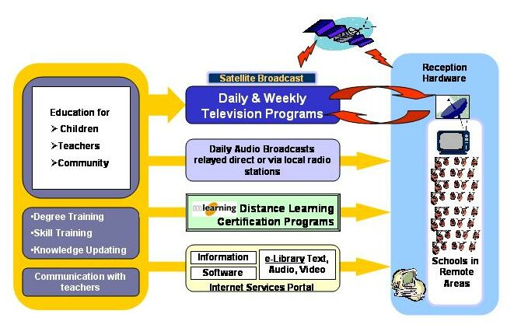
Learn – Interact – Communicate

Our target for coverage is all over Indonesia at the Province, District and sub-District level, with special focus to remote areas where there is limited reach of educational facilities. We hope to set up the following network within the scope of this funding request

Schools (SD/SMP/SMA) : 2,000
Universities : 200
Pesantrens and Pondokans : 500
Community Learning Centers & Others : 1,300

Total : 4000 centers

The multimedia learning centers will offer the following educational services to the local community
- Television Broadcast
- Audio Broadcast
- Data Service
- Distance Learning Programs (Certification based)

i) Television Broadcast
Included in the general daily 24 hour educational broadcast, are the following programs, arranged in a repeat format during the week to maximize viewership and provide flexibility to participants.
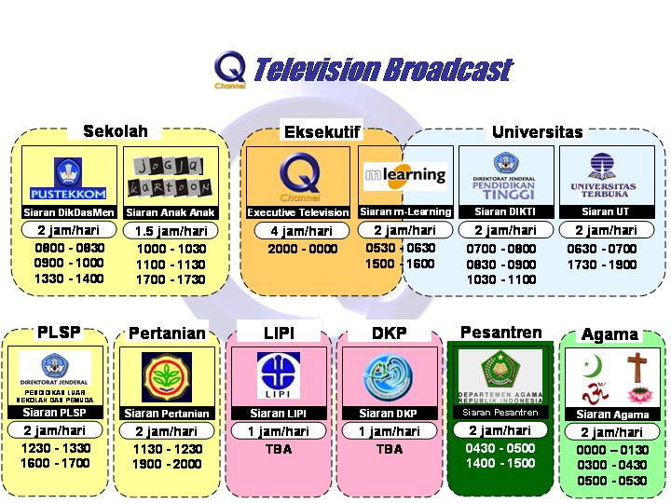

ii) Audio Broadcast: Working together with leading radio stations, we will provide audio programs that can be heard at the schools or relayed through the local radio stations in the local community area. Audio programs shall be of the following types,

- Language lessons
- Story telling
- Talk Shows & Interviews
- Educational bulletins
- Discussion programs
- Edutainment

iii) Data Broadcast Service: We will be providing a data service to each center with the following content
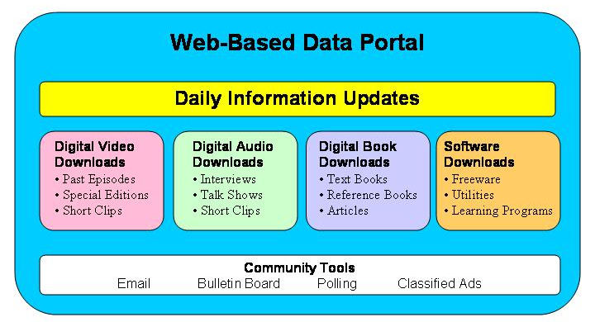

iv) Distance Learning Programs: In association with leading experts in education field, we will provide the following types of education courses to the community members. Each school will be an AUTHORISED TRAINING PARTNER of these certified courses.

  - Degree Training: Formal Education
    - Equivalency for SD/SMP/SMA
    - Relevant Courses for Teachers
    - International Degree Courses in IT

  - Skill Training: Non-Formal Education
    - Infiniiti First Step – Basic Computer Literacy
    - Infiniiti Swift Expert – Microsoft Office Advance Level
    - English Speaking
    - Industry Awareness in Management
    - Industry Awareness in Marketing & Competition
    - Industry Awareness in Advertising & Communication
    - Industry Awareness in Banking & Finance
    - Rural Marketing
    - Life Skills courses
    - Other courses

These certification courses are available at a fee to students.

- Additional Multimedia Content Development: Program Productions for Education are required in several categories, especially the following.

- Children’s Education
- Family Health & Nutrition
- Women’s Issues
- Adult education
- Life skills programs
- Medical Education
- Civil Society Education
- Democratic principles
- Conflict Resolution
- Religious Tolerance
- Expert Lecturing from well known education specialists

- Improving Production Facilities: Building the following Infrastructure for Education Program Production

  - Production Studio for additional recording capacity
  - Post Production Facility to increase capacity
  - Correspondent Production Units in 33 Provinces

- Ongoing Training of Teachers and Coordinators
One of the key success factors of this initiative is having ground level facilitators at each location. We are establishing up a network of multimedia training coordinators, one at each location, who will help students in benefiting from mLearning techniques offered by the network. These mLearning Coordinators will receive a monthly training fee, paid initially by iMEN and eventually supported by the local center through its local sources of funds.

There will be ongoing training programs for trainers run by the network.

  - Grant Amounts Required

imen would like to work with multiple donors for the above requirements

The Grants requests are in the range of US$25,000 up to US$1,000,000 to fund specific projects within imen that lie within the scope of the funding agency.

Some of the specific grant requests are for the following projects within the imen

[A] Establishing a Network in across Indonesian regions
        - Schools
        - Universities
        - Pesantrens (Islamic Boarding Schools)
        - Village Community Centers
        - Out of School Education Centers
        - Agricultural Training Centers
        - Fisheries Training Centers
        - Other Government-run Training Centers

The following table shows examples of Education Network projects that can be supported for several contribution values.

Project Value/year | US$25,000 | US$100,000 | US$500,000 | US$1,000,000
No of Centers Supported consisting of  - mLC Equipment  - Computer Sets  - Satellite Data Card  - Instructor Training | 6 | 15 | 83 | 170
TV Programs Support | No | Basic | Advanced | Advanced
Data Access | Yes | Yes | Yes | Yes
Data Content Support | No | Basic | Advanced | Advanced
These can be customized based on specific requirements of the community

[B] Special Segmented or Community based Education Programs
- Preschool and Elementary School Education
- Civil Society for Teens
- Family Health for housewives
- Adult Education
- Support for Physically disadvantaged
- Support for Drug Addicts
- Support for HIV+ Patients
- Women’s Empowerment
- Decentralization
- Anti Corruption Education
- Elections Staff Education
- Small Scale Sector Education
- Conflict Resolution
- Environment Protection
- Consumer Protection
- Copyright Protection
- Human Rights
- Legal Reform
…etc

The following table shows examples of program productions projects that can be supported for several contribution values.

Project Value/year | US$25,000 | US$50,000 | US$100,000
No of Episodes produced | 13 | 26 | 52
Frequency | Weekly | Weekly | Weekly
Period Covered | 3 months | 6 months | 12 months

  - Partnerships and Alliances
We have the following companies working with us for implementing the project in various capacities

FUND RAISING AND PROJECT ADVISE PARTNERS

  - Yayasan SDM-IPTEK
- IFES: International Foundation for Election System

PROGRAMMING AND CONTENT

- Department of National Education (DEPDIKNAS)
  - UT: Universitas Terbuka (Open University)
  - DIKTI: Direktorat Jeneral Pendidikan Tinggi (Higher Education)
  - DIKDASMEN-PUSTEKKOM: Pusat Teknologi Komunikasi dan Informasi Pendidikan for the Primary and Secondary Education
  - PLSP: Direktorat Jeneral, Pendidikan Luar Sekolah dan Pemuda (Out of School Education and Youth)
- Jogjakartoon
- MQTV Productions
- Yayasan Nurani Dunia
- DEL Foundation
- NIIT
- Markplus&Co
- Arrbey Marketing Consultants
- Partners Management Consultant
- Digital Studio Workshop
- Cyber Media College

CONTENT SALES AND TRAINING PARTNERS

- Universitas Indonesia (Fakultas Teknik)
- ARS International University
- STIE Swadaya
- Universitas Wiraswastha Indonesia

DISTRIBUTION SUPPORT PARTNERS

- Indovision
- Kabelvision
- Sekolah 2000

Descriptions of these partners are provided in Annexure C

  - Team proposes for the implementation of the project

The main implementation is proposed to be done by PT Jaring Data Interaktif, working together with the appropriate partners who offer the relevant skill and experience.

  - Evaluation mechanism foreseen: The evaluation of the project and its success will be done by developing a series of key indicators that can be monitored against milestones laid out.

  - Duration and plan of action
This project is expected to be an ongoing service provided in perpetuity to the people of Indonesia. The duration of the initial project will be three years after which suitable revenue streams would continue to support its existence.

It is planned to raise the project funding requirements through a combination of Grants, Loans and localized fund raising activities.

- EXPECTED RESULTS

  - Estimated impact on target groups and/or situation addressed

The essential impact that is desired is the even distribution of educational opportunity for all, irrespective of age, gender, race, religion, culture or socio-economic factors.

  - How the proposal will improve the situation of the target groups

By providing access to the best of educational resources even in the remotest part of Indonesia, we will make a significant impact in the development of the education system, which will have significant results in the development of the nation’s future via its human resource capital.

Specific benefits to the target segment are as follows

Schools (SD/SMP/SMA):
- Improve the overall quality and standard of education
- Help train teachers to teach better
- Improve interactivity and communication among students
- Attract students and increase interest levels for attendance

Community Learning Centers
- Get access to training and certification programs
- Get specialized and segmented education and knowledge
- Provide Life Skills training to improve job productivity and stimulate self employment opportunities
- Improve interactivity and communication among community
- Offer out of schools education programs for adults

Pesantrens and Pondokans
- Get a wide range of educational topics not only religious based
- Get well balanced exposure to national and international issues
- Improve interactivity and communication among community

Universities
- Get access to wide range of high quality education
- Get access to expert knowledge from well known international and local speakers, lecturers and industry professionals
- Get certification based curriculum enhancement programs
- Get access to highly standardized curriculum from reputed content partners

  - Financial sustainability (where necessary, how will the activities be financed after the funding ends?)

A strong revenue model governs the activities and plans of the imen.
The revenues streams are from

- Equipment Installations
- Multimedia Production
- Building and maintaining media infrastructure
- Education licensing and certification
- Advertising and Sponsorship

Year-wise revenue projections will be provided on specific request
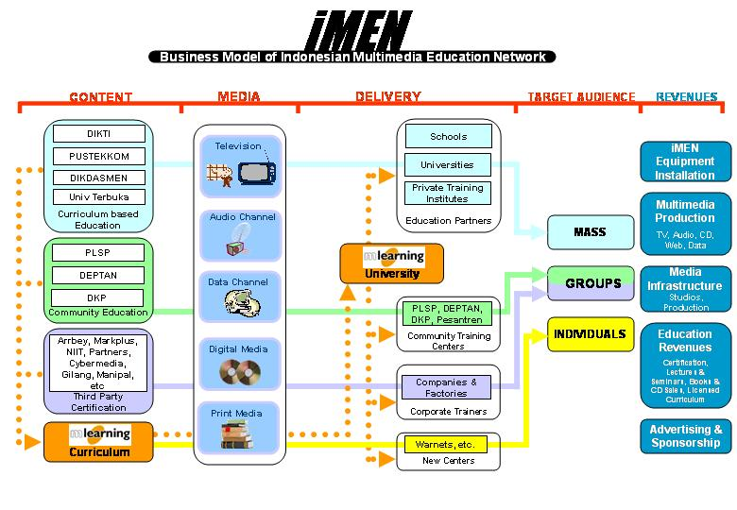

The imen will be operated by JDI, an existing organization that is currently handling another funded channel called SWARA which is now self sustainable. Much of the funding goes towards establishing such an institutionalized structure that is self sustainable.

- BUDGET FOR THE IMPLEMENTATION OF THE PROPOSAL

Amount in US$
 | Year 1 –2004 | Year 2 – 2005 | Year 3 – 2006 | Total
Multimedia Learning Centers | 3,450,000 | 2,070,000 | 1,380,000 | 6,900,000
Program Production | 1,257,000 | 1,257,000 | 1,257,000 | 3,771,000
Instructor & Training | 2,160,000 | 3,456,000 | 4,320,000 | 9,936,000
Admin. & Contingencies | 346,050 | 341,850 | 350,550 | 1,038,450
 | 7,213,050 | 7,124,850 | 7,307,550 | 21,645,450

Details are available in Annex B

- THE APPLICANT

  - IDENTITY
- Full legal name (business name) PT Jaring Data Interaktif
- Acronym (where applicable) JDI
- Legal status: PMA
- VAT registration number: 01-903-863-7-056-000
- Official address: Wisma Indovision, 11th Floor, Jl. Raya Panjang Block Z/III, Green Garden, Jakarta 11520, Indonesia
- Headquarters location, if different from official address
- Postal address : Idem
- Contact person : Sachin Gopalan
- Telephone number : 62-21-5818855
- Fax number: 62-21-5825530
- E-mail address : sachin.gopalan@jditeam.com
- Website : www.jditeam.com

  - DESCRIPTION OF THE APPLICANTS

4.2.1 When was your organization founded and when did it start its activities?

JDI is a PMA company founded in 1998. With the inception of several new shareholders in 2001, JDI has been run by a professional management team comprising of industry professionals. JDI is Indonesia's first convergent media company, with operations in Multimedia services. JDI’s Multimedia services consist of Broadcast Television, Radio, Print, Website, CD and Video products.

4.2.2 What are the main activities of your organization at present?

JDI operates two television channels that are carried on Indovision, Kabelvision, Indonusa, Fasindo and other private satellite and cable subscribers all across the country. Currently, around 4 million cable and satellite dish owners all over Indonesia have access to our channels.

Jaring Data Interaktif has been involved in several projects in the past that serve as credentials to carry out a national level project such as iMEN. Some of these are as follows.

1. Swara Channel: JDI independently operates and manages SWARA Channel for the Indonesian Parliament. This channel has been established to promote transparency in the process of democracy. This is the local equivalent of the US based CSPAN channel. SWARA regularly develops several live and recorded Programs for creating political awareness among the people of Indonesia. This channel was established in 1999 with the financial assistance of IFES, USAID and technical assistance of Datakom, Indovision, Kabelvision, and other agencies. Since the end of the funding period, JDI has supported and operated this channel by establishing operational revenues.

2. Ministry of Education Programs – Siaran DIKTI and Siaran Pustekkom: Since 1999, JDI has supported the Ministry of Education to relay national educational programs on our channels for 60 minutes daily. These programs from Pustekkom and DIKTI address a vast array of topics ranging from social and civic education to teacher training based programs.

3. Universitas Terbuka Programs– Education Program: JDI has been airing 30 minute daily educational programs, 7 days a week, to support over 230,000 students of UT all over Indonesia

4. DPR Kommisi II – Internet Support: JDI has developed a website for Kommisi II and provide other training and web hosting support to them.

5. MPR - Internet Support: JDI has developed Internet sites and provide several Internet services for the MPR

6. KPU - Internet Support and Training: JDI has developed the KPU website and have trained their staff in Internet and multimedia video production.

7. Social Organization Projects – JDI has supported several organizations with free of cost or on highly subsidized media services on both Q and Swara channels. Some of these clients are International Republican Institute, National Democratic Institute, Yayasan Anak Bangsa Mandiri, Badan Koordinasi Penanaman Modal, Gereja Pantekosta di Indonesia and others.

JDI as an organization has the track record of being a socially responsible media through the projects handled in the past.

The iMEN will be our latest application of media technologies.

4.2.3 List of the management board/committee of your organization

Chairman: James Castle
President Director: Suhardi Gunawan
CEO: Sachin Gopalan
CFO: Januar Chandra

- CAPACITY TO MANAGE AND IMPLEMENT OPERATIONS

  - Experience with similar grants

    - The object and location of each project

Swara Channel: This is the independently operated 24 hour Channel for the Indonesian Parliament. This channel has been established to promote transparency in the process of democracy and is the local equivalent of the US based CSPAN channel. SWARA regularly develops several live and recorded Programs for creating political awareness among the people of Indonesia. This channel was established in 1999 with the financial assistance of IFES & USAID.

    - The result of the project

The SWARA channel has made significant contributions to Improved transparency in the political processes of the MPR and DPR. Since the end of the funding period, JDI has supported and operated this channel by establishing operational revenues.

    - Your organization’s role (leader, partner) and level of involvement in the project

JDI was the project leader and main operations partner for the SWARA Channel. The remaining services were established with technical assistance of Datakom, Indovision, Kabelvision, and other agencies.

ANNEX B – PROJECT BUDGET

 |  | Cost/ | Year 1 - 2004 |  |  |  |  | Year 2 - 2005
No | Keterangan | Unit | Unit | Mth | Total Cost | By JDI | By Donors | Unit | Mth | Total Cost | JDI | Donors
1 | Decoder Indovision package, television and installation
 | (Includes decoder, ODU, LNB, 20 meter kabel. 2 connector, TV 21" & installation)
 | - Schools | 800 | 1,000 |  | 800,000 | - | 800,000 | 600 |  | 480,000 |  | 480,000
 | - Universities | 800 | 100 |  | 80,000 | - | 80,000 | 60 |  | 48,000 |  | 48,000
 | - Pesantren | 800 | 250 |  | 200,000 | - | 200,000 | 150 |  | 120,000 |  | 120,000
 | - Community Center & Others | 800 | 650 |  | 520,000 | - | 520,000 | 390 |  | 312,000 |  | 312,000
 | Sub total |  | 2,000 |  | 1,600,000 |  | 1,600,000 | 1,200 |  | 960,000 |  | 960,000
2 | Instructors and training | 90 | 2,000 | 12 | 2,160,000 | - | 2,160,000 | 3,200 | 12 | 3,456,000 | - | 3,456,000
3 | TV Programs production (includes TVC & Fillers)
 | - Recoded - 12 programs, @26 episodes | 2,500 | 312 |  | 780,000 | - | 780,000 | 312 |  | 780,000 | - | 780,000
 | - Live - 4 programs, @26 episodes | 3,250 | 104 |  | 338,000 | - | 338,000 | 104 |  | 338,000 | - | 338,000
 | Sub total |  | 416 |  | 1,118,000 |  | 1,118,000 | 416 |  | 1,118,000 | - | 1,118,000
4 | TV, Radio and Data channel Airtime, Channel Operations (Q Channel - 24 hours/day) |  |  |  | 1,960,000 | 1,960,000 |  |  |  | 1,960,000 | 1,960,000
5 | Computer sets & Cyberstream Cards | 925 | 2,000 | 12 | 1,850,000 | - | 1,850,000 | 1,200 | 12 | 1,110,000 | - | 1,110,000
6 | Internet Content & Data Broadcast
 | - Portal Multimedia Edu. Network | 40,000 | 1 |  | 40,000 | - | 40,000 | 1 |  | 40,000 | - | 40,000
 | - Update data & Portal info | 10,000 | 1 |  | 10,000 | - | 10,000 | 1 |  | 10,000 | - | 10,000
 | - Satellite transponder for Data Service | 4,500 | 1 | 12 | 54,000 | - | 54,000 | 1 | 12 | 54,000 | - | 54,000
 | - Data digitalization (Book, Audio, Video) | 35,000 | 1 |  | 35,000 | - | 35,000 | 1 |  | 35,000 | - | 35,000
 | Sub total |  |  |  | 139,000 |  | 139,000 |  |  | 139,000 |  | 139,000
7 | Adminstration & Contigencies (5%) |  |  |  | 346,050 | - | 346,050 |  |  | 341,850 | - | 341,850
 | Total |  |  |  | 10,813,050 | 1,960,000 | 7,213,050 |  |  | 10,724,850 | 1,960,000 | 7,124,850

 |  | Cost/ | Year 3 - 2006 |  |  |  |  | Total 3 years
No | Keterangan | Unit | Unit | Mth | Total Cost | By JDI | By Donors | JDI | Donors
1 | Decoder Indovision package, television and installation
 | (Includes decoder, ODU, LNB, 20 meter kabel. 2 connector, TV 21" & installation)
 | - Schools | 800 | 400 |  | 320,000 |  | 320,000
 | - Universities | 800 | 40 |  | 32,000 |  | 32,000
 | - Pesantren | 800 | 100 |  | 80,000 |  | 80,000
 | - Community Center & Others | 800 | 260 |  | 208,000 |  | 208,000
 | Sub total |  | 800 |  | 640,000 |  | 640,000 | - | 3,200,000
2 | Instructors and training | 90 | 4,000 | 12 | 4,320,000 | - | 4,320,000 | - | 9,936,000
3 | TV Programs production (includes TVC & Fillers)
 | - Recoded - 12 programs, @26 episodes | 2,500 | 312 |  | 780,000 | - | 780,000
 | - Live - 4 programs, @26 episodes | 3,250 | 104 |  | 338,000 | - | 338,000
 | Sub total |  | 416 |  | 1,118,000 | - | 1,118,000 | - | 3,354,000
4 | TV, Radio and Data channel Airtime, Channel Operations (Q Channel - 24 hours/day) |  |  |  | 1,960,000 | 1,960,000 |  | 5,880,000
5 | Computer sets & Cyberstream Cards | 925 | 800 | 12 | 740,000 | - | 740,000 | - | 3,700,000
6 | Internet Content & Data Broadcast
 | - Portal Multimedia Edu. Network | 40,000 | 1 |  | 40,000 | - | 40,000
 | - Update data & Portal info | 10,000 | 1 | 12 | 10,000 | - | 10,000
 | - Satellite transponder for Data Service | 4,500 | 1 | 12 | 54,000 | - | 54,000
 | - Data digitalization (Book, Audio, Video) | 35,000 | 1 |  | 35,000 | - | 35,000
 | Sub total |  |  |  | 139,000 |  | 139,000 | - | 417,000
7 | Adminstration & Contigencies (5%) |  |  |  | 350,550 | - | 350,550 | - | 1,038,450
 | Total |  |  |  | 10,907,550 | 1,960,000 | 7,307,550 | 5,880,000 | 21,645,450

The breakdown of the amount to be raised in a combination of grants and loans are as follows:

Multimedia Learning Centers : US$ 6,900,000
Program Productions : US$ 3,771,000
Instructor Teacher Training & Support : US$ 9,936,000
Admin. & Contingencies : US$ 1,038,450

TOTAL : US$ 21,645,450

The total amount is required over three consecutive years as follows

Year 1 – 2004 : US$ 7,213,050
Year 2 – 2005 : US$ 7,124,850
Year 3 – 2006 : US$ 7,307,550

TOTAL : US$ 21,645,450

Our contribution for the project is 21.3% of the total project cost
 | Year 1 | Year 2 | Year 3 | Total | %
PT JDI | 1,960,000 | 1,960,000 | 1,960,000 | 5,880,000 | 21.3
Donors | 7,213,050 | 7,124,850 | 7,307,550 | 21,645,450 | 78.7
Total | 9,173,050 | 9,084,850 | 9,267,550 | 27,525,450 | 100

Note: Further details will be provided on specific request

ANNEX C – DESCRIPTION OF PARTNERS

FUND RAISING AND PROJECT ADVISE PARTNERS

- Yayasan SDM-IPTEK: Established under The Habibie Center, the objective of the foundation is to provide qualified Indonesia Human Resource and in the same time has the ability to independently control the science & technology for building the nation future. The Habibie Center (THC) is a leading think tank that vision is to promote the modernization and democratization of Indonesian society based on the morality and integrity of sound cultural and religious values. BJ Habibie, the 3rd president of the Republic of Indonesia, established this foundation in 1999 as an independent, non-govermental and non-profit organization. SDM-IPTEK is headed by Prof. Dr.-Ing. Wardiman Djojonegoro, former Minister of Education and Culture.

  - The programs of the foundation are:
  - Giving scholarship for Doctorate degree.
  - Award & Prize for breakthroughs in science & technology area in Indonesia.
  - Establish centre for research in science & technology.
  - Develop human resource in science & technology.

- IFES: International Foundation for Election System: The International Foundation for Election Systems (IFES) is a private, non-profit foundation established in 1987 to support elections and other democratic institutions in emerging and established democracies. Non-partisan in approach, IFES has conducted assessments, technical assistance, research, media activities, training, procurement, and conference activities in over 100 counties worldwide. IFES draws from an international human resource base, using consultants from all over the world.

PROGRAM PRODUCTIONS SUPPORT PARTNERS

- Department of National Education (DEPDIKNAS)

  - UT: Universitas Terbuka (Open University)
  - DIKTI: Direktorat Jeneral Pendidikan Tinggi (Higher Education)
  - DIKDASMEN-PUSTEKKOM: Pusat Teknologi Komunikasi dan Informasi Pendidikan for the Primary and Secondary Education
  - PLSP: Direktorat Jeneral, Pendidikan Luar Sekolah dan Pemuda (Out of School Education and Youth)

- Jogjakartoon: An Indonesian cartoon community base in Jogjakarta, the city of art, they produce short animation films to educate children. The topics vary from Indonesia traditional stories that bring messages about life, heroism, friendship, religion and science. In producing their programs, Jogjakartoon work together with Najdatul Ulama, Muhammadiyah, Manajemen Qolbu and others. The key persons behind the organization are Idris Sardi, WS Rendra, Marzuki Usman, HG Kamarullah, Nina Pane, Ali Audah, KH. Muhdi Sirajudin, KH. Mudjab Mahalie, KH. Muhammad Djawis, Syafei Maarif, and AA Gymnastiar.

- MQTV Productions: Managemen Qolbu, a leading Indonesian production house producing religious educational programming. The key person behind the organization is AA Gymnastiar.

- Yayasan Nurani Dunia: This Foundation was established for providing humanitarian aid to victims of social and natural disasters. One of their divisions is KUMPUL (Community for Plural Society). Spearheaded by Bpk. Imam B. Prasodjo, PhD, Director, ND also works with Taufiq Ismail, well known Indonesian poet and Elizabeth F. Collins, PhD, Director center for Southest Asian Studies, Ohio University USA. Nurani Dunia is working on several school projects in Indonesia in remote areas and regions of conflict.

- DEL Foundation: This Foundation has established the Polytechnic of Informatics situated in Lake Toba, North Sumatra. Headed by Bpk. Luhut Panjaitan, the former Minister of Trade & Industry. NIIIT, DEL Foundation & imen together produce a multimedia distance-learning program for executives on Microsoft Office.

- NIIT: is the only Asian company to be ranked in the Top-15 Global IT Education and Training Providers listing instituted by International Data Corporation, USA. NIIT is one of the fastest growing IT Education companies in the world, with 500,000 student enrolments in 2002. NIIT's Online Learning portal netvarsity.com has over 157,192 distance-learning students. Today NIIT has a network of 2,447 centres globally and it is one of the largest IT Education centre networks in the world.

- Markplus&Co: is a leading management consulting firm headed by Bpk. Hermawan Kartajaya, the Management Guru of Indonesia. It serves the need of institutional clients to formulate innovative and executable business strategies into sustainable enterprise. Founded in 1989, MarkPlus&Co is a leading strategy advisor to multinational, state-owned and private institutions. Markplus develops a weekly program about Management among CEOs of leading companies in Indonesia and a monthly business seminar programs featuring international speakers.

- Arrbey Marketing Consultants: is a consulting, education and training company headed by Bpk. Handito Hadi Joewono, a well known expert in Marketing & Management. Together with imen, Arrbey is developing a weekly program about branding & advertising education and a certification based Industry Awareness program to enhance Marketing curriculum for universities and offices.

- Partners Management Consultant: is a management consulting and training company headed by Bpk. Gunadi, who is also a lecturer in Universitas Kristen Indonesia. Together with imen, PMC is developing a certification based Industry Awareness program to enhance Management curriculum for universities and offices.

- Digital Studio Workshop: A graphics and animation training firm based in Jakarta with offices in several cities in Indonesia.

- Cyber Media College: A design and graphics education firm based in Jakarta

CONTENT SALES AND TRAINING PARTNERS

- Universitas Indonesia (Fakultas Teknik): A leading University in Indonesia.

- ARS International University: A private university based in Bandung.

- STIE Swadaya

- Universitas Wiraswastha Indonesia

DISTRIBUTION SUPPORT PARTNERS

- Indovision: is the leading satellite television content provider in the country, with over 70,000 installations all over Indonesia. Indovision satellite decoders will be used for transmitting the imen channels to schools, universities, training centers, community centers, offices and homes in remote areas.

- Kabelvision: is the leading cable television content provider in the country, with over 70,000 installations primarily in Jakarta. Kabelvision services are now available in other cities such as Bali. They will transmit the imen channels to schools, universities, training centers, community centers, offices and homes in their area of coverage.

- Sekolah 2000: This education project under the APJII (Association of Indonesian Internet Service Providers) is to provide internet connectivity to schools in Indonesia.

CONTACT DETAILS

Sachin Gopalan
Chief Executive Officer
E-mail: sachin.gopalan@jditeam.com

Januar Chandra
Chief Finance Officer
E-mail: januar.chandra@jditeam.com

Andi Budimansyah
Vice President Operations
E-mail: andi.budimansyah@jditeam.com

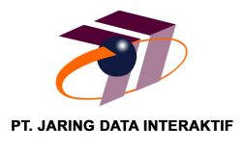
Wisma Indovision, 11th Fl. Jl. Raya Panjang Blok Z No. III
Green Garden, Jakarta 11520 Phone: +6221-5818855;
Fax: +6221-5825530, +6221-58302414

