Encourage Country’s ICT Development

In a clean environment with not much corrupt government officials and a large number of “clean” law enforcement, a direct intervention to government regulatory and policy framework & do e-government might be the quickest route to encourage country’s ICT development. However, in a distorted environment, one might consider an alternate path to encourage the grassroots ICT movement to take a significant role in country’s ICT development.

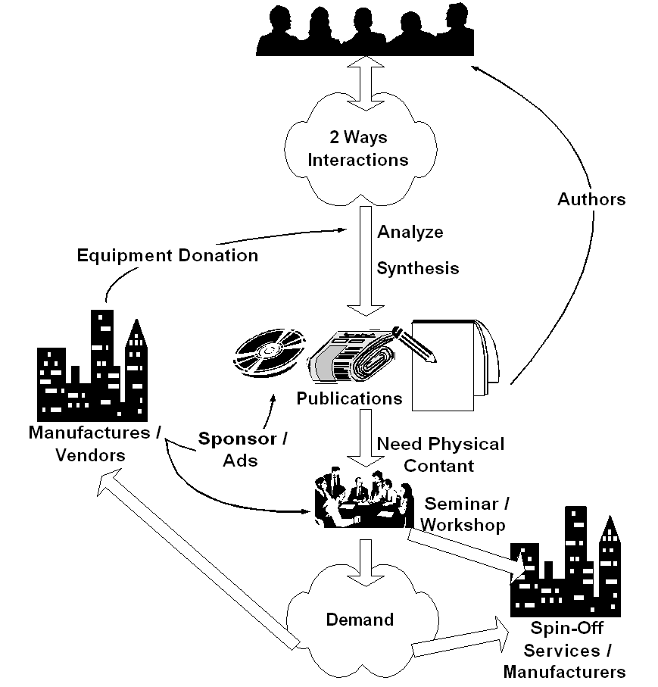
Assuming we are agree on the fact that there is a possibility of grassroots ICT movement in the country. Such community movement will normally rely on community investment to minimize any distortion. Such approach may significantly reduce the cost for any country or government in ICT deployment. A self-finance community education and demand creation process is the key.

Keep in mind that most modern ICT equipments require the ability to read & write. Communities’ mode of communication would be important in deciding the appropriate ICT technology as well as community development strategies.

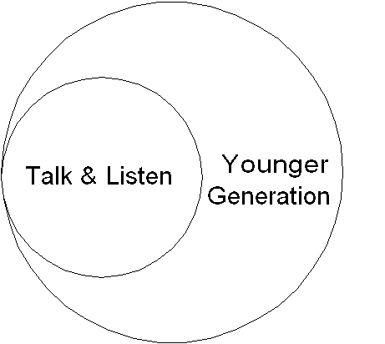
If I may stereotyping developing world communities, I will likely divide the communities into two (2) major categories, i.e.,

- Those who would more comfortable in speak and listen. They might be an older generation, uneducated or primary school dropped out. They will likely more resistance to change especially the one introduced by aliens.
- Those who would be more interested in new things and technologies. They might be a younger generation & have some sort of education above primary school level.

The younger generation may easily adapt the new ICT technology. However, to reach larger audience within the communities, voice communication mode should be considered as well.

Proposed Basic Strategic Approach

The basic strategy is to encourage the individual within the community to become a knowledge producer and sharing the knowledge to their community or surrounding other communities. Knowledge may not be in written form. It may be in audio form to reach larger audience in poor communities specially the older generation.

Intervention Not Disturbing The Process

Any government International bodies or donor agencies may speed up the scaling up and replication processes in society movement. In order not disturb any self-finance processes; a careful intervention should be performed in one of the point in demand creating processes. It can be in

- 2-way interaction platform – to accumulate & manage community tacit knowledge.
- Information analyzing & synthesis processes. Testing & development processes.
- Encourage explicit knowledge creation, e.g., in book and article.
- Expedite explicit knowledge distribution.

Those are the long-term processes that involving a large number of people. It is normally very limited interest to the commercial sectors for sponsoring the process. It is not surprising to see the communities rely on free services over the Internet for such processes.

Language barrier would be one of biggest barrier in south-south development strategies. It really impedes interaction among south-south communities and reduces trust needed for collaboration processes. I personally don’t know the best solution to such barrier.

Just to give some ideas on the kind of intervention by government, international and donor agencies to facilitate the process without disturbing the self-finance & sustainability process of the movement, some of them are,

- Creates free mailing list platform at the country’s Internet Exchange to confine the bandwidth of discussion traffic in the country. It might be possible to work together with yahoogroups.com (http://groups.yahoo.com). To be honest, yahoogroups.com may be the best free mailing list service in the world today. We may always work from scratch using the existing open source solution such as mailman.

- Supporting a development server. Where young programmers can try their ideas. In return, they have to publish their knowledge gain from their experiments, in terms of magazine articles, books, both in their local language and English as well as put their script and code under GNU License.

- Encourage knowledge producers. For example,
  - Organize some sort of ICT book competition to encourage young authors.
  - Collaborate with ICT manufactures to write book on their technology in local language.

- Community radio broadcasting, which affordably costs US$50-100 each, would be the most strategic tool for knowledge sharing of older generation as well as the young in the communities. Encouraging people to be part of broadcast programming will in turn encourage individuals to be a local knowledge producer. It guarantees information diversity and minimizing information colonialism by national broadcasters.

- For younger generation, focused on ICT on schools. It may affordably cost only 10-50 cents/students/month. We are looking at millions of country’s future generation ICT literate. Curriculum wise, we need to focus these students to be a knowledge producer rather than consumer. These young generation would likely to influence their parents, their families, and, in turn, their surrounding communities. It takes a longer path, a longer time, but it guarantees a change in a long run.

Initiate Local Development Server

In practice, initiate a development server might be the most strategic entry point into the movement. For example, a lot of young Indonesian developers ask me if I have access to free web server with PHP & MySQL capability to test their script. If such approach would like to be performed, we can set the condition for these young developers to publish & share their work under GNU license if they use the server.

There are several conditions to be considered, such as,

- The Development Server should be physically located at the national Internet Exchange for practical reasons, i.e., removing any bottleneck in accessing the service. In Indonesia, the Indonesia Internet Exchange has local bandwidth in the range of Gbps. It is good for the local ISP as we create demand for local connection while reducing the high cost International bandwidth. This may cost some money (funding).

- The local co-location service provider must do physical maintenance of the server. There are several co-location / hosting service provider in the country. This may cost some money (funding).

- The largest Open Source community in the country must transparently do access management of the development server. Depending on the agreement, this may or may not cost any money (funding).

- Every individual / groups should be allowed to access to the development server under certain condition, such as,

  - All scripts / code must be published under GNU Public License (Open Source).
  - Must be able to proof publish articles in magazine.
  - Ability to publish book would be a plus.
  - Ability to publish work in English would be a plus.

Monitor and Interact with Local Communities

It is important to monitor the reaction, get feed back and interact with the community through various Internet mailing lists. It is very important to have an intense interaction with the community. Trust is developed through rapid and intense interaction. Fail to do so, namely less or slow interaction; sets some distance the local communities, take out trust from the communities and, thus, leads to difficulties to move the communities forward.

Under rapid interaction with the communities in the end more people will be connected to the Internet. Such condition will create higher pressure for the regulators to work on a more favorable policies and regulatory framework. Hoping no distortion made during the processes.

The normal (not the ideal) sequence would be awareness, demand creation, business response, and policy / regulation changes. These steps would not be completed over night. It will take years to complete these steps.

Existence of committed leaders & personals would be significant factor in such long-term deployment ICT movement.

