Self-Financing The Knowledge Cycle

To sustain a digital divide bridge deployment in a long period of time, ability to self-finance local knowledge generation cycle is crucial. Key success in deploying the information infrastructure would rely heavily on the mass of quality & skill of the human resources. Ability to distribute the needed knowledge & skill at low cost would be crucial in creating demand & needed skilled technician to deploy the infrastructure. Ability to access ICT knowledge in English would be a plus. Interestingly, as equipment can be shared and is getting cheaper, funding is not the primary concern in deploying ICT infrastructure.

In creating a self-finance knowledge cycle, there are basically two (2) critical strategies, namely,

- Transforming some locals into local knowledge producer.
- Supply created-by-demand strategy.

Unfortunately, the whole process takes at least ten (10) years. Thus, never ever expect financial benefit in a short period of time. It will never happen that way.

Most failure is likely due to demand created-by-supply path or heavy top-down approaches. Demand in information infrastructure as well as ability to exploit abundant information & knowledge on the information infrastructure may only occur in an educated society. Failure to increase the society's level of education will likely to impede the development of information infrastructure within the society.

A conservative route would go for connecting the school and university network first, as it will affordably cost US$ 0.50/student/month with Return of Investment in 1-2 years. Furthermore, young generation would be an effective agent of change for their parents and surrounding communities.

In developing country, like Indonesia, practical know how on various ICT technologies in local language is in high demand. Publishers are begging for manuscripts on various ICT practical guides in local language. Most of the best Authors are in their 30’s and acquiring their ICT knowledge through their school and university’s Internet access. Thus, it is very crucial to integrate schools and universities to the Internet, as they are the one that produce the desperately needed local knowledge 3-5 years after their initial introduction to the Internet.

Simplified Steps in Knowledge Generation & Demand Creation

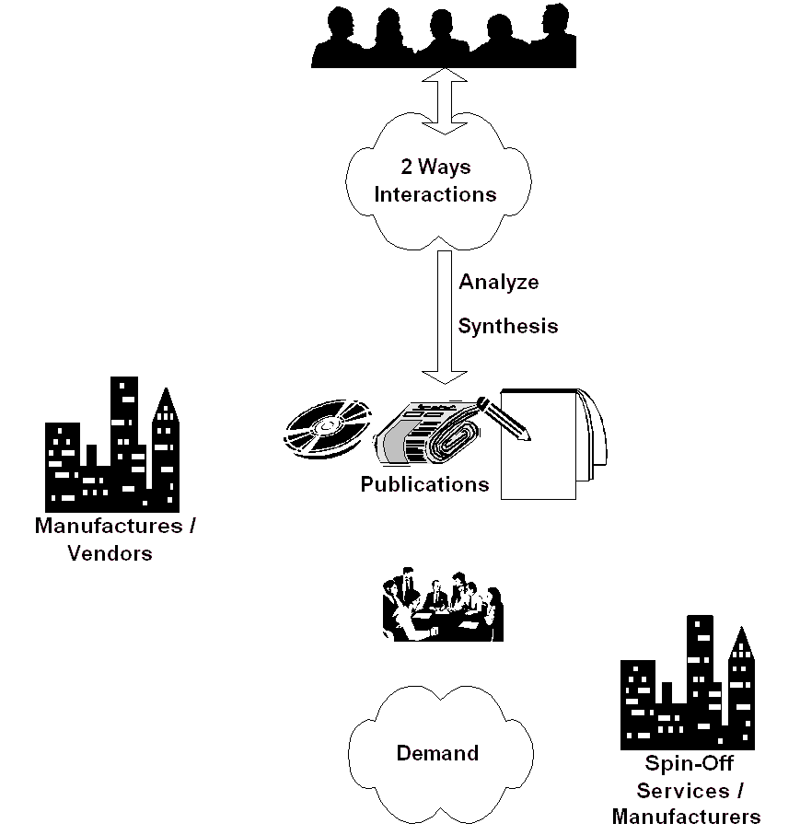
- Create discussion platform for 2 ways interaction. Such platform is basically to facilitate tacit (implicit) knowledge exchange. It may be radio or TV talk shows, or Internet mailing lists at no cost. Unlike most assumed condition by 1st world countries, no abundant local content is necessary to start with. Community may create their own content through platform that exploits community implicit knowledge exchange. Existence of informal community leaders is crucial in such platform, a leader not necessary the moderator.

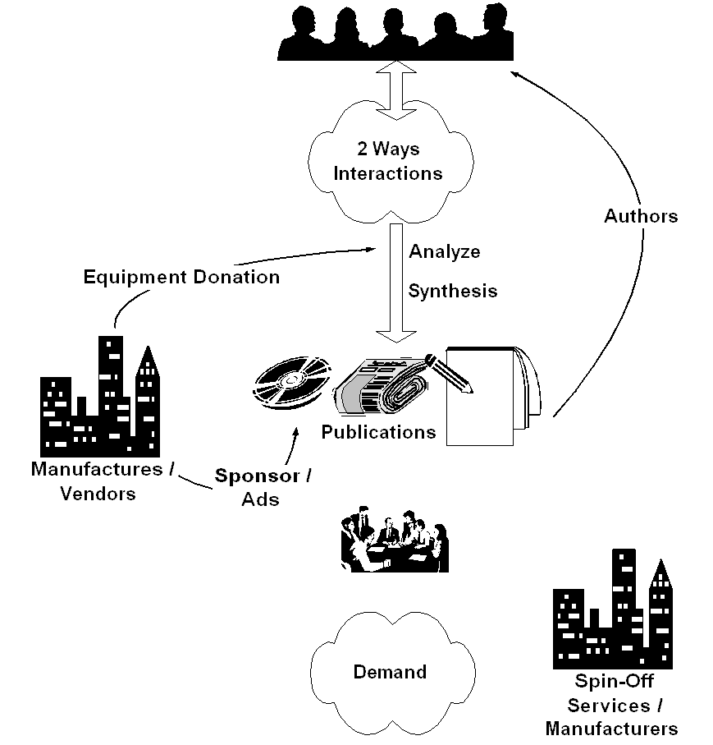
- It may take 1-2 years, before some individuals start analyze and synthesis the collective community knowledge. These individuals, mostly young, should make their knowledge implicit in written form. It should be distributed through conventional channels, such as, newspaper, magazine, radio & television, and, thus, transform the mindset of others who are not yet using ICT. It costs US$ 1-2 to access the knowledge in books or magazines. The young authors, in return, normally receive an incentive of US$ 15-25 /article or US$ 400-700 /book. The best selling and the most productive Authors, it would be easy to get equipment donation from various vendors.

- Some may need physical contact through seminar and workshop to be convinced. We are normally looking at 500-1000 participants/seminar. The favorite seminar agenda would be to provide tutorial and demonstration on various ICT technologies. It costs US$ 3 /person to enter such seminars as many vendors may likely give sponsorship. Marketing through local newspaper or computer magazine is crucial in getting such large participants. A hands-on workshop with two (2) persons on one computer will be more costly about US$ 40-50 for 1-2 days workshop, and normally accommodate 30-50 participants.

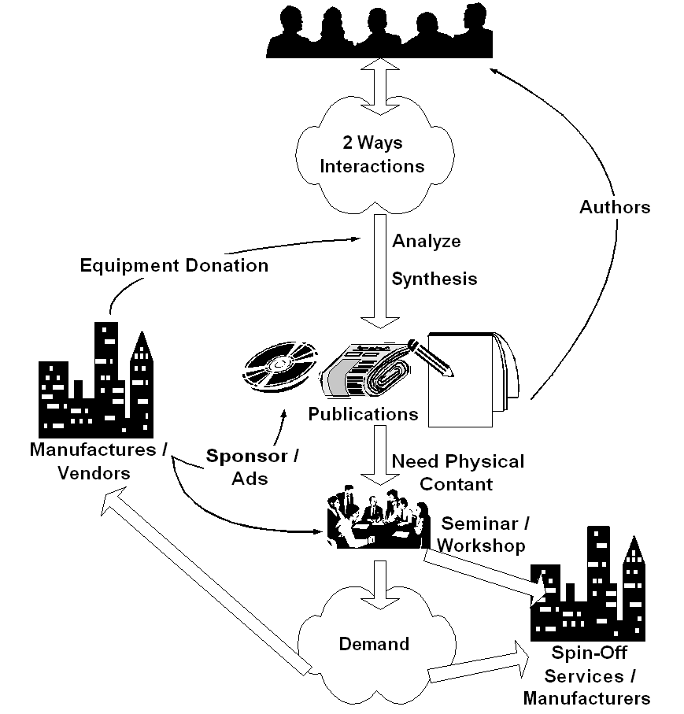
- As more people convinced, demand is created within the communities for their very own "digital divide bridge". Sound business plan, with US$ 2000-4000 investment and return in 1-2 years, will persuade people to invest their money to deploy their very own "digital divide bridge". A 50 cents/student/month in a school network or US$15-30/house/month with Return of Investment within 1-2 years is a good enough incentive for people to invest their own money into the "digital divide bridge". Success stories & word of mouth is the typical process to spread the words. Manufacturers and business communities will gladly responds to such opportunities. Some individual would spin-off and create their service companies to meet the demand. A conservative path would connect the school network first before connecting the neighborhood.

- Deploy & maintain the "digital divide bridge" may be done at 50 cents/student/month at school or about US$ 15-30/month/house. Ah, we finally have financially sustainable digital divide bridges with minimal support from the Bank, the government & hopefully license free.

In the end, as more and more people connected to the Internet, pressure will be high for the regulators to work on their policies. Hoping no distortion made during the processes.

As shown clearly, all the sequences are self-finance. The normal (not the ideal) sequence would be awareness, demand, business response, and regulation. These steps would not be completed over night. It will take years to complete these steps. Committed leaders & personals are needed for such long-term deployment ICT movement.

Closely Examine Investment, Cost and Impact

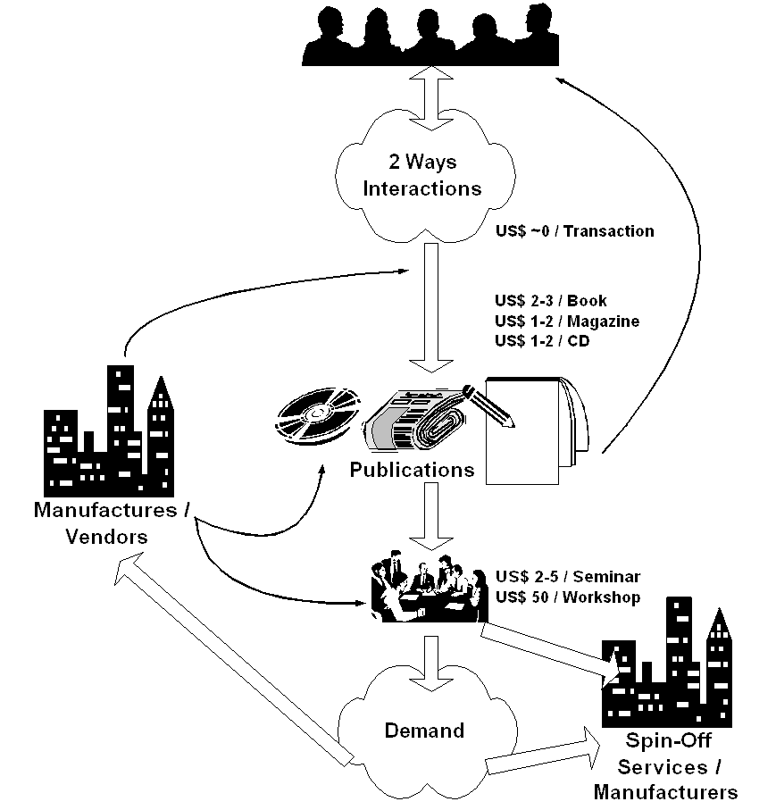
Let us closely examine the access cost to knowledge. As a reference, a decent lunch for common people costs about US$0.25. The access cost to knowledge may basically divided into several stages, i.e.,

- No cost, for discussion platform / two ways interaction. It would be the best place for communities to learn the technologies. A good example of such platform is http://groups.yahoo.com.
- Publication costs US$2-3/book, US$1-2/magazine and US$1-2/CD-ROM. It is quite affordable for most students.
- The most costly access to knowledge would be face-to-face interactions. A seminar will cost about US$ 2-5/participant including the snack, Linux CDs, magazine not to mention all the door prices. Hands-on workshop costs US$50/participant.

From the operator, publisher or organizer point of view,

- Providing a discussion platform will generate traffic and mass gathering. It is a good place for getting advertisement and sponsorships.
- A normal ICT book will sell a minimal of 5000 copies. Best sellers will sell around 40-100.000 copies. Having a minimal 5000 copies at US$2 each will cost the publisher around US$10.000/title. As more readers in the market, it is common to see a title sold out in 6 month to 1 year. Thus, US$400-700 incentive for the author is virtually nothing for the publisher.
- A 500-1000 participant seminar at US$3/participant generates about US$1500-3000/seminar not to mention some funding received from many sponsors. It costs only about US$150-600 for the speakers including their travel budget. Marketing costs would be around US$150-200 in local newspaper. The rest would be divided between the cost for participant coffee break and incentive for the organizer.
- Hands-on workshops with all the equipments are best suited for vocational schools or technical colleges. It costs about US$ 50 / participant for a 1-2 days hands-on workshop.
Failures in seminar activities are mainly due to,

- No investment in marketing / advertisement in local newspaper / ICT magazines. It is a common mistake in many students run seminars.
- Pick an expensive place and hotel to run the seminars and pay high price for the luxury. It in turns increases the entrance fee and significantly reduces the number of participants. It contradicts the fact that most sponsors and speakers would like to see a large number of participants. A simple campus hall would in fact best suite such activities. Our experience in Indonesia, US$ 3 for students and US$ 5 for general audience would be the maximum entrance fee for ICT seminars.

Most sponsors, speakers, and authors would normally like to see a large number of audience and participants in the crowed. Let us now examine the impact of each stage, e.g.,

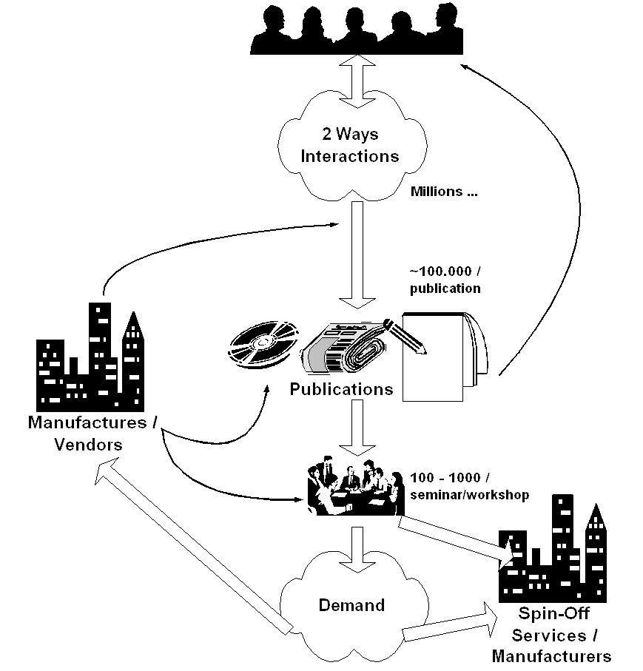
- Depending on the media / technology, we will see thousand of e-mail mailing list participants. It is a round the clock and year long service. It is very advantageous for manufacturer or vendor to participate in such long-term discussion activities. It is a soft-marketing process.
- In some cases, we organize weekly radio or television talk show. We normally see a much larger audience in millions. However, the airtime is normally very short less then an hour per week. Such talk show is best for eye opening efforts at user level, but not at increasing technical skill.
- Magazine and book would cover 20-10.000 readers per volume or title. Article in a magazine is mainly for eye opener, while book is mainly for in depth discussion of certain topics. Having a dozen ICT weekly magazines and thousand-book title published, it surely covers a large number of people in the country.
- Seminar and workshop is a more costly approach, and cover a smaller number of participants as compared to the previous one. However, it is very important to have a face-to-face physical interaction as it builds the needed trust within the communities.
- Some of us are currently working on creating VCD on ICT education. Others put their work on the web for free download. As Internet access is quite expensive in many areas, CD distribution of the knowledge as well as many open source / Linux is helping the knowledge dissemination processes.
To give some extreme ideas, we can actually mingle with current education system. For example,

- When I teach at Institute of Technology Bandung, I removed the necessary attendance. No mid term exam. No final exam. Mark is based on student ability to become a knowledge producer. A simple tactic, forcing the students to publish article in the magazine, e.g. 5 articles A, 4 articles B, 3 articles C etc. or publish a book for an A.

- Other way to encourage the students, I give free access to the Internet for those who like help me maintain and run the system. In the end, I ask them to write book based on the knowledge gain during the process.

- The private sector will be gladly helping us in performing the process as we create huge demand for their products. Getting free equipments to do the experiments is not that difficult. Most companies would be interested in sponsoring the seminar / workshop if there are 500-1000 people showed up.

Through these simple processes, we force young students to become a knowledge producer to benefit the whole society through local knowledge accumulation and publishing the knowledge.

In rural and remote areas where talk-and-listen is the primary communication means, computer & Internet based ICT may not work well. Community radio and television might be the best alternative. One can easily build a community radio transmitter for under US$100, and, thus, enables its surrounding community to speak up and creates an information-diversity environment. A network of community radio would be a strong barrier against information domination by national / multinational broadcasters. We unfortunately have to fight again with the local government for frequency allocation.

Knowledge Cycle From Author Point of View

Knowledge & skill is the most important key success factor in a self-funding sustainable community based ICT infrastructure. In previous sections, knowledge and skill benefit for the society, the publishers, editors as well as equipment manufactures has been reviewed. In this section, we will review the knowledge cycle from Author’s point of view.

If I may use a simplified model of the circle of knowledge, it basically contains knowledge publishing and packaging, disseminating, and generating processes. Within the knowledge generating process, the author will normally read references from the Internet, read feedback or any discussions over the Internet mailing lists, tried various software downloaded from the Internet, and in some cases receive equipments from manufacturer to be reviewed etc.

Speed of knowledge flow is an important parameter in knowledge cycle.

Ability to accelerate the cycle will benefit the authors, publishers, as well as readers. Having Internet based media, information & knowledge flow may be accelerated. Compared with hundred million populations, having hundreds of local ICT authors, such as in Indonesia, is not a handicap. Ability to rapidly publish, disseminate and interact with the readers would be a plus for any ICT authors in developing countries. It is common to see young ICT authors less than 30 years old and have been publish more than 5 ICT books. I have published close to 40 books, most of them inspired by interaction with the readers in various Internet mailing lists in my 600 e-mails /day.

To reach larger common audience, conventional media, such as, magazine, newspaper, books, radio and television, is best. In reality, we need to supply the journalists, editors, and producers of conventional media with an appropriate ICT knowledge. After five (5) years Indonesian Internet evolution, most Indonesian journalists, editors and producers have access to the Internet. Putting the ICT knowledge in electronic public domain package, such as, softcopy, CD-ROM and Web servers, is a plus to reach larger audiences.

In the accelerated cycle of knowledge would in the end educate many people and may transform part of the communities into knowledge producer rather than passively stays as knowledge consumers. It is the ultimate goal to see more knowledge producer, writer etc. cultivated as a result from abundant freely available knowledge over the network. Some of these knowledge producers are quite militant and normally becoming the driving force behind the Internet development in Indonesia.

Most of the Indonesian Internet activists, such as, I Made Wiryana (Germany), Michael Sunggiardi (Bogor), Adi Nugroho (Makassar), Irwin Day (Makassar), Ismail Fahmi (Bandung), Rahmat Samik Ibrahim (Jakarta) etc. would prefer to publish their work freely on the Internet. You may find their work in Indonesian Digital Knowledge Foundation (IDKF) http://www.bogor.net/idkf, Pandu Team Website http://www.pandu.org, http://www.ilmukomputer.com, and http://bebas.vlsm.org. It contains thousand articles and references on various ICT aspects in Indonesian language.

Copyleft & copywrong movement provides free literature and education and really helps the building of Indonesian Internet society. Many Indonesian new dotcommers may mirroring these sites, thus, enable rapid distribution of the knowledge to the society.

Since most, if not all, of the necessary knowledge is freely distributed, some may ask - what about the reward, especially financial reward, for those who provide the free knowledge? Fortunately, God is fair and provides ample rewards in unimaginable ways. Well, to be more practical, in a more realistic picture, it may go very pragmatics. When one distributes one’s knowledge freely to public, public is educated & demand on certain aspect of technology or services arise. The private sector or entrepreneur may take up this opportunity. In the end, the public will receive the required technology or services provided by the entrepreneurs within the public or larger private sector, which, will in the end receive capital gain. The private sector sees this in a simple ways, the one who create demand in the market should be supported for maintaining the demand / market. It is logical to see one who provides free knowledge may receive most attention and sponsorship in various forms such as arrangement of seminars, workshops, talk show etc. Thus, enable the knowledge producer to continually distribute their knowledge freely to public.

One may be surprised by the amount of funding & sponsorship received by putting the copylefted knowledge in public domain. Depending on the coverage of the audience / readers, it may surpass the salary of professional executive with fixed job and fixed income in Jakarta the capital city.

