Introduction

The digital divide has never been about just access to computers: it is also about education and opportunity. If every family in every community had Internet access tomorrow, the digital divide would still be there because access to technology is useless without the computer skills needed to really take advantage of that technology. In addition to access, people need knowledge and competence in a wide variety of computer skill areas.

I strongly believe that digital divide alleviation can only be done through education processes. It may not be a formal education. In fact, mostly informal education process that encourage individual within the community to be a knowledge producer and share it to one’s community and ignite a bottom up self-finance community based development process to alleviate poverty. One’s value highly depends on the benefit received by ones community.

Having spent 10+ years in helping the Indonesian to build people own Internet infrastructure with minimal (if not no) support from the government, World Bank or IMF. ICT is basically only a communication tool to accelerate the knowledge sharing processes. My experience shows that it is not the technological superiority or the financial dominance that matters in a bottom-up self-finance community based ICT development.

Most community has some money; the bigger the community the larger amount of money can be accumulated. ICT technology enables multi-tasking, multi-user, and resource sharing. It, in turn, enables lower operational cost per individual in large communities, e.g., 10-50 US cents/student/month for 24 hours e-mail / Internet access with Return of Investment (RoI) within 1-2 years time in most schools is quite affordable for any poor communities. US$10-30/month for 24 hours WiFi Internet access in urban household is quite affordable for mid income families.

The major stumbling block is mainly in knowledge on ICT. Awareness, skill to build and run ICT infrastructure would be the main aspect in a bottom-up self-finance community based approach.

The heart of transformation processes including ICT for development is,

- Education! Education! Education! Education!

- Youth is the agent of change.

- Accountable leaders may catalysts transformation processes.

- Putting technology in place is the easiest part. People, its education, social, cultural, politics, and policy aspect would be the most challenging part. Build the usefulness of technology into the values of the culture would ease the acceptance processes.

- Demand-created supply scheme works best as compared to supply-created demand. It is an art in itself like chicken and egg, which comes first?

Deployment of community based ICT infrastructure will likely to face significant policy and regulatory challenges. Shift in mind set within the policy and regulatory framework would likely be needed that,

- All policy and regulatory framework must aim to fulfill the right of communication and access to knowledge.

- Concept of privatization and competition may create the needed constructive environment that should be balanced by empowering and funding rural and underserved communities' infrastructure.

- Bandwidth and frequency management must aim for the benefit of the majority of people. In most cases, ability to provide free public access would be paramount in facilitating the people transformation processes towards a better stage.

Digital Divide Bridge Main Strategy

Lesson learned in knowledge transfer processes as well as infrastructure deployment may be adapted into developing country condition. A simple picture of the digital divide bridge layout in Indonesia (an example of developing country) is shown in the figure.

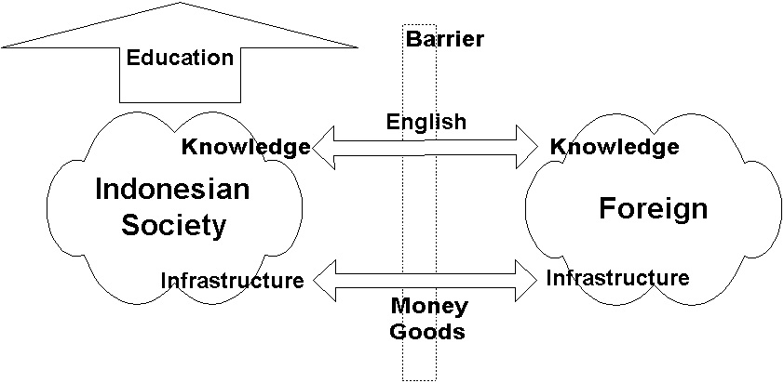

Education especially among young Indonesians is the most strategic key process to transform the Indonesian people towards knowledge-based society. Ability to read and write in English would be very essential in gaining the required knowledge. As for the infrastructure, a rapid flow of money (capital) and goods between Indonesia and Foreign countries would be essential. Unfortunately, within the current Indonesian condition, a significant policy and regulatory challenges will be prevailed especially in the infrastructure. Hoping the shift in mind set within the policy and regulatory makers can be performed within a short transient period for a better Indonesia.

Well, the bridge may not be perfect as …

"Life is like driving a car at night. You can only see a few dozen feet ahead - as far as the headlights. But you can make the whole trip that way."
Richard Vohs, CEO Iowa Network Services

Importance of Vision & Visionary Leader

Experience shows that the key ingredient for a successful long term ICT movement is,

- The vision
- Existence of visionary leaders

In Indonesia case, all activities are driven by a simple vision, such as,

To see a knowledge-based society in Indonesia.

ICT is believed to be the tool of choice to accomplish the task.

The existence of visionary leaders is an important factor to drive the mass. A leader is the one who knows the way, goes the way and shows the way. In Indonesia ICT case, it would be difficult to find such ICT knowledgeable leaders in the neither government nor ruling parties. Thus, informal, sometimes underground, visionary leaders / pioneers is mostly the case.

Community based telecommunication / ICT infrastructure using WiFi and VoIP would facilitate many transactional processes. It is 24 hour connected to the Internet. Expanding the Telecenter concept into Neighborhood Net Infrastructure. Its investment costs US$ 80-100/house; operating costs US$ 15-30/house/month. If voice only communication is of interest, VoIP investment costs US$ 25-35/handset vs. US$ 1000/handset by Telco. VoIP operating costs US$ 15-25/month unlimited including unlimited long distance calls. Supported by IDRC and Bellanet, the technology may be freely downloaded from http://sandbox.bellanet.org/~onno/.

As a result after 10+ years struggling on an alternative bottom-up self-finance community based movement, it has proven to be a good ICT development model, at least for Indonesia; as a result, we are currently seeing:

- 4+ million Indonesian on the Internet
- 2500+ WiFi outdoor nodes for bypassing local Telco infrastructure
- 2000+ Internet Cafes
- 1500+ schools on the Internet

Most of these activities are community based funded with not much government support as well as no funding from World Bank or IMF.

Intervention Into Self-Finance Process

My experience shows that it would be much easier to initiate a self-finance sustainable process if there is no funding from any donor agency to begin with. We can easily see the committed individuals & successful approaches in a free donor agency zone.

Scaling up and replication is of interest by many government, international bodies and donor agencies. Care has to be carefully exercised to intervene a self-finance community based process. Most people will likely to assume that international bodies, donor agencies and government would likely to bring free funding for them. It may work for pilot projects; the process may unfortunately stop as soon as the funding source dried up.

Key successes rely heavily on ability to create a tacit knowledge exchange platform enabling knowledge producing young authors follow up by education processes focused on scaling & replicating the process for high impact to the society. Open source, open document, copy left movement would be significant. All processes are self-finance. It has nothing to do with the technological superiority of the equipments.

Adjustment should be made for different countries & regulatory environment.

