Setup Linux Based Wireless Gateway

In this section, Linux Mandrake is used. Some of the tool used in the examples may not be readily available in other Linux distribution.

To make our life a little bit easier, it is preferable to use Mandrake Control Center on your Mandrake desktop or Webmin at https://localhost:10000 to set up the gateway. Both are using Graphical User Interface (GUI) and, thus, very easy to use.

Activate WLAN card as eth0

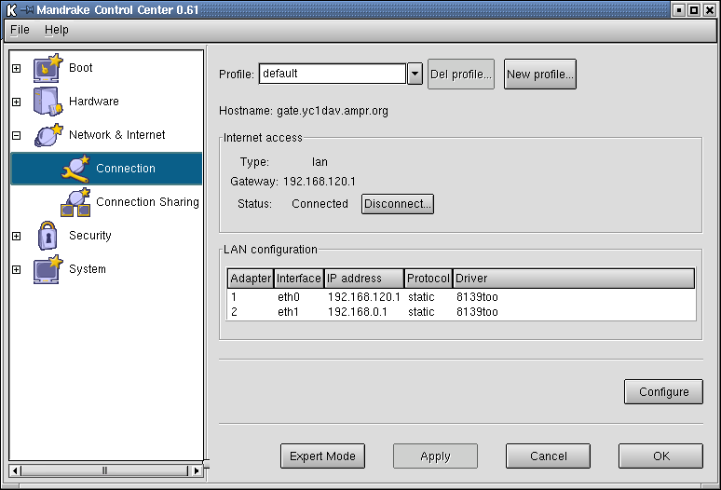
After WLAN driver is properly installed, PC is correctly booting, the next challenge is to activate the WLAN interface & to give a proper IP address to it.

It is quite challenging as in most cases a PC gateway will likely to have two (2) Ethernet cards interface in it, Both WLAN & LAN Ethernet cards will likely to be recognized as device eth in Linux. Thus, we have to check the card manager to identify correctly which one is the eth0 and eth1.
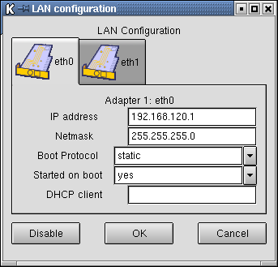
The easiest way to set the IP address of Ethernet card is using the Mandrake Control Center. Mandrake Control Center → Network & Internet → Connection, we will entering LAN configuration and may set the IP address of eth0 and eth1.

As shown in the figure, for PC gateway, we statically set the IP address, netmask etc. It will automatically started on boot.

During most of my installation, WLAN card will normally recognize as eth0, and LAN as eth1. It is shown in messages during the booting of the machine. We can always use Webmin at https://localhost:10000 → Hardware, to set the Ethernet cards.

Simple Routing Technique for the Gateway

In configuring wireless gateway, a very simple routing technique is implemented. A wireless gateway will likely to interconnect a Local Area private Network (LAN) with private IP (192.168.x.x) to the Access Point. The Access Point may use public IP or private IP.

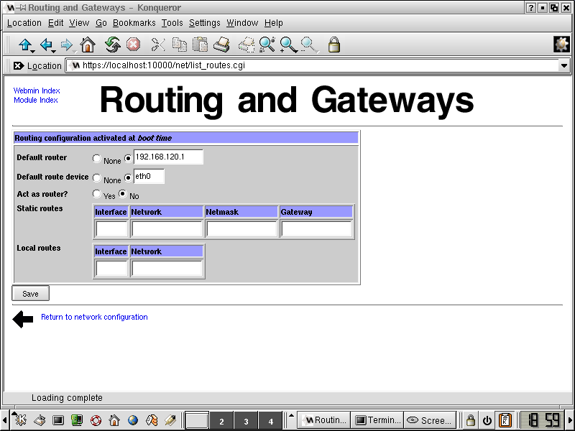
Simple routing requirements mean a simple routing configuration. On the Linux gateway we have to set the IP address of the Access Point as the gateway for default traffic. It is normally set in /etc/pcmcia/network.opts.

We can also use gateway parameter in routing configuration in Webmin https://localhost:10000.

Webmin → hardware → network configuration → routing and gateways will show us a familiar GUI. All we have to do is fill,

- The IP address of the Access Point as default gateway / router to the Internet.
- Default route device is the WLAN eth.

For security measure, please DO NOT set the parameter Act as router → Yes. If this parameter is set, our wireless gateway will run RIP (Routing Information Protocol) and broadcast our routing table to the Access Point as well as other wireless node. Thus, routing information of our machine will be available to others on the network, including, unfortunately, crackers that may attack our network.

Simple Proxy & Network Address Translation (NAT) Technique

There are at least two (2) simple proxy techniques, namely,

- Use proxy server program, such as, squid in Linux.
- Use Network Address Translation (NAT) facilities in IP filtering mechanisms with in the operating system, such as, ipchains or iptables in Linux..

Software proxy techniques using squid in Linux is fairly similar to Wingate in Microsoft Windows. The main benefit in using such techniques is in the ability to cache the traffic and, thus, reduce the traffic and save some bandwidth. Squid configuration file can be found at /etc/squid/squid.conf. Login as root, we can use a normal text editor to edit squid.conf and adjust the parameters.

If squid is used, we would likely to set on our LAN workstation to proxy the Web traffic through the IP address of the wireless gateway at port 3128. port 3128 is the default port for squid. We can always change it to other number by editing /etc/squid/squid.conf.

As always, Webmin at https://localhost:10000 will help any beginners to configure the squid proxy server through its user friendly GUI.
The only thing must be changed in the default squid configuration is the Access Control List (ACL) to open the squid access for other users on the IntraNet LAN to use the squid server & proxy their traffic. The default configuration is not allowing IntraNet users to use the proxy server.

The squid ACL configuration is very easy to do through Webmin https://localhost:10000 → Servers → Squid Proxy Server → Access Control.

We need to do two (2) things, namely, (1) create the Access Control List and (2) set the proxy restriction. First create New ACL with type ACL Client Address to be controlled / proxied. In New ACL menu, please enter few parameters, such as,

ACL name = ok-users
IP address = 192.168.0.0
Netmask = 255.255.255.0

Assuming all IntraNet LAN workstations are using private IP 192.168.0.0/24.

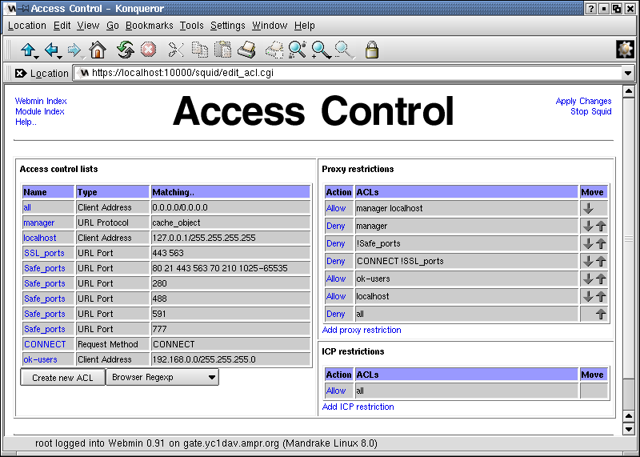
After new Access Control List ok-users created, we move back to section Access Control → Proxy Restriction → Add proxy restriction. When you enter the add restriction menu, please add ok-users into the allow column of the table. Press Apply Changes after completed.

Done, your proxy server is now ready to served for IntraNet LAN Workstations.

Please remember to configure the proxy settings at each workstations to use the IP address of the wireless gateway as proxy at port 3128.

The second proxy technique is using the Network Address Translation (NAT) facility build-in into the operating that can be controlled through iptables or ipchains. In contrast to the use of proxy server software, we don’t have to set each workstation to proxy their traffic to the Internet as well done automatically by the gateway operating system.

Unfortunately, there is normally no cache ability in NAT and, thus, no bandwidth reduction will be gain. In Linux Mandrake 8.0, kernel version 2.4.x is used and iptables is supported to do the NAT processes.

The NAT process is set through a script that execute during booting time. There are many NAT script floating around. There are several ways to do the NAT, such as,

/sbin/iptables -t nat -A POSTROUTING -o eth0 -j SNAT --to 192.168.120.114

Where eth0 is our WLAN interface, and 192.168.120.114 is our WLAN IP address. One example of the NAT script posted by akuhon@kompas.com in linux-admin@linux.or.id is listed below

#!/bin/bash

# From: AHK <akuhon@kompas.com>
# To: linux-admin@linux.or.id

# Save this file and activate through # nama_file start
# and de-activate through # nama_file stop

# This firewall-script can be used for workstation, laptop, router
# or server that are not running network service (such as web server, ftp
# server etc)

# change the parameter UPLINK with Interface device to the Internet.
# In our case WLAN router with NIC eth0 connected to the Internet
# and LAN connection with eth1.
# if you use dial-up modem, you might use ppp0 as your UPLINK

UPLINK="eth0"

# if you run the gateway as router and forward IP packet between eth devices
# please fill “yes”, if not, please fill “no”

ROUTER="no"

# Please change “192.168.120.114" to your static IP address of UPLINK device.
# For those who use dial-up or dynamic IP, please enter “dynamic”

NAT="192.168.120.114"

# please list all network interfaces including eth devices
# as well as dial-up interface such as ppp0

INTERFACES="lo eth0 eth1"

if [ "$1" = "start" ]
then
echo "Activate Firewall ..... "
/sbin/iptables -P INPUT DROP
/sbin/iptables -A INPUT -i ! ${UPLINK} -j ACCEPT
/sbin/iptables -A INPUT -m state --state ESTABLISHED,RELATED -j ACCEPT
/sbin/iptables -A INPUT -p tcp -i ${UPLINK} -j REJECT --reject-with tcp-reset
/sbin/iptables -A INPUT -p udp -i ${UPLINK} -j REJECT --reject-with icmp-port-unreachable

# turn off ECN function
if [ -e /proc/sys/net/ipv4/tcp_ecn ]
then
echo 0 > /proc/sys/net/ipv4/tcp_en
fi

# turn off packet spoofing in all interfaces
for x in ${INTERFACES}
do
echo 1 > /proc/sys/net/ipv4/conf/${x}/rp_filter
done

if [ "$ROUTER" = "yes" ]
then
# Activate IP forwarding at router
echo 1 > /proc/sys/net/ipv4/ip_forward
if [ "$NAT" = "dynamic" ]
then
# Dynamic IP address, activate Masquerading
echo "Activate Masquerading (Dynamic IP) ...."
/sbin/iptables -t nat -A POSTROUTING -o ${UPLINK} -j MASQUERADE
elif [ "$NAT" != "" ]
then
# Static IP address use source NAT
echo "Activate SNAT (static IP) ...."
/sbin/iptables -t nat -A POSTROUTING -o ${UPLINK} -j SNAT --to ${NAT}
fi

fi

elif [ "$1" = "stop" ]
then
echo "Deactivate Firewall ..."
/sbin/iptables -F INPUT
/sbin/iptables -P INPUT ACCEPT
# Turn off NAT or MASQUERADING
/sbin/iptables -t nat -F POSTROUTING
fi

