WLAN Installation in Windows

For those uses newer Windows XP or Windows 2000, it would be easier to find the needed WLAN card driver. However, for older Windows versions it may require a little bit more effort.

In this chapter, an example of WLAN driver installation process in Microsoft Windows 98 will be shown. I am using an old Samsung MagicLAN SWL-2000P at my home installation. The newer models may be much easier to install.

Please note that after the driver installation, we need to configure the TCP/IP network settings. It is treated as normal LAN connection. The network configuration can be performed through normal way, i.e.,

Start → Settings → Network.

WLAN Card Driver Installation

Several steps to install WLAN card driver is as follows,

- Remove WLAN card from your PC.
- Boot the PC and logon.
- Insert CD provided by the WLAN card, in this case is MagicLAN SWL 2000P. CD will autorun to install the required driver.
- The first page shown is the License Agreement.

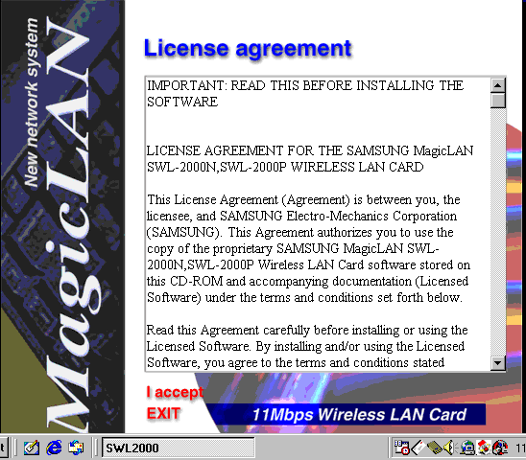

- Clik “I accept” to accept the proposed License Agreement.

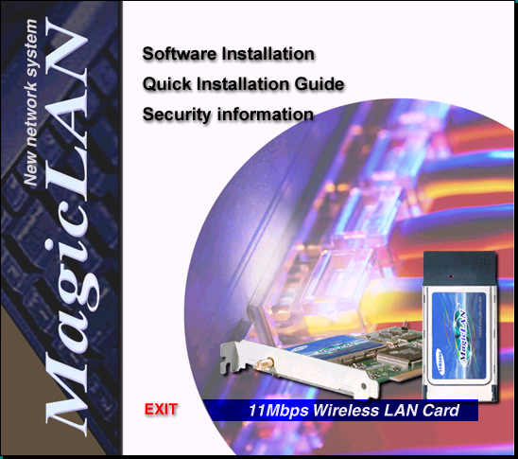

- Select software installation to install the required driver for the card. For those who wish to have a better understanding may read the Quick Installation Guide.

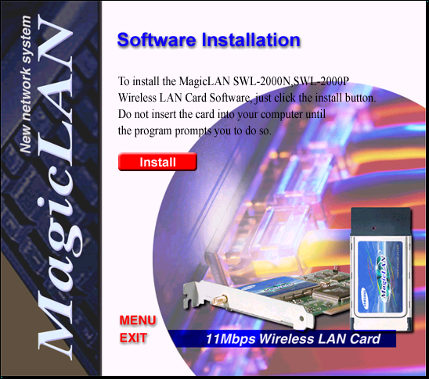

- Next step is to click red Install button.
- Please note that on above the red Install button it says “Do not insert the card into your computer until the program prompts you to do so”

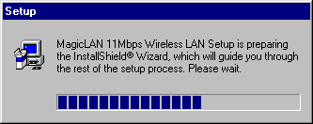

- It will take a short time to load the installation software.

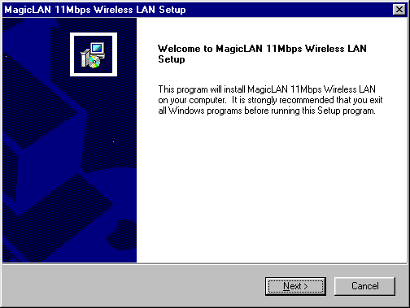
- As soon as the installation software is ready, a Welcome message is shown on your screen. Press Next> as usual.

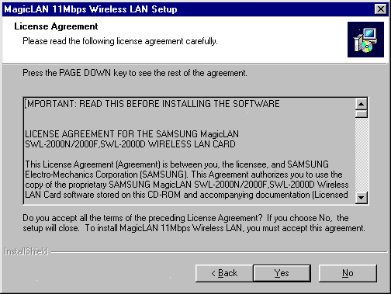
- It will proposed the License Agreement, press Yes if you access the License Agreement and continue the installation process.

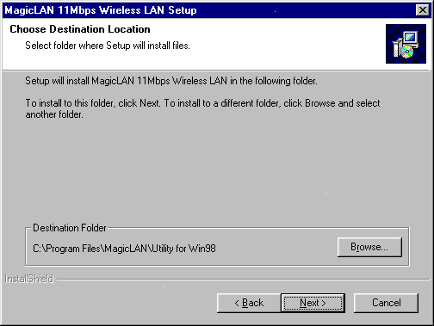
- Pick the location of the utility software. As usual click Next> after completed.

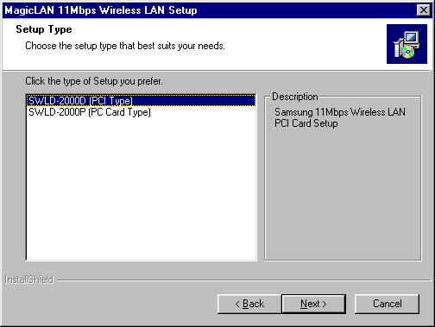
- Select type of WLAN card, there are two (2) types, namely, PCI card and PCMCIA card. Click Next> after selecting the correct type.

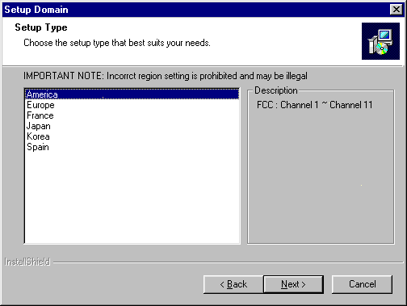

- Select the language to be used. Default is America. Press Next> after completed.
Next stage would be very critical to the operation of your WLAN. Any error in filling the parameter would cause failure in the operation of the system. I would strongly suggest to discuss it with your Internet Service Provider (ISP) who provide the Access Point (AP).

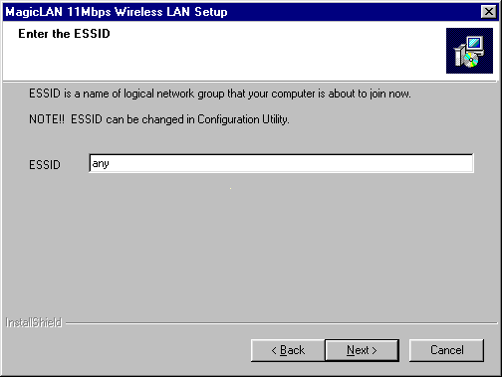

- The default value of ESSID is any. It means the card will be connected to any good available Access Point it hears in the frequency. In fixed wireless Wide Area Network (WAN) applications, we don’t want to set our ESSID to any.
- We normaly configure the ESSID parameter to match with the one used at the Access Point (AP) we are connected to at the ISP. Thus, coordination with your ISP would be very crucial.

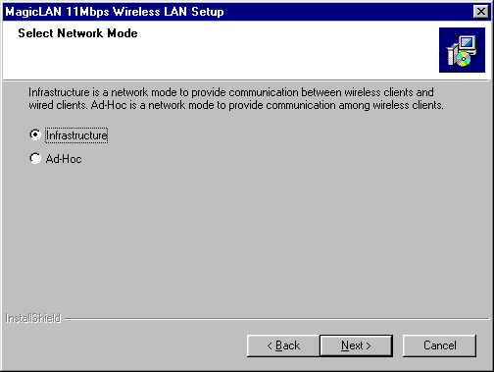

- Set operation mode of the Wireless Network. There are two (2) mode of operations, namely, Ad-Hoc and Infrastructure. Network configuration with Access Point (AP) is infrastructure mode. The one without Access Point (AP) is ad-hoc mode. In a Wireless Metropolitan Area Network (MAN), infrastructure is normally used.

Driver installation is completed. We may now check if the operating system recognizes our WLAN card.

Next step to be performed, after the software driver is installed, is as followed,

- Shutdown the PC.
- Insert MagicLAN SWL 2000-P card into any empty PCI slot.
- Connect the external antenna or dummy load into the antenna connector. Operating a WLAN card without any antenna connected may be harmful to the WLAN card.
- If the driver software is installed properly, PC is normally detect the WLAN card.

From my experience, the most difficult part in all is to take apart the casing and inserting the WLAN card into the available PCI slot ☺ ….. Next step to be performed is to check and configure the card. Several processes can be performed at this stage, namely,

- Use PC Card status utility
- Use Start → Settings → Control Panel → System Properties → Device Manager.
- Use Configuration utility of MagicLAN SWL 2000P.
- Configure Network Card, using Start → Settings → Control Panel → Network.

For those who uses newer Microsoft Windows operating systems, such as, Windows XP or Windows 2000, it is likely the needed WLAN card driver’s are already installed. It will likely recognize the WLAN card and automatically installed the correct driver. Thus, configuring the TCP/IP networking setup and the ESSID of the WLAN card would be the next steps to be done to make it work.

PC Card Status Utility

On our desktop at the bottom right hand side icons, we can find an icon for PC Card (PCMCIA) Properties. Click the icon, we can easily see whether the card is installed & recognizes by our PC.

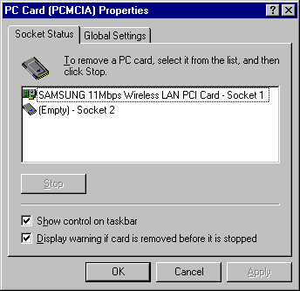

If the PC recognizes the card, we may see in one of the socket (in this case socket 1) that SAMSUNG 11Mbps Wireless LAN PCI Card is attached.

Device Manager

To know the software driver of MagicLAN SWL 2000P card working properly or not can easily be checked through Device Manager. It can be access through Start → Settings → Control Panel → System → Device Manager.

In the Network Adapter section in System Properties → Device Manager we can see any network equipment attach to our PC. As shown in the example, SAMSUNG 11Mbps Wireless LAN PCI Card is attached.

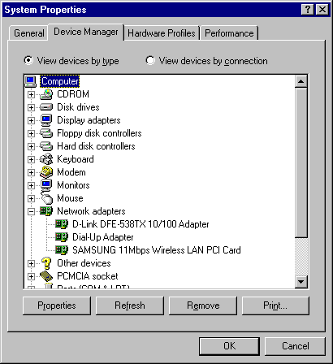

Place the cursor at the SAMSUNG & click properties button to see the condition of the software driver used. If the software driver working properly, we will see in the Device status section that “This Device is working properly”. If it is not working properly, we may want to reinstall the software driver.

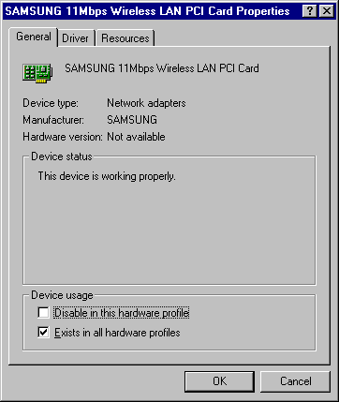

Configuration Utility for WLAN Card

In most cases, we want to configure the frequency as well as some other parameters related to the operation of the card at 2.4GHz. Such activities can easily be performed using the configuration utility for the card.

On our desktop at the bottom right hand side icons, we can find an icon belong to the card. By clicking the card configuration utility icon, we will see the configuration utility panel on our screen.

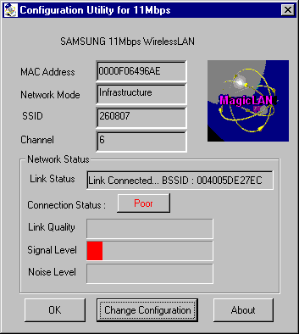

Shown on the panel are the link condition, link quality, signal level, noise level as well as other operational parameter of the WLAN card.

WLAN card parameter is easy to configure by pressing the Change Configuration button. In the Configuration Change Dialog, we can configure some operational parameter of the card, such as:

- Mode of operation – whether we use Access Point (AP) for infrastructure operation or operating without any Access Point (AP) on ad-hoc mode. In Wide Area Network (WAN) operation, we normally use Infrastructure mode.
- SSID – is basically the wireless workgroup we are operating on. We need to coordinate it with the ISP or anyone who run the Access Point (AP).
- TxRate – is the transmitted data speed. We can set it into automatic or fixed speed. The maximum speed for IEEE 802.11b is 11Mbps. In the newer versions of IEEE 802.11, it is possible to run up to 54Mbps on 2.4GHz.
- WEP – Wireless Equivalent Privacy is the encryption mechanisms in wireless network.
- Channel – configure the frequency of operation.
- Threshold – will set the threshold value at which more robust medium reservation mechanism techniques in sending the data using RTS/CTS packet will be performed. Such mechanism is needed in heavy traffic areas.
- PS Mode – will set the power save mode. It is very usefull for those who use laptop to save power.

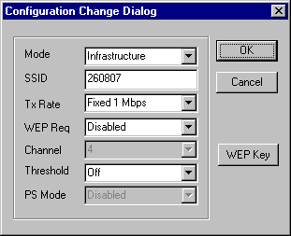

Configuring the TCP/IP Network Parameter

Having completed the radio configuration, our next step is setting the TCP/IP network parameters. The WLAN card is basically treated as normal LAN card during the TCP/IP configuration.

Through Start → Settings → Control Panel → Network we can set the IP address of the card, IP address of the gateway, netmask and other TCP/IP parameters.

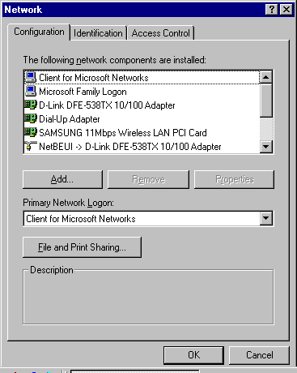
Other application that follows, such as Internet Sharing, proxy, Internet Telephony, or any other Internet applications can now be implemented as a common Internet infrastructure.

