Preparing Wireless Neighborhood Equipments

In this chapter, we will discuss item to be prepared to be able to build a wireless neighborhood network. We basically need to prepare some hardwares, such as,

Personal Computer to act as the router
Wireless LAN (Wi Fi) card
Coaxial Cables
Antenna
UTP Hub for LAN

In most cases, we need to decide which operating system to be used at the router. I normally use Linux as my operating system, specially, Linux Mandrake as it is very easy to use and to install. When it runs in text mode, very minimal resources would be needed, and, thus, an old Pentium I or Pentium II PC can always be used as the router. One can always use Windows as the operating system.

Hardware Preparation

The Personal Computer
If Linux used as the operating system of the router, personal computer (PC) needed for acting as the router / gateway between wireless network and neighborhood LAN would be something simple, such as,

Pentium II 166MHz
Memory 64Mbyte
Hard drive 3Gbyte

The Wireless LAN Card
Not all Wireless LAN card can be used for long distance / outdoor application, in fact, most of Wireless LAN vendors originally manufacture wireless LAN cards for indoor applications. Fortunately, there are several type & version of wireless LAN (Wi-Fi) card that can be used for long distance applications. The one that can be used for outdoor / long distance applications would likely to have an external antenna connector.

Shown in the figure is an example of PCI Wireless LAN card. It has an SMA connector for external antenna.
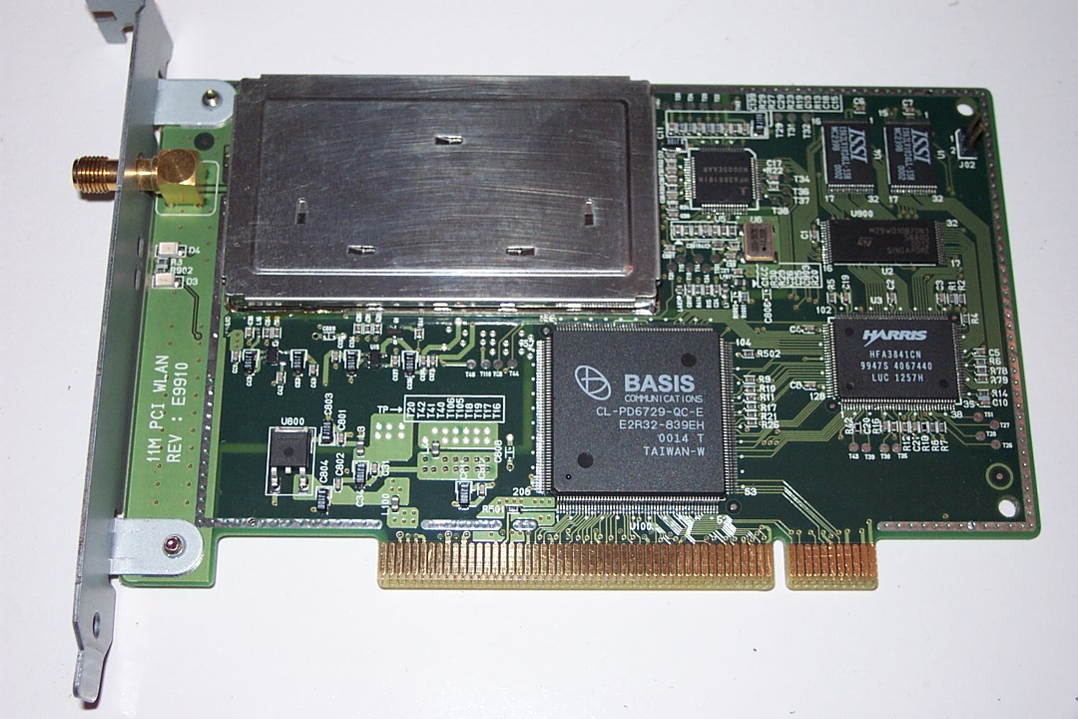

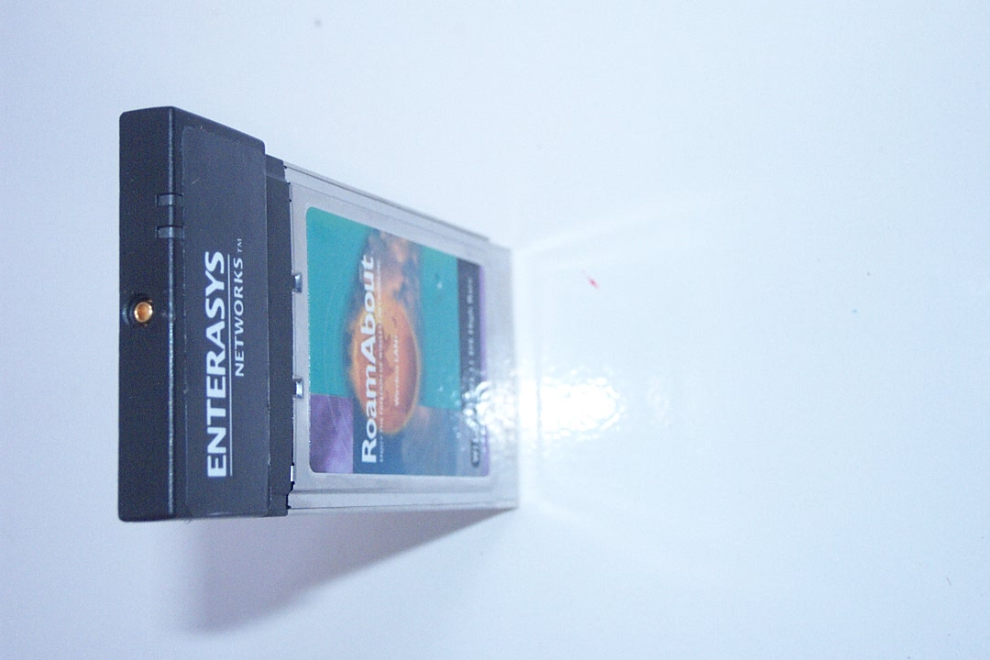
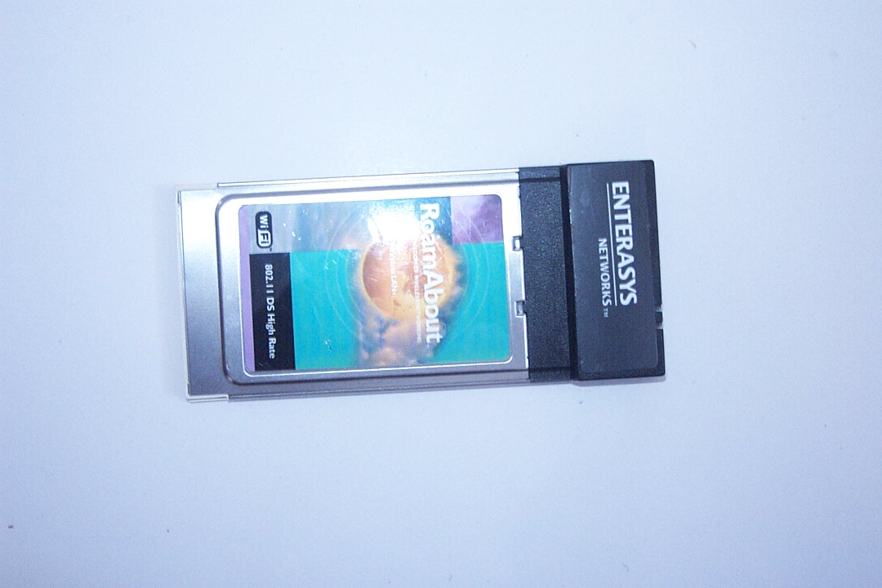
One of the favourite WLAN PCMCIA Card is the Lucent / Orinoco WaveLAN like cards. At the time of this manuscript, Orinoco has been purchased by Proxim. All Orinoco products now carry the Proxim name. A longer History is Lucent bought Orinoco, then later spun off a new wireless division call Agere. Proxim later bought the Orinoco line from Agere. Drivers as well as application software to support such card in Linux is very easy to find. It is a PCMCIA type card and, thus, need a PCI adapter if it is used in normal desktop computers.

One of the major drawbacks for using WaveLAN compatible card would be the connector for external antenna. As shown in the figure a small tiny connector is available. However, it would be very difficult for an ordinary engineer to make an adapter for such tiny connector. Well, we can always buy one for US$25-50. Unfortunately, it costs a little bit too much for most of us in developing countries.
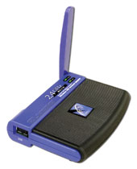
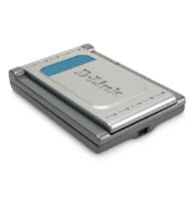
Based on my friends’, such as, sumaryo@netadsl.net, experience in implementing wireless LAN network. The total cost of implementation would be much cheaper to use USB Wireless LAN card rather than PCI or PCMCIA cards.

All we need is a long USB cable to the USB WLAN card, and make sure all are shielded for environment protection.

To make the transmission to reach a longer distance, we normally put a reflector in front of the USB WLAN card. A used Satellite Cable TV disc would be sufficient to extend the distance for a couple of kilometers.

Pigtail
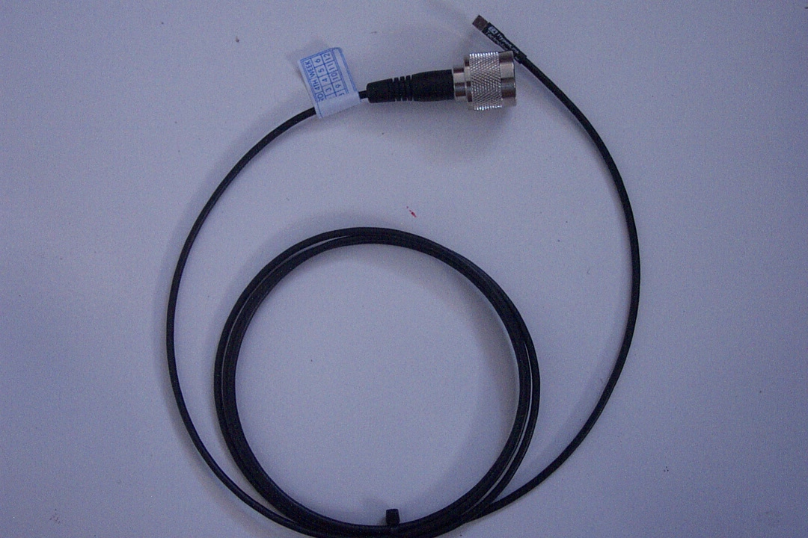
At 2.4GHz band, we normally use an N-type connector for our coaxial cable & antenna. To adapt different type of connector, we normally use a pigtail that is a short coaxial cable with two different coaxial connector at both ends to adapt different type of connector needed at the WLAN card and the coaxial to the antenna, respectively.

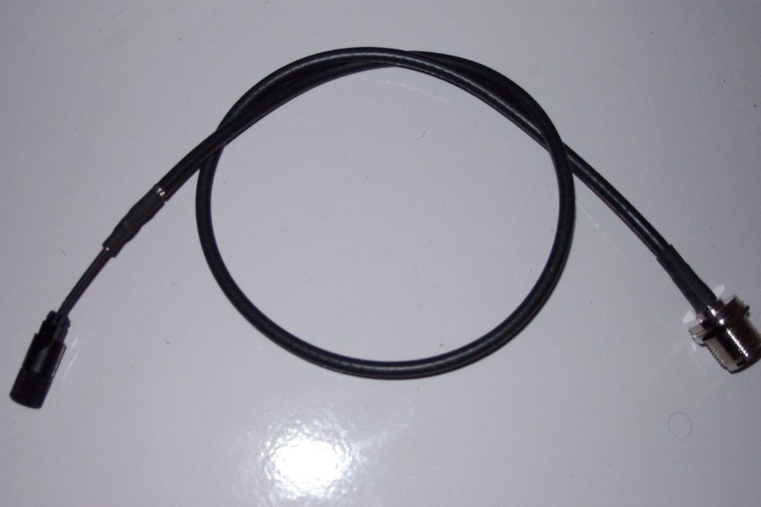
Shown in the detailed picture, each end of the pigtail uses different type of connector. In the detailed picture, it shown the connector needed to connect to Orinoco type PCMCIA Wireless LAN card. The small connector of the Orinoco cards is called an MMCX connector.
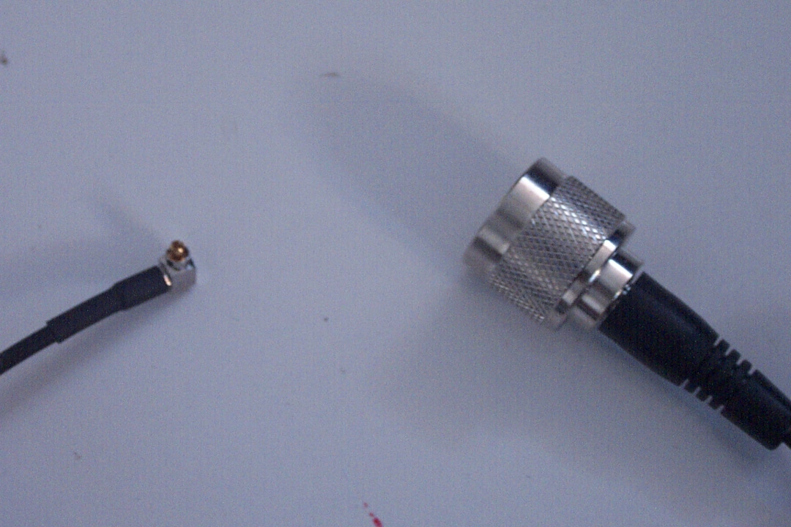

For a longer cable run between the transmitter and the antenna, we normally used coaxial cable. There are several type of low loss coaxial cables can be used. The best one would be the heliax coaxial cable. LMR coaxial cable has a slight higher cable loss, at lower cost.

Antenna
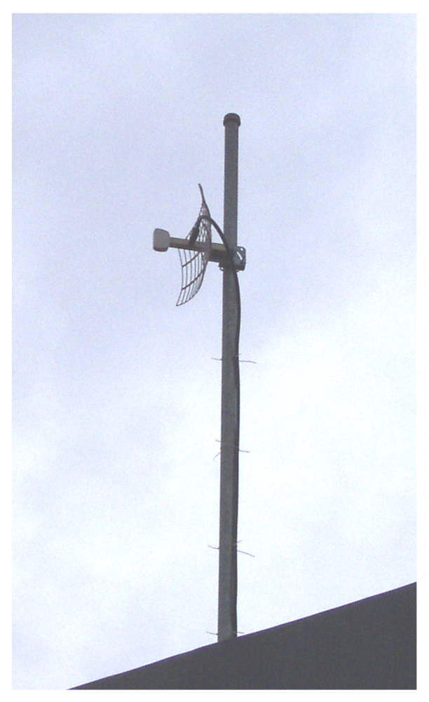
An external antenna is normally used to extend the distance. There are variety of Antennas can be used. Depending on the location / application, we normally need,

- At client side, a directional antenna, such as, parabolic antenna, yagi antenna, tin can antenna etc.

- At the access point, an omni-directional antenna or a sectoral antenna.

Detailed calculation of the link budget is needed to ensure the installed antenna would be sufficient to reach the required distance. A simple example for the System Operating Margin calculation can be found at http://www.ydi.com/calculation/som.php.

Access Point
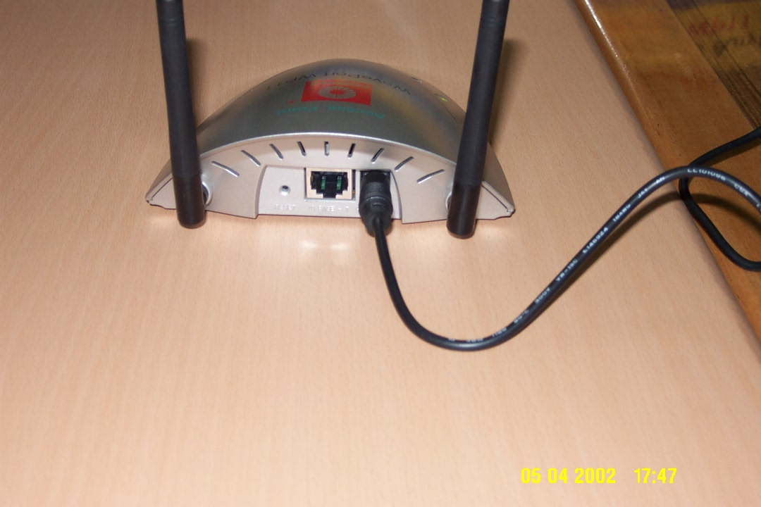
At the Internet Service Provider (ISP), we normally need an Access Point (AP) to serve the wireless clients. The access point is basically serving as the hub for wireless client and a bridge to UTP LAN network. Thus, an Access Point (AP) will normally have both antenna as well as UTP port.

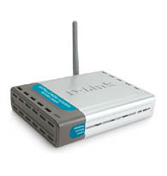
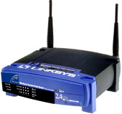
Some Access Points (AP) may have a more complex function, such as, DHCP server, Firewall, NAT, proxy server built-in into it. The Antenna is normally replaceable with an external antenna connected through a coaxial cable.

Some protections are normally provided at the Access Point (AP) to limit the access for certain MAC Address or IP address.

In the figures are the pictures of a Compex Access Point (http://www.compex.com.sg), BEFW11S4 an Access Point with 4-port switch Linksys (http://www.linksys.com) and D-Link DWL 2000AP (http://www.dlink.com) Access Points.

Software Preparation for the Router

For serious Router applications, I normally use Linux based machines. In particular, Linux Mandrake would be my favorite due to its easiness in installing the system and readily support most Wireless LAN cards. Linux Mandrake will normally detect the attach WLAN card & install the required driver. The card will be treated as a normal Ethernet card and do the routing normally.

The software required setting a Linux machine, as router is readily available in the Linux box. Some of the important package would be iptables and DHCP. Iptables is a newer kernel built-in for processing any incoming, outgoing and forward packet in a Linux box, it is a natural choise for setting a firewall in a Linux box. A typical example of iptables usage is in setting a Network Address Translator (NAT) to share a single IP address from the provider with many workstations behind the NAT.

Those who wish to use Microsoft Windows may always use Microsoft Windows operating system. Unfortunately, Microsoft Windows is not a recommended operating system for router applications.

