Some Notes On Securing The Infrastructure

A good reference on securing WiFi infrastructure is the book by Bruce Potter and Bob Fleck, 802.11 Security, O’Reilly, 2002.

Securing Windows Machine

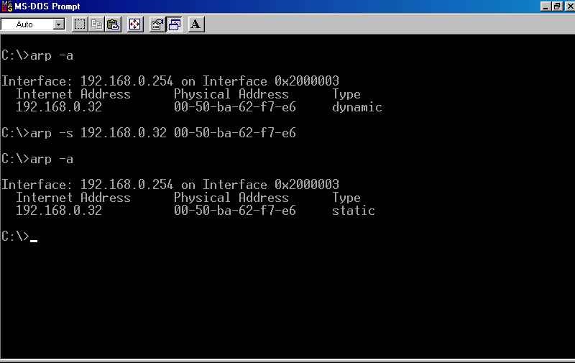
To reduce the possibility for intruder to spoof into the network is necessary to a static entry in Address Resolution Protocol (ARP) table. ARP table contains a list of IP address with its corresponding MAC address listen by our machine.

ARP Table is normally dynamically set through Address Resolution Protocol (ARP). Shown in the example, by entering the command

arp –a

the operating system will gives the list of IP address with its corresponding MAC address. It is shown in the top command that the type of entry is dynamic. An intruder can spoof into the network and pretend to have the particular IP address.

Such condition can be circumvent by setting a certain IP address to a fixed MAC address. It is can be done through,

arp –s ip.ad.dre.ss mac-add-res-ss

For example,

arp –s 192.168.0.32 00-50-ba-62-f7-e6

To see if the entry is a static entry, we can enter “arp –a” command again and check if the type of static.
For those who use Windows 98, you may have to look for personal firewall software to secure your machine in WiFi infrastructure. Such software can be easily find through Google search.
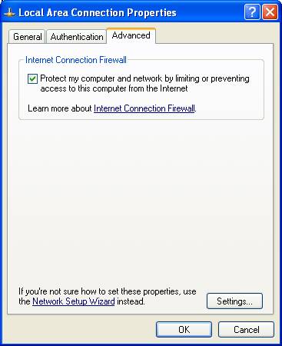
For those who use Windows XP, you are in luck as XP has a built-in firewall facility. The firewall can be access through Start → Control Panel → Network Connections → Local Area Network → Properties → Advanced → Settings.

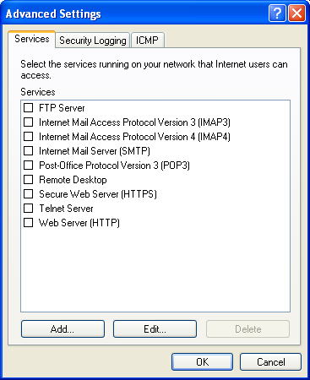
We have to check “Protect my computer and network by limiting or preventing access to this computer from the Internet” before we can click firewall Settings button.

In Firewall Settings page, we can check which services we want our firewall will allow Internet users to access into our computer.
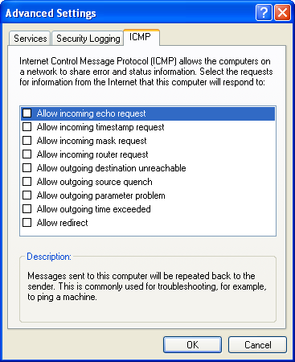
We can also Add the service if it is not readily available on the Firewall.

A facility to configure the Internet Control Message Protocol (ICMP), used in various program such as ping, can also be controlled through ICMP facility.

Securing a Linux Machine
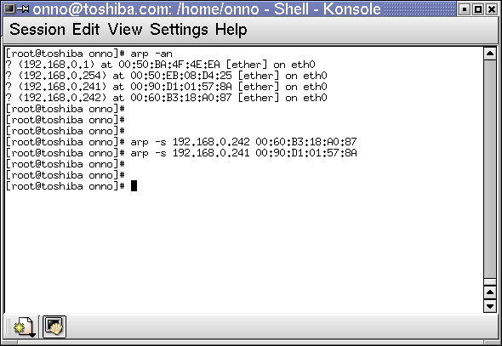
A static entry on the ARP table can be entered into ARP Table using a similar command as in Windows. Well, actually the other way around, arp command in windows follows the one on Unix machine.

In contrast to Windows, there are many facilities in Linux that can be used to beef-up the machine’s security.

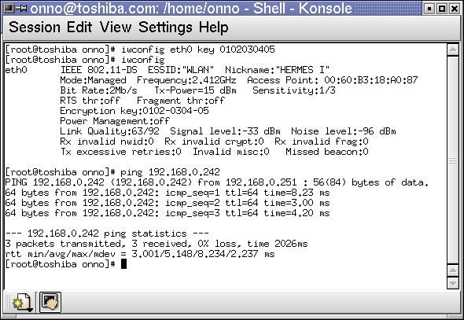
To protect the data being transmitted over the wireless link from eavesdropping, we normally activated the Wired Equivalent Privace (WEP) encryption. In Linux, iwconfig command can be used to set the key for WEP encryption, for example,

# iwconfig eth0 key 0102030405

Where 0102030405 is theWEP encryption key. At this point, others may have some difficulties to dump the content of the packet sent over the air.

Having the packet encrypted is not enough. We need to secure the machine to tightly control the access to / from the machine. Such controlled packet flow can be done through firewall mechanism.
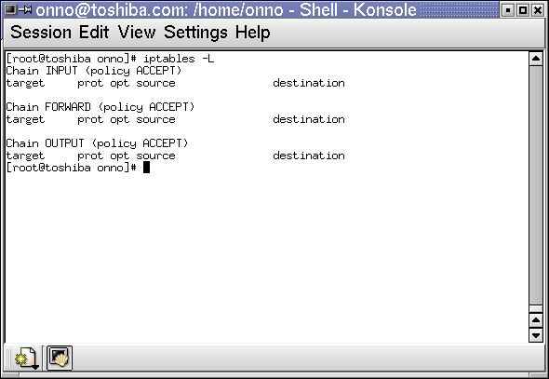
In Linux, it can be done through,

# iptables

The normal condition of the firewall, it will accept all input packet, output packet and forward chain.

The firewall settings can be seen through,

# iptables –L
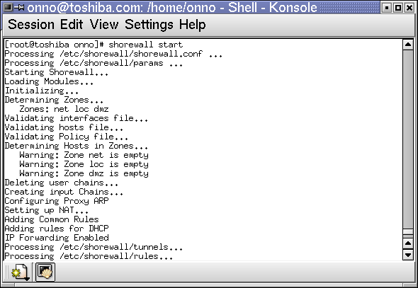
To make our life a little bit easier, it would be easier to use “shorewall” to manage the firewall. Shorewall will activare the firewall by invoking the command,

# shorewall start

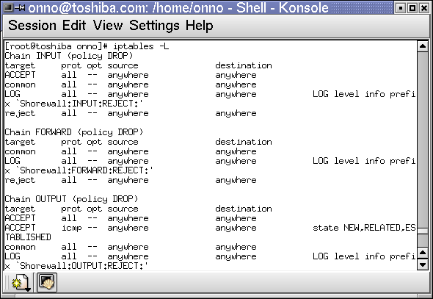
As we can see clearly in

# iptables –L

The iptables is now populated with firewall rules.

A good thing with Linux Mandrake, we can configure shorewall through Webmin Web interface at http://localhost:10000.

