Antenna and Coaxial Cable

For those who is previously not familiar with radio world, it is advisable to read some of the amateur radio books, such as, the ARRL Antenna Handbook (http://www.arrl.org), ARRL Technical Information Pages (http://www2.arrl.org/tis/tismenu.html) and W1GHZ online microwave antenna handbook at (http://www.qsl.net/n1bwt/preface.htm). Surfing to various amateur radio sites will help us to gain information and necessary software to build our own antenna. There are many things to be considering in antenna installation, such as grounding system, good coaxial cable and type of antenna. Having WiFi card is not enough; survival key is in the antenna system used. Some the good sites to buy the antenna equipment can be found on the Internet, such as, http://www.ydi.com, http://www.rflinx.com.

Type of Antenna

We have basically several type of antenna used in WiFI based Metropolitan Area Network, some of them are:

- Omnidirectional Antenna usually used at the Access Point (AP). It has 360-degree radiation pattern.
- Sectoral Antenna usually used at the Access Point (AP). It has higher gain than omnidirectional antenna, but normally only cover much reduced area 90 to 180-degree coverage.
- Directional Antenna usually used at the client side. It has high gain, it is normally aimed to the Access Point (AP).

Some countries mandate that the entire radio system be certified together. It means that only antennas tested with the radios can be used. This is for sure an FCC regulation, and many countries follow those regulations. That being said, enforcement of that regulation is almost impossible.
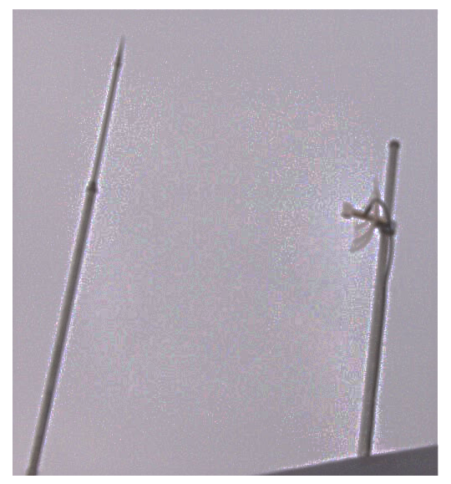
Shown in the figure is my antenna at home. It is a directional antenna, a 19 dBi parabolic antenna. It is used for 24 hour Internet connection link to the Access Point located about one (1) km away.

As it is placed about 1.5 meter on top of my two story house roof, the antenna is actually located about 9-10 meters above the ground. The antenna is screwed into a three (3) meter long 1.5-inch tubing plows half its length into the wall. The height of the antenna is enough to reduce any mutipath, or signal reflection problems at we need only about 3.5 meter clearance for the signal.

In a proper lightning protection installation is needed to protect the equipments. Protecting against lightning is a matter of reducing electrical potential, not being shorter then the guy next door. A well grounded cell tower, with proper lightning rods will be of no help to a nearby antenna. I have to admit, I am fortunate enough to have a cellular tower not too far away from my house and no lighting problem in the last two (2) years. Please don’t follow my step & please install your lightning protection to protect your equipments.

Coaxial Cable

Coaxial cable is normally used to connect a radio transceiver to an antenna. Each coaxial cable is designed for specific impedance. In WiFi equipment as well as most radios, we normally used 50-ohm impedance coaxial cable. Fail to meet the impedance will reflect the radio signal from the transmitter back into the transmitter rather than to the antenna. Thus, the impedance of the transmitter, the coaxial cable and the antenna must match to 50 ohm.

Unfortunately, the use of coaxial cable introduces signal loss before it reaches the antenna or vice versa the receiver. Shown in the table is the cable loss at 2.4 GHz for several type of coaxial cable.
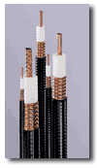
Andrew Corporation Heliax
Cable Type | Loss / 10 meters  (on 2.4GHz).
RG 8 | 3.3 dB
LMR 400 | 2.2 dB
Heliax 3/8” | 1.76 dB
LMR 600 | 1.7 dB
Heliax ½” | 1.2 dB
Heliax 5/8” | 0.71 dB

The field experience shows that it would be best if one uses at least LMR coaxial cable. For those who are fortunate enough may use the high performance heliax coaxial cable. It is quite expensive for most of us in developing countries to buy such cable as it costs in the range of US$ 25 / meter. Black market price of heliax cable would be around US$3-4/meter. We normally find heliax coaxial cable from a used or unused cut heliax coaxial cable from a telecommunication project. If it is possible, do not use RG-8 coaxial cable for the installation.

Some of us normally restrict the length of coaxial cable to less then one (1) meter. Consequently, we must put the Access Point or other WiFi equipment up on the tower. The UTP Local Area Network (LAN) cable then run down from the top of the tower to the Network Operating Center (NOC) located at the bottom of the tower. Environment enclosure should be used to protect the WiFi equipment located on top of the tower.

Coaxial / Antenna Connector

To connect the Wireless LAN (WiFi) equipments, coaxial cable and the antenna, we uses special connectors. There are several type of RF connector can be used at such high frequency. A good connector will normally have 0.3-0.5 dB losses. Unfortunately, a good connector will likely to cost around US$5-7 each. There is cheap connector that cost US$1 each. Unfortunately, bad connector will likely to give a significant signal loss and, thus, reducing the system operating margin.

There is several type of RF connector that normally used in WiFi equipments, namely,

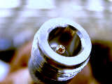
N-Female connector is usually used at the antenna or lightning protector.

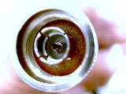

N-male connector is usually used at the coaxial cable to connect the antenna.



Male SMA Right Hand Polarization connector is usually used for the small coaxial cable (usually called pig tail) to connect to Female SMA connector on Wireless LAN card.

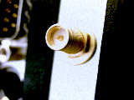

Female SMA Right Hand Polarization connector is usually located on Wireless LAN card.

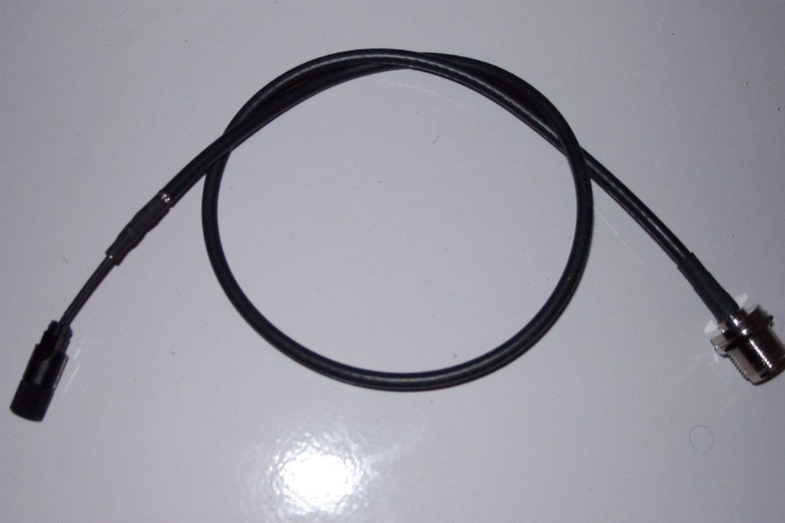
Since Wireless LAN (WLAN) uses female SMA connector, while the antenna and the heliax coaxial cable uses N-type connector. We need a cable interface between the two (2) types of connector. In WiFi parts, we usually use a pigtail to do the job. It is a short coaxial cable with SMA connector at one end, and N-type connector at the other end.

Some of us even use these pigtails directly to the antenna without any connection through long heliax coaxial cable to minimize any cable loss. Consequently, we need to put the Access Point on top of the tower.

Antenna Gain

In a wireless system, antennas are used to convert electrical waves into electromagnetic waves. The amount of energy the antenna can ‘boost’ the sent and received signal by is referred to as the antennas Gain.

Antenna gain is measured in:

- dBi - relative to an isotropic radiator
- dBd - relative to a dipole radiator

The relationship between dBd and dBi can be represented in the following equation

0 dBd = 2.15 dBi

In most cases, we use dBi as our antenna gain measurement.

Omnidirectional Antenna

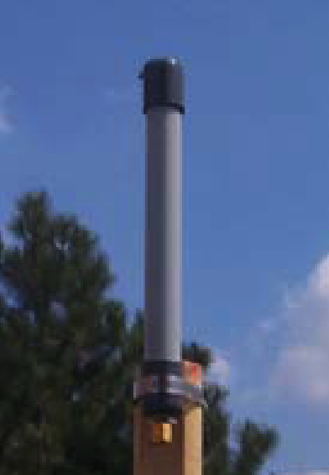
Omnidirectional antennas have normally a 360-degree RF radiation from it. It is vertically polarized E-field. Omnidirectional antenna gain is normally low around 3 to 12 dBi. It is used for Point-to-Multi-Point (P2MP) links. It is quite good for 1-5 km coverage, especially if the client uses high gain directional antenna.

Shown in the figure is the example of an omnidirectional antenna. It is a RFDG 140 a 2.4GHz 6.5 dBi Omnidirectional antenna made by RF Linx (http://www.rflinx.com).

Shown in the below figure is typical radiation pattern of the RFDG 140 omnidirectional antenna. The horizontal radiation is fairly close to 360-degree radiation. The horizontal radiation is basically the E-Field. In contrast, the vertical polarization is very narrow slice of signal radiation.

All of these mean that only stations within 360-degree radiation patterns that will be served by an omnidirectional antenna. An omnidirectional antenna may not serve station far above the antenna.
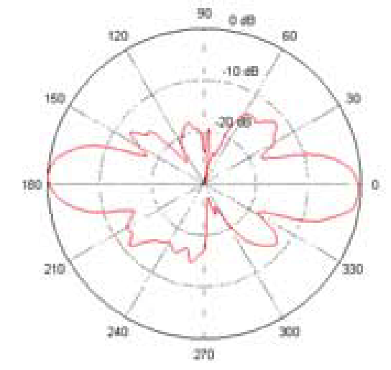

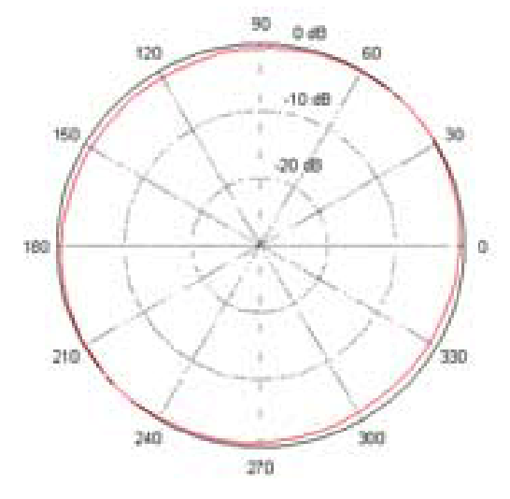

Sectoral Antenna
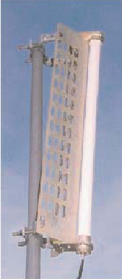
Sectoral Antenna is fairly similar to an omnidirectional antenna. It is used for the Access Point to serve a Point-to-Multi-Point (P2MP) links. Some sectoral antenna is vertically polarized, some horizontally polarized.

Sectoral antenna is normally having a much higher gain than omnidirectional antenna in the range of 10-19 dBi. It is quite good for serving an area of 6-8 km distances. Narrowing the beam-width of horizontal radiation to only about 45-180 degree must unfortunately compensate higher antenna gain. It natural benefit as it defines a narrower service area.

Shown in the figure below is the radiation pattern of sectoral antenna. The horizontal radiation patterns is mostly radiated away of the front end of the antenna. Not much radiation behind the sectoral antenna. The vertical polarization is very narrow fairly similar to omnidirectional antenna.

A sectoral antenna will usually placed on top of a high tower and tilted slightly so that the horizontal radiation will serve the area below it.

Shown in the figure is a 2.4GHz vertically polarized 180 deg. sectoral antenna model A2.45LP14 sell at YDI.COM. The typical horizontal and vertical pattern of the antenna is shown in the figure.

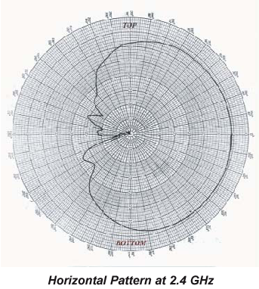
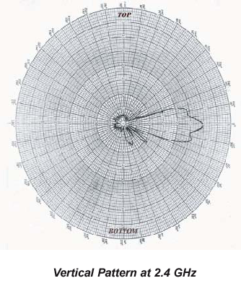

Directional Antenna

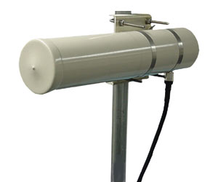
At client side, we normally use a directional antenna aiming to distance Access Point. There are many type of directional antenna, the commonly used directional antenna are,

- Yagi
- Flat Panel
- Parabola

Others may be shown in the homebrew antenna, such as, tincan antenna.

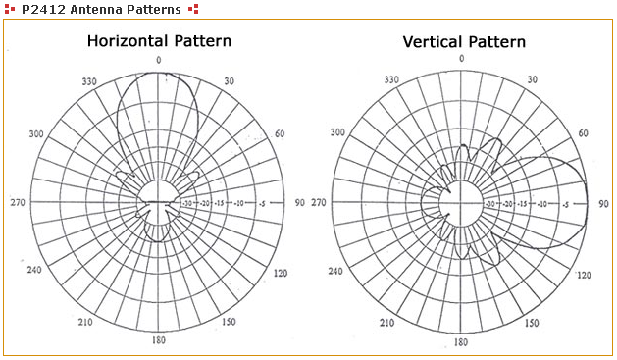
Yagi antenna is basically a dipole (sometimes called a radiator) with director elements in front of it. The more director element in front of the radiator leads to a higher antenna gain. Yagi antenna has normally 7-19 dBi gain. For short distances, it would be advisable to use a lower gain antenna.

A 12 dBi gain P-2412 2.4 GHz directional, radome-enclosed, Yagi antenna is shown in the figure. The typical radiation pattern of the yagi antenna is shown in the figure. As shown clearly, the horizontal radiation pattern is fairly similar to vertical radiation pattern. Both horizontal and vertical radiations are aiming away from the antenna and no radiation behind the antenna. The wide angle radiation is quite typical for low gain directional antenna.

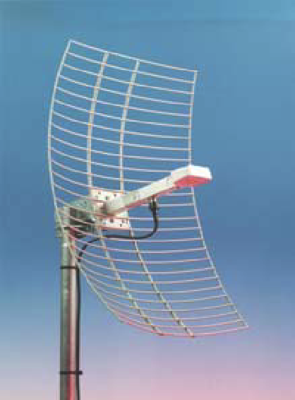
To increase antenna gain, people will normally use parabolic reflector to reflect the RF signal generated by the dipole radiator in front of it. A parabolic antenna has usually 18-28 dBi gain. Shown in the figure is an RFL-MANT 19 a 19 dBi parabolic antenna. RFL-MANT19 is made by RFLinx http://www.rflinx.com.

The parabolic antenna radiation pattern is fairly similar to yagi antenna. However, it has a much narrower angle as most of the RF energy aims towards a single direction. Thus, a parabolic antenna is much more difficult to aim. Consequently, it is more fragile to physical and mechanical disturbance especially by strong wind. Thus, for short distance, it is not that effective to use such high gain antenna.

The figure below shows the integrated antenna patterns of the RFL-MANT antenna of both 19 dBi and 24 dBi antenna. Shown clearly the horizontal and vertical pattern is fairly similar. A 19 dBi antenna has a wider 3dB beam angle about 17 degree than that a 24 dBi antenna (about 8 degree 3 dB beam angle).
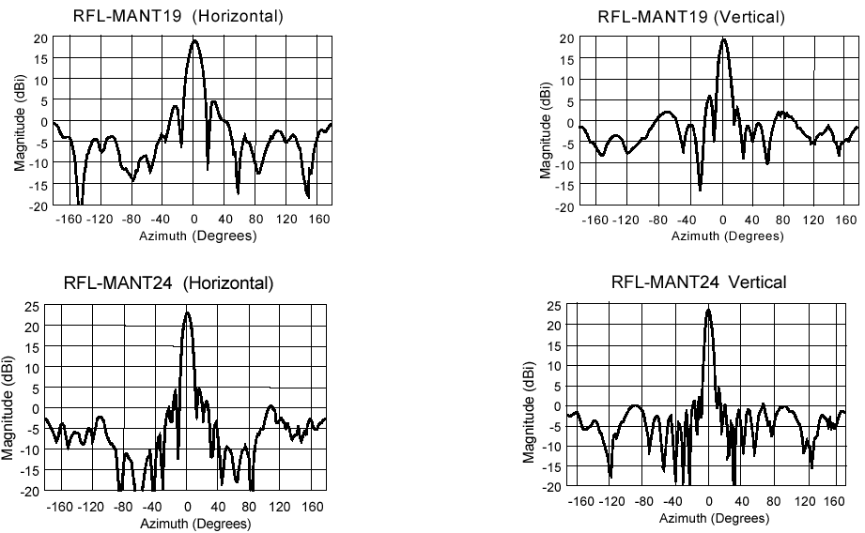

Homebrew WiFi Antennas

Build your own WiFi 2.4GHz antenna? Why not? It is one of the fun parts in playing with WiFi technology. There are several references on homebrew 2.4 GHz antennas on the Internet. Some of them are,

- http://www.oreillynet.com/cs/weblog/view/wlg/448 (the famous Pringles can antenna).
- http://users.bigpond.net.au/jhecker/ (homebrew 2.4GHz antenna helical)
- http://www.saunalahti.fi/~elepal/antenna1.html (homebrew simple yagi antenna).
- http://www.seattlewireless.net/index.cgi/BuildingYagiAntennas (yagi antenna).
- http://www.qsl.net/ki7cx/wgfeed.htm (feed system for parabolic antenna).
- Etc. much more.

All can be easily find on http://www.google.com by key in “homebrew 2.4GHz antenna”. You will be surprise. By a little bit of creativity one can easily make your own homebrew antenna. The followings are some of the home brew antenna build by my friends.

USB Tincan Antenna

Judhi Prasetyo judhi@prasetyo.net, an IT professional in Singapore, has been putting a tincan on his USB WLAN card.

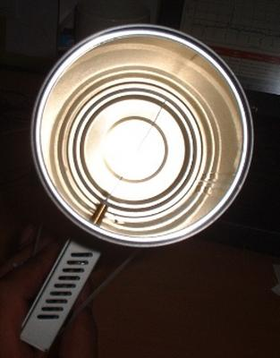
Show in the figure, the USB WLAN card is connected to his IBM laptop.USB WLAN cards have normally a small antenna sticking from it. Using such small antenna, normally about 3 dBi gain, limits the range to a maximum of around 200 meter.

He drilled a hole into a tin can and stick the small antenna of the USB WLAN card into the tin can. He has very his own tin can antenna. The advantage of putting a tin can into the small antenna is in effect aiming all the RF energy into a single direction. Thus, it can reach further distances in a single direction.

Some of us may add parabolic reflector in front of the tin can extend the distance further.

USB Parabolic Antenna
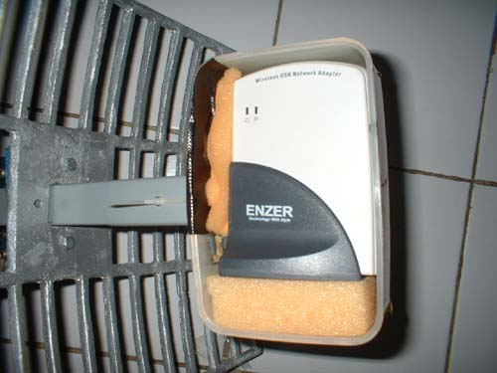
M. Ihsan ihsan@sofrecom.co.id, an IT professional in Jakarta, is building a simple parabolic antenna using a USB WLAN card.

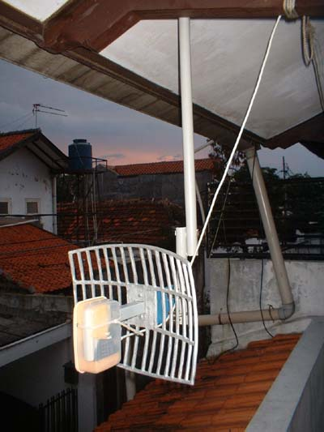
He put the USB WLAN card in front of a parabolic reflector. The USB WLAN card is put into a plastic enclosure for environmental protection.

As demonstrated in Indonesia, vocational school (high school level) students may be made these parabolic reflectors for the antenna.

Having no coaxial cable in the system as it uses USB cable to the computer, the cable loss is basically none.

For those who wish to make their own parabolic reflector, W8GVU has written a page on parabolic reflector calculation formula at http://www2.gvsu.edu/~w8gvu/geo/geo2.html.

The Famous Tincan Antenna

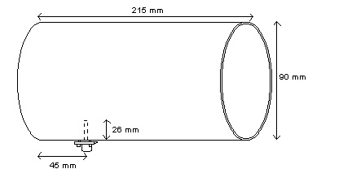
One of the famous homebrew 2.4GHz antennas is the tin can antenna. It is very easy to build and high success rate. In this particular example, the antenna is build by M. Ihsan ihsan@sofrecom.co.id.

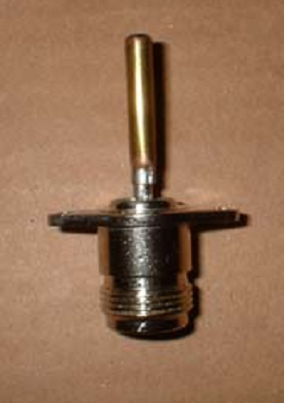Typical dimension of the tin can antenna is shown in the figure. Typical dimension of the can is about 9 cm diameter and 21 cm length. A small omnidirectional antenna about 2.6 cm length sticks into the can about 4.5 cm from the bottom of the can.

The radiator in a tin can antenna is a 2.6 cm length omnidirectional radiator. It can be build by soldering a 2.6 cm metal stick into an N-type male connector. Some people put screw sticking on the stick to tune the length of omnidirectional radiator to get the maxim match of the antenna.
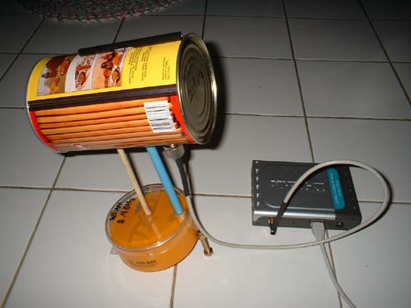

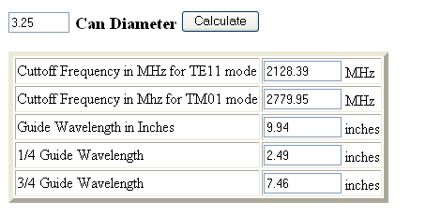

In some cases, we need to calculate the possibility to use a certain diameter tincan for 2.4GHz antenna. The calculation is provided at http://www.turnpoint.net/wireless/cantennahowto.html. Shown in the figure is the calculated result for a 3.25 inches diameter. Make sure the tincan can be operated in frequency 2.4-2.47 GHz.

Antenna Polarization

Electromagnetic radio signal propagate through the air in two polarizations, electric field (E-field) or magnetic field (H-field), crossing 90-degree each other. An antenna polarization is relative to the E-field of antenna.

- If the E-field is horizontal, than the antenna is Horizontally Polarized.
- If the E-field is vertical, than the antenna is Vertically Polarized.

No matter what polarity you choose, all antennas in the same RF network must be polarized identically regardless of the antenna type.

Using a correct polarized antenna, it would be possible for us to:

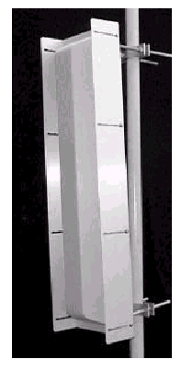
- Increase isolation on unwanted signal source. Cross polarization (x-pol) discrimination is around 20-25 dB.
- Reducing interference.
- Defining coverage area.

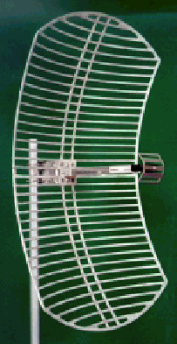
Shown in the right figure is a sectoral antenna. A sectoral antenna as well as an omnidirectional antenna is normally stand vertically. It creates a vertically polarized E-field. Due to its radiation pattern that covers a large area, sectoral and omnidirectional antennas are normally used for the Access Point in Point-to-Multi-Point (P2MP) link. Thus, it is logical to see a vertically polarized antenna in Point-to-Multi-Point configuration. It may not totally correct. We may found horizontally polarized omnidirectional or sectoral antennas.

The antenna shown in the figure is a parabolic reflector with a small dipole antenna in front of it. The dipole radiator is in horizontal position. It thus creates a horizontally polarized E-field. Horizontally polarized antenna is normally used for Point-to-Point (P2P) communication link.

Some Notes on Antenna Installation
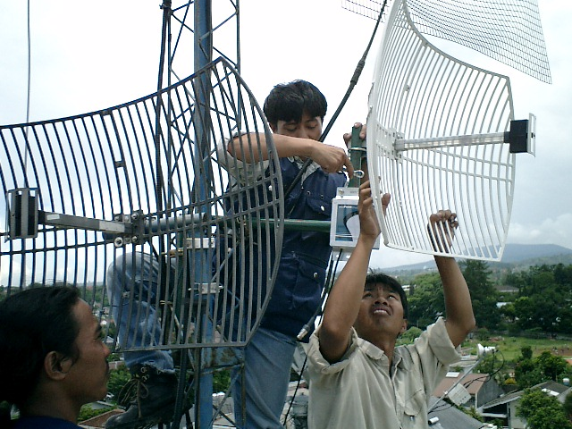

These installation pictures are the courtesy of my colleague Henry Syarifuddin, henry@cgd.co.id. Their team use SmartBridges http://www.smartbridges.com wireless equipment for their outdoor installation.

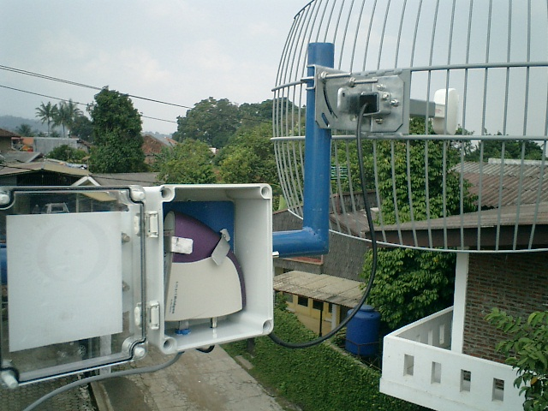
An example of a WiFi client installation is shown in the figure. A client premise equipment (CPE) is enclosed in a plastic environmental protection enclosure. It is connected through very short, less than one (1) meter, coaxial cable to a 24 dBi parabolic antenna. The whole installation is installed far above the ground. Unshielded Twisted Pair (UTP) cable is then run from the CPE to the computers at the bottom of the antenna. Power is injected into the CPE through a Power Over Ethernet (PoE) jack prepared for the UTP cable used by the CPE. A special outdoor UTP cable or Shielded Twisted Pair (STP) cable is used.
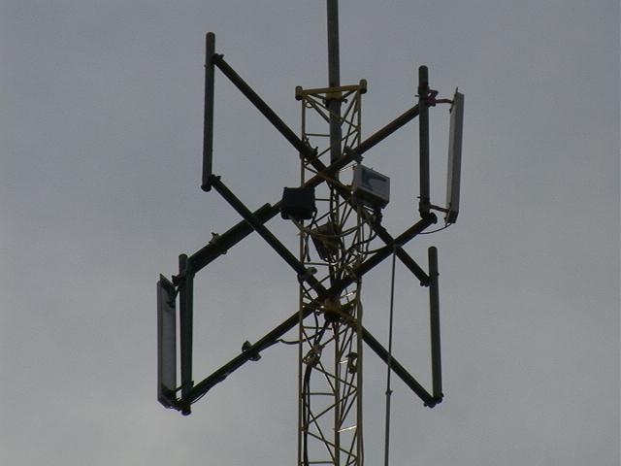
Similar to the client side, the Access Points are normally put on top of the tower. The coaxial cable connecting the Access Point to the sectoral antenna is kept short, sometimes below one (1) meter. Several Access Points running on several different channels with no interference to one and another are put together on a single tower.

Power Divider For A Simple Repeater
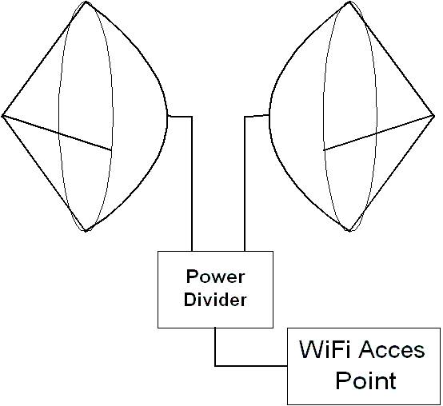
Power divider sometimes called power splitter may be used to combine several antennas together as shown in the figure. There are many reasons to combine several antennas into a single antenna system. Often, antennas are combined to modify the directivity and the gain of an antenna system. We might have situations in which we need to combine antennas to create a custom coverage pattern.

A power divider will spread the power into equal amount of power to each individual antenna within the antenna system. In figure, a 802.11b Access Point is connected to two (2) back-to-back antennas through two-port power divider. Through the divider one-half of the power goes to each antenna. Such configuration may be used to pass traffic from the North antenna to South antenna; the Access Point acts as a repeater.

Vertical Antenna Isolation
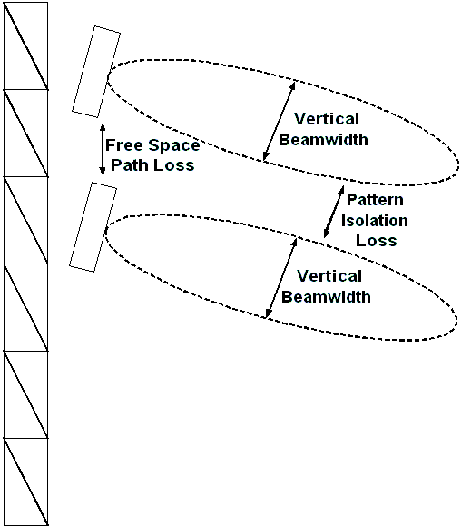
Separating two antennas vertically is fairly simple to do. Mounting the antenna one above the other may do the separation.

There are two mechanisms interact in isolating the two system, i.e.,

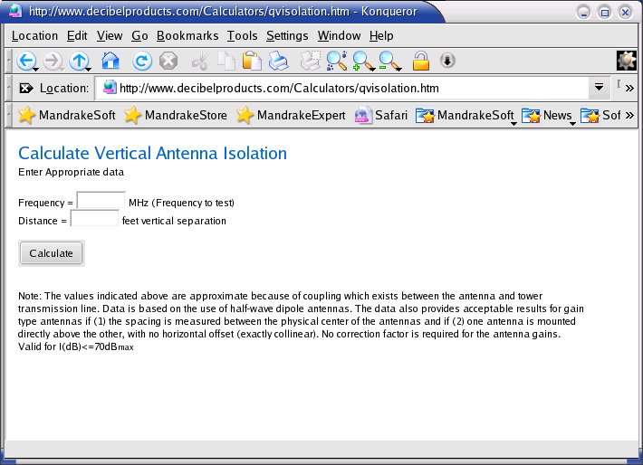
- The Free Space Loss as signal travel over the air. Traveling 3 meter distance at 2.4GHz, signal will experience 49 dB Free Space Loss. In other words, only 1/100,000 of the signal will remains.
- Pattern isolation will be possible if the antenna has a fairly narrow vertical beam width with no significant minor lobe upward or downward.

Note that the antenna’s near field may vary significantly as nearby object may affect the signal strength. The above mechanisms are valid for antenna’s far field. It is still useful to give some estimate on the reality.
Vertical Separation (Meters) | Vertical Isolation (dB @ 2.4GHz)
0.3 | 43
0.4 | 48
0.5 | 52
0.6 | 55
0.7 | 58
0.8 | 60
1 | 64
1.2 | 67
1.5 | 70
1.8 | > 70
2 | > 70
2.5 | > 70

The vertical isolation calculation can be done online through http://www.decibleproducts.com/Calculayions/qvisolation.htm. Shown in the figure is the resulting vertical isolation for two dipole antennas at 2.4 GHz for various distances.

Horizontal Antenna Isolation
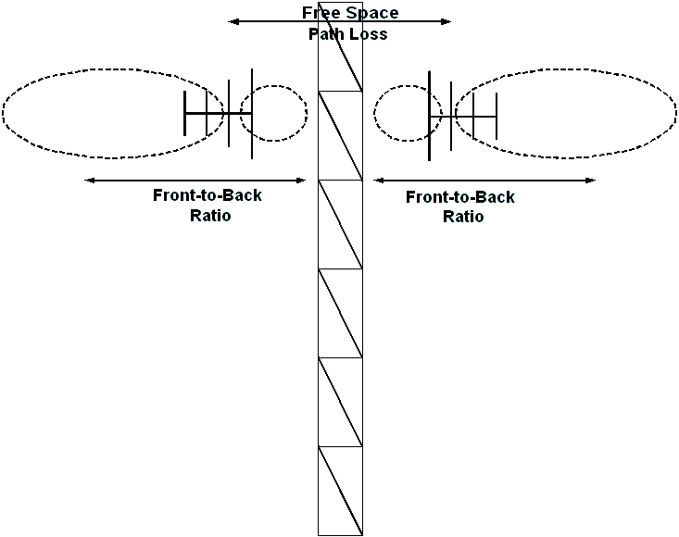
Horizontal antenna isolation can be obtained when we put two (2) antennas horizontally separated. It can be easily done on the rooftop.

As in vertical antenna isolation, there are two mechanisms interact, namely,
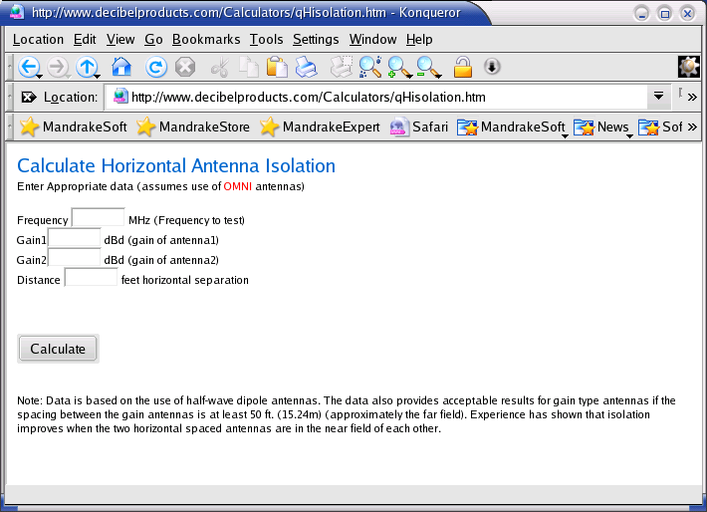
- Free Space Loss as signal travel.
- Pattern isolation. In a directional antenna, there is a Front-to-Back ratio (F/B). The energy of the main (front) lobe of an antenna divided by the energy of the back lobe of the antenna. A good antenna will focus most of the energy to the main (front) lobe and very little to the back lobe. The higher F/B the better pattern isolation for the horizontal antenna isolation.

The horizontal isolation calculation can be done online through http://www.decibleproducts.com/Calculations/qHisolation.htm. Shown in the figure is the resulting horizontal isolation for two (2) 24 dBi antennas at 2.4GHz for various distances.
Horizontal Separation (Meters) | Horizontal Isolation (dB @ 2.4GHz)
0.5 | 10
1 | 16
2 | 22
5 | 30
6 | 32
8 | 34
10 | 36
12 | 38
15 | 40
20 | 42
30 | 46
40 | 48

Diversity Antenna: Point To Point

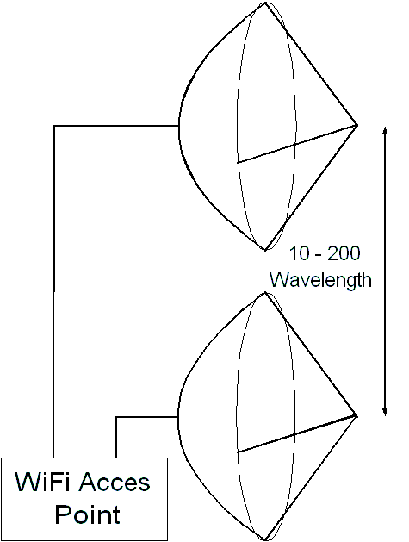
The primary fading mechanism affecting outdoor microwave links is multipath fading. To maximize the ability to receive the faded signal, some wireless equipment incorporated a diversity antenna feature. Thus, if the received signal from the main antenna fades or degrades, the signal from the diversity antenna may be selected.

Space diversity is the primary diversity technique used in low cost WiFi installation. This requires that the main antenna separated enough with the diversity antenna about 10 - 200 wavelength (or about 1.3 – 25 meter) in case signal at the main antenna is faded, the diversity antenna does not fade.

Vertical separation between two diversity antennas is normally used for point-to-point links in suburban or rural areas.

Diversity Antenna: Point To Multipoint
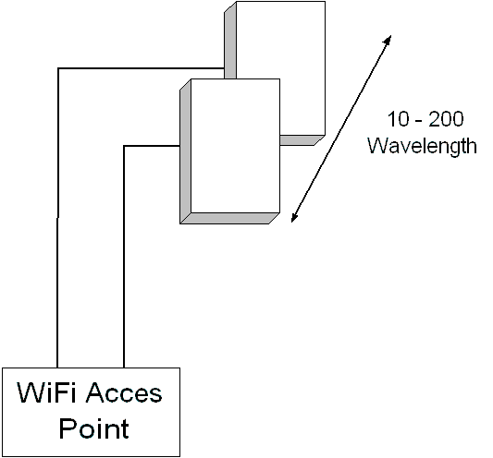
Unlike point-to-point links, a point-to-multipoint in urban area will likely to benefit from horizontal separation of the two (2) diversity antennas. The separation between the two (2) diversity antennas is around 10-200 wavelengths.

Some notes on in implanting diversity antennas, such as, make sure the Access Point implements diversity switching, place the Access Point at the midway between the two (2) diversity antennas to reduce any signal loss. However, if we are not sure, it would be better to disable diversity and use one antenna.

Grounding System

Lightning ground in detailed can be read at http://www.arrl.org/tis/info/lightning.html. There is basically three (3) types grounding system, namely:

- Safety ground, usually used for high voltage power equipments.
- Lightning ground, to run the lightning directly to the earth.
- RF ground, for grounding the radio equipments.

All of these three grounding systems are needed, we normally adding lightning ground for our electricity, our phone lines as lightning will likely to strike through any lines outside the system. Please note that each of these grounding lines must be separated and not be interconnected to each other.

RF Grounding system is especially needed for omnidirectional and sectoral antenna. Directional antenna usually has its own RF ground. Several radial cables in the ground may construct the RF ground of the coaxial cable.
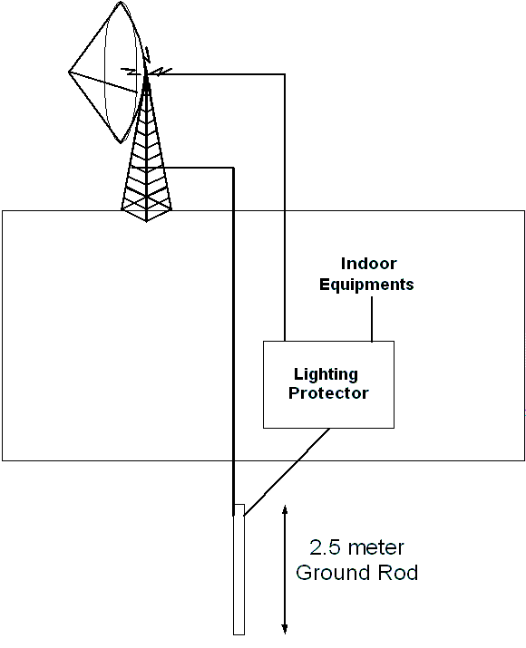
Shown in the figure is the typical grounding system. A much more detail the grounding accessories & its installation are shown in the capture figure from http://www.glenmartin.com/catalog/lighting.htm.

The best ground wire route is to run the shortest possible large diameter ground wire straight down from the antenna system to the ground rod. The lightning protector must also be grounded.

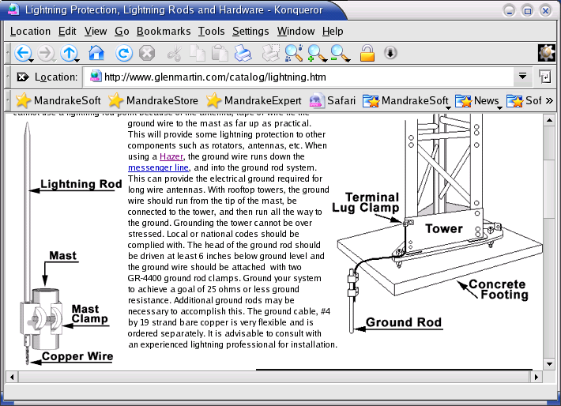
A 2.5-meter long metal is typically used as the ground rod. Some of my friend drill a hole into the ground until it reach the ground water, and plug the cable from the lighting arrestor into ground rod that touches the ground water.

One of the major problems by the grounding system is the keep increasing ground resistance. It may increase in time. Some of my friends use urea that usually used by farmer on their farm to keep the ground resistance down.

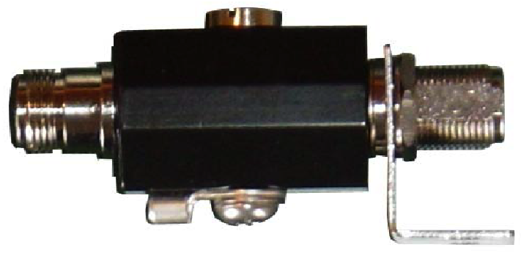
Shown in the picture is RFL-SP a gas discharge surge protector builds by RFLinx http://www.rflinx.com that can be operated between 100 up to 3000 MHz. It has 0.1 – 0.4 dB insertion loss. The ultra fast gas discharge design gives quick responds to power surges and dumps the excess power into the ground.
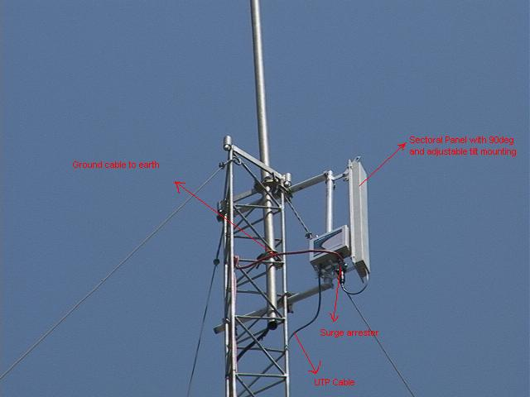
To guard the antenna from lightning strike, both the antenna and the tower are grounded into the earth through lightning protector as shown in the figure. These installation pictures are the courtesy my colleague Henry Syarifuddin, henry@cgd.co.id. Their team use SmartBridges http://www.smartbridges.com wireless equipment for their outdoor installation.

Radio Tower For WiFi Infrastructure

Unlike the plumbing pipe used in my home installation, there is several type of tower configurations. There are countless tower manufacturers, but two to look into are Trylon Towers of Canada, and Webb Industries out of South Africa. Webb is also an antenna manufacturer. With the dollar conversion, South African solutions can become much more cost effective over US solutions.
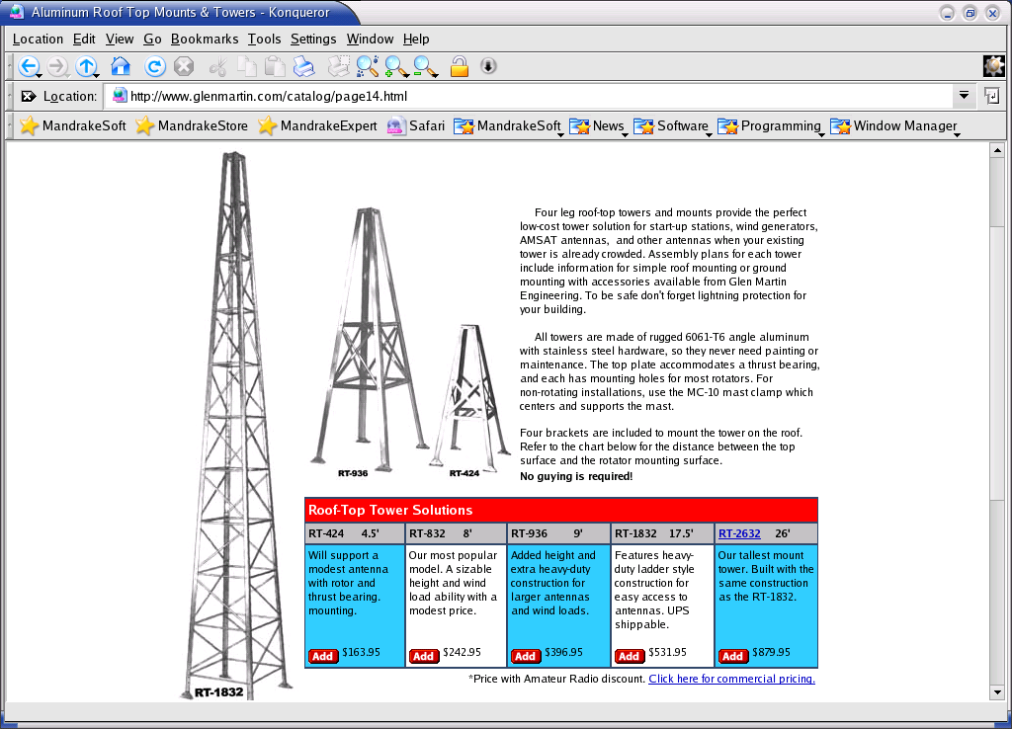
As shown in http://www.glenmartin.com, the simplest low cost roof-top start-up / client configuration is the four leg tower configuration. The tower height is between 1.5 – 8 meter, and cost between US$ 164 – 880, respectively.

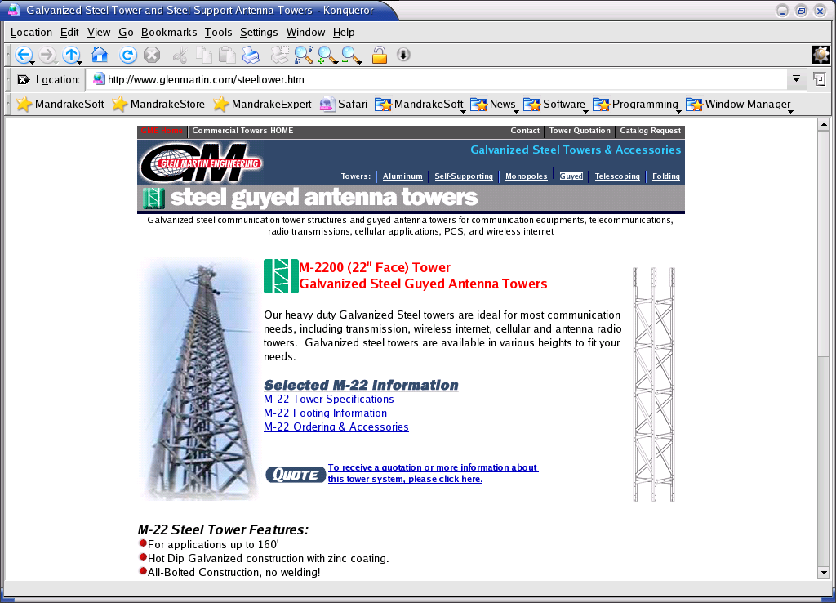
For the Access Point, up to about 50-meter height, we may use a guyed antenna tower. It is based on triangle element stack 3-meter length shown in the figure. The tower is supported by guyed wire tied on every stack.

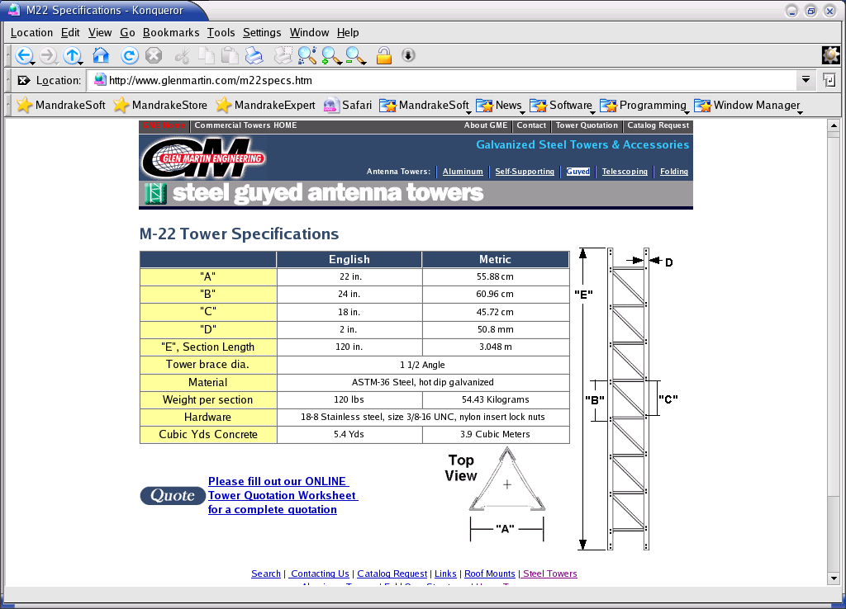
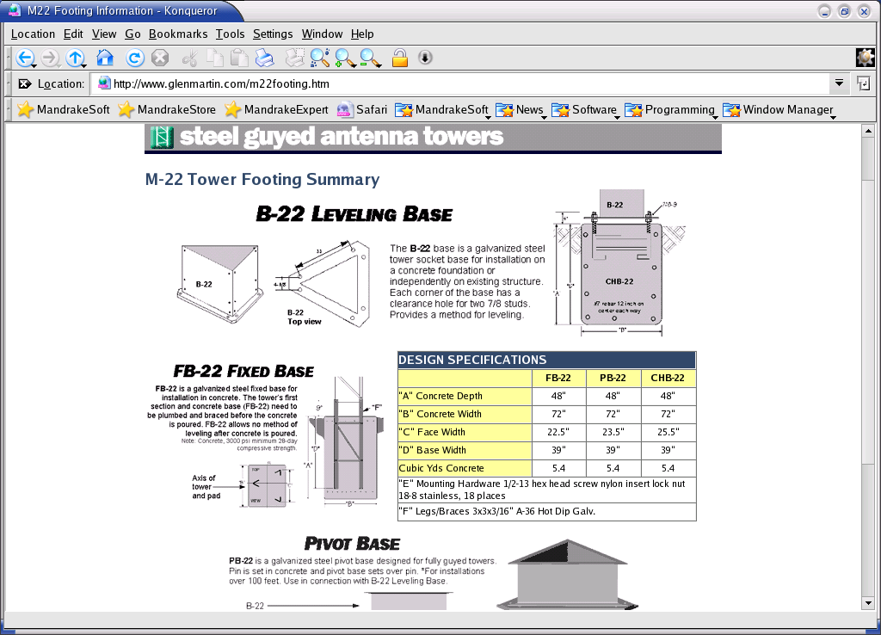
There are at least three (3) type of base for guyed antenna tower, i.e, leveling based so that we can adjust the tower base level, fixed based non-adjustable, and pivot base for sitting over pin that pinned into a concrete.

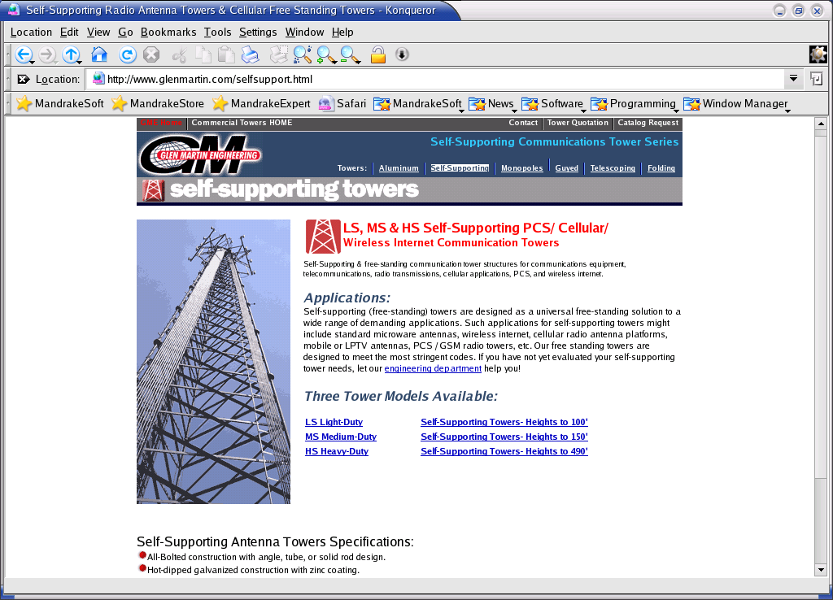
If space is limited, or need to have a high tower installation, a self-support (or free-standing) tower might be the solution. Light duty specification may be used up to 30 meters. The highest self-supporting tower may reach 150 meter. It is not a cost effective solution for most WiFi operator. A better solution would be rent a space at the tower run by the cellular operators.

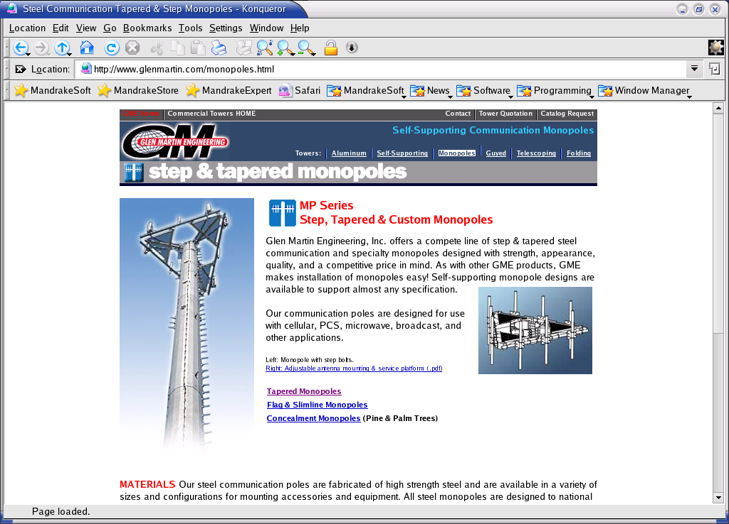
For strength, appearance and quality, there is self-supporting monopole design. It may cost dearly for most WiFi operators.

In some cases, we need to calculate the maximum safe height of a self-supporting tower for any antenna configuration as a function of wind velocity. Frank Travanty, W9JCC has written a good article on “Tower and Antenna Wind Loading as a Function of Height”, QEX July/August 2001, pp. 23-33 (http://www.arrl.org/qex/1123.pdf).

