NetMeeting for Windows based VoIP

To do VoIP from your PC, a fairly simple setting is required, namely,

- The PC should be connected to the Internet. A dial-up connection is sufficient. It is not necessary a 24 hour connection. It would be nice to have a 24-hour connection though. One may have a low cost 24 hours Internet connection using WiFi and Neighborhood network.
- sound card, mic and headphone. In some cases, headphone will help to reduce feedback of the voice from speaker to the microphone. It costs about US$2 to get a headphone with attached microphone in Jakarta, Indonesia.
- NetMeeting 3.01 is normally available in Windows. If it is not available, we can freely download from http://www.microsoft.com/netwmeeting. For those who use Linux, we can uses GnomeMeeting.

Downloading NetMeeting from Microsoft.Com

For most Windows operating system, NetMeeting is readily available. It may normally access through

Start → Programs → Accessories → Communications → NetMeeting.

In Windows XP machine, it can be accessed through,

Start → Run → conf

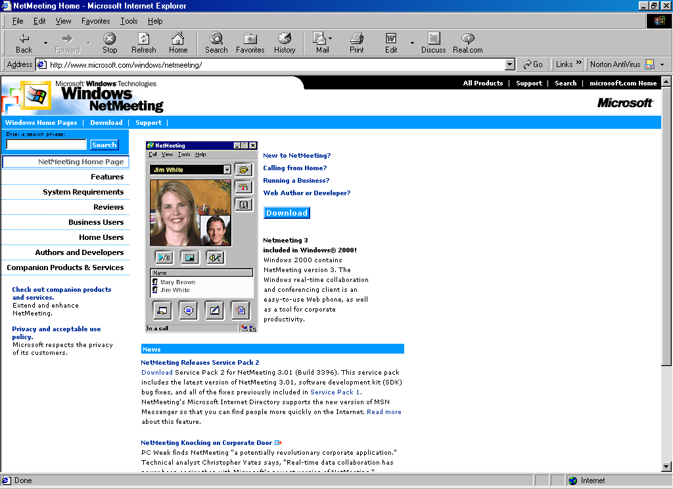
For those who don’t have NetMeeting in their Window, the NetMeeting 3.01 can be freely downloaded from http://www.microsoft.com/netmeeting/ or http://www.microsoft.com/windows/netmeeting.

All we have to do on http://www.microsoft.com/netmeeting is finding the download menu to download the software.

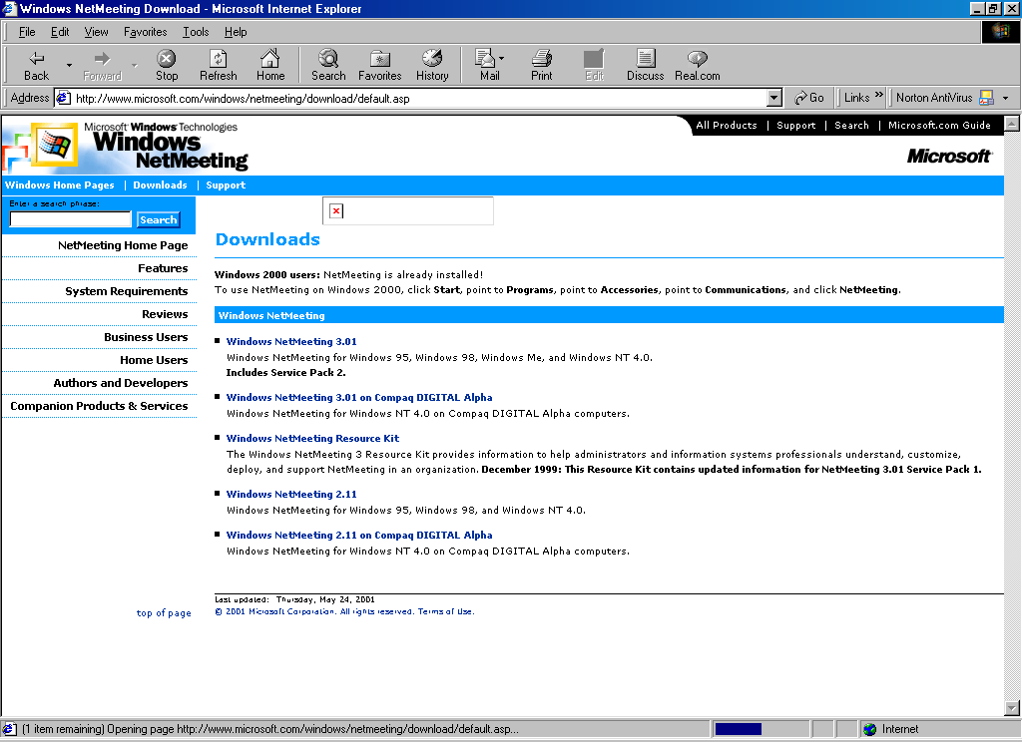
In download page, we need to choose type of machine as well as version of NetMeeting to be downloaded. In most PC machine, we may click the link to Windows NetMeeting 3.01.

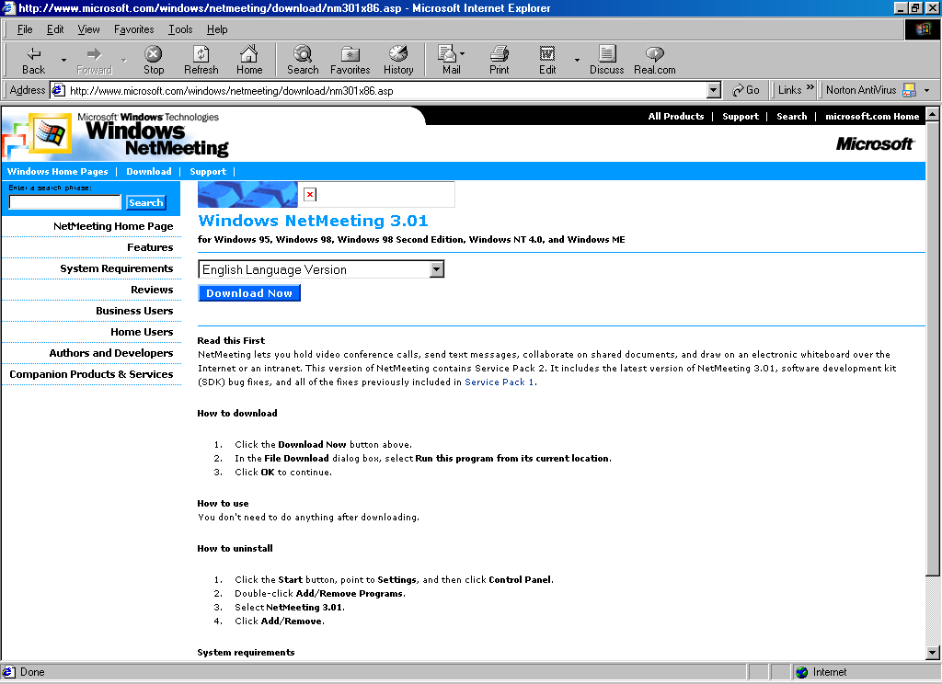

As soon as we completing the NetMeeting 3.01 selection, we will entering the actual download page. Clicking the Download Now will execute the downloading of 1.6Mbyte nm30.exe of NetMeeting 3.01. It normally takes about 15-20 minute to download such file via a 33.6 kbps dial-up connection in Indonesia.

The nm30.exe can be immediately run to install NetMeeting 3.01 into our computer. We normally need to reboot the machine to complete the installation process.

NetMeeting 3.01 Configuration on The First Run

If Microsoft Windows is used, the operating system is normally ready for VoIP as well as video conferencing. Configuration of NetMeeting 3.01 is normally being performed on the first time NetMeeting is run. We can always change the settings later.

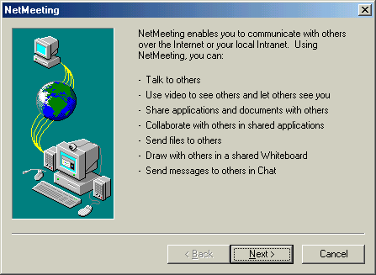

NetMeeting 3.01 will give an overview on its ability on the first run.
After Next button pressed, we may be completed the information form on our identity, such first name, last name, e-mail address, location.

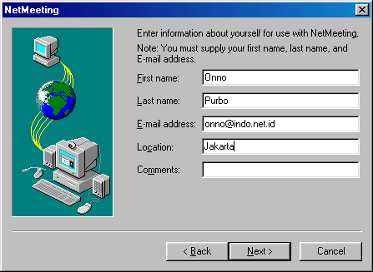

In the next wizard, we may choose whether a directory service or not. In a VoIP environment connected to an Internet Telephony Gateway (ITG), PBX and Telco, we are not normally using any directory service rather using a gatekeeper.

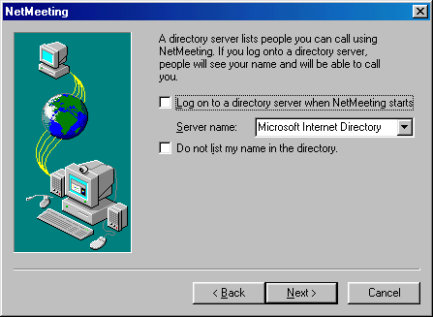

The next wizard, we may specify the Internet link bandwidth. Specifying the bandwidth is basically configuring the type of audio / video code and decoder (CODEC) that will be used.

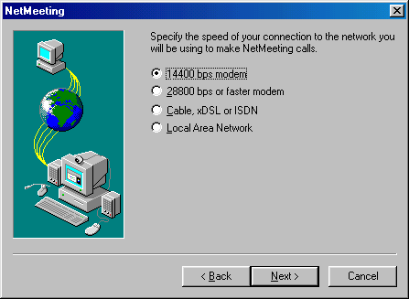

Each speed leads to different consequences, such as,

- 14400 bps – limits the ability to voice only communication. If a G.723.1 codec, it will consume about 12-13 kbps for two ways voice communication.
- 28800 bps and faster – may be used for carrying a simple video link in addition to voice.
- Cable, xDSL or ISDN as well as Local Area Network (LAN) – would enable the best quality voice and video codec.

If we want to use the Internet as our primary link, it is advice able to select 14400 bps or 28800 bps as our speed even if the computer is connected to a LAN and connected to a xDSL link. Selecting the lowest speed will make sure a safe boundary to communicate with others who are using low speed dial-up links.

In the next wizard, we can check for the option to put a short cut to NetMeeting on desktop and/or on Quick Launch bar.

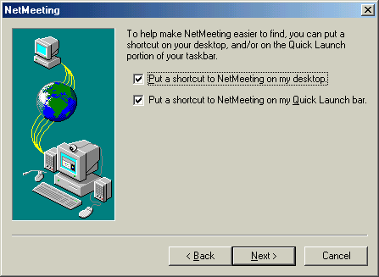

The next wizard, we will configure the audio settings. It is advisable to close all audio related programs, such as, Winamp etc.

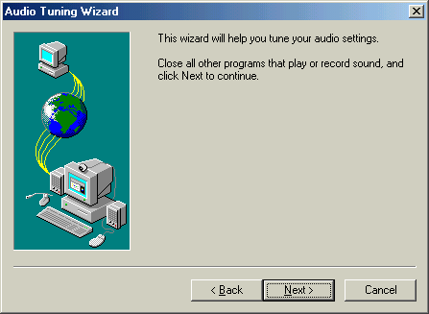

The first audio setting to be configured is the speaker volume. Pressing the Test button, NetMeeting will be playing a sound to test the speaker. We can set the volume of the speaker.

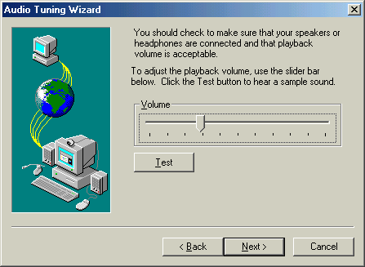

Next wizard is to set the microphone volume. NetMeeting will set the volume automatically. The microphone volume should be as low as possible to minimize any feedback.

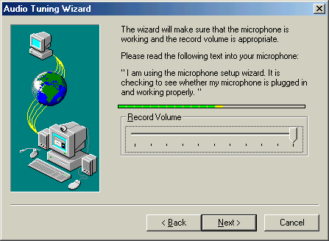

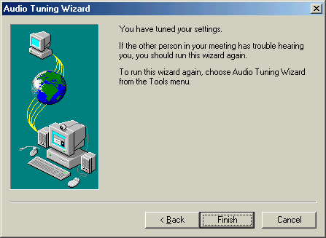

That’s it. We nearly completed most of the needed configuration process. Gatekeeper settings & our phone number should be set from the configuration option of the NetMeeting.

Example of NetMeeting 3.01 in a Community VoIP Infrastructure

One of the largest community VoIP infrastructures is the Indonesian VoIP Merdeka http://voipmerdeka.net. Merdeka means Free / Independent. Gatekeeper is used in Indonesian VoIP Merdeka.

The gatekeeper configuration in NetMeeting 3.01 is fairly simple, through,

Tools → Options → General → Advanced Calling

Check “Use a gatekeeper to place a calls” put the IP address of the gatekeeper; and Check “log on using my phone number” put the phone number.

The main Indonesian gatekeeper of Free VoIP infrastructure is,

202.53.224.172

It would accept any number registered. No registration, no fee is required. Other Indonesian main public gatekeepers are

202.155.39.157 - for area code 62 88
218.100.4.194 - for area code 62 88 888
      - - for area code 62 88 999
202.150.8.15 - for area code 62 88 925

Most Indonesian will use 6288 as the first four (4) digit of their number, where 62 is the country code, and 88 is the area code.

Major headache in running a community based VoIP infrastructure is in coordinating the area code of each gatekeeper. The Indonesian Free VoIP infrastructure is running a web page to register Indonesian gatekeeper and allocate the prefix for each gatekeeper at http://www.cic.ac.id/gkregistration/

The Indonesian Free VoIP community is centered on a mailing list

voipmerdeka@yahoogroups.com - end user mailing list.
gk-admin@yahoogroups.com - gatekeeper administrator mailing list.

It might be advisable to set a larger Internet community based VoIP infrastructure mailing list.

Visualization Gatekeeper Setting in NetMeeting

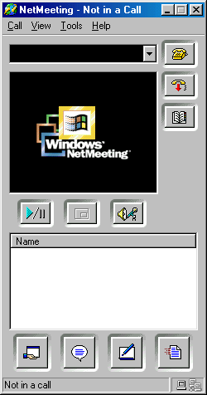
To make Windows user a little bit easier, a visualization of the gatekeeper settings will be desribed.

Shown in the figure is the NetMeeting somewhat ready to be used. We need to use the gatekeeper settings through Tools menu located as the third top button from the left.

Please note the drawings of two computer interconnected at the bottom right of NetMeeting. If it is blank, it means the NetMeeting is not yet registered to any gatekeeper.

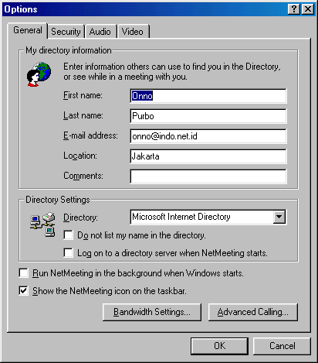
Click Tools → Options, you’ll see the options to configure the NetMeeting, namely, General, Security, Audio dan Video.

The setting to join a VoIP infrastructure with gatekeeper is fairly simple. All we have to do is click Advanced Calling …

Off course, we can always completing the first name, last name, e-mail address, and location if we wish.

If we want NetMeeting to be run on background every time windows runs, check “Run NetMeeting in the background when Windows starts.”.

Please do not check / configure the Directory Settings as we do not use Microsoft Internet Directory for our VoIP configuration.

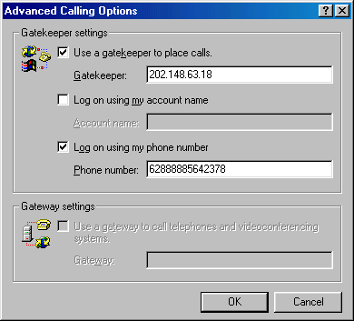
Under Advanced Calling Options, we have two (2) calling options, i.e,

- Use Gatekeeper
- Use Gateway

In most serious VoIP infrastructure, such as, the Indonesian Free VoIP infrastructure, we will likely to find a significant numbers of gateways.

It would advisable to use gatekeeper rather than gateway. Only two (2) parameters to be set, namely,

- The IP address of the gateway, check “Use a gatekeeper to place calls”.
- The phone number, check “Log on using my phone number”.

Please make sure that the IP address of the gatekeeper is correct. Example of some of the public gatekeeper of Indonesian Free VoIP infrastructure is listed in the previous section.

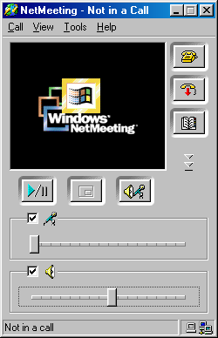
If the gatekeeper IP address is correctly set and the Internet connection is correctly prepared, we should see the two computers interconnected at the bottom right hand corner change its color. It means the NetMeeting is correctly registering to the gatekeeper.

At this point, to communicate with other endpoint in the network would be very easy. We can enter destination phone number and click the telephone button on the top right hand corner to make the call.

If the call is established, we will see the single computer figure next to the two interconnected computer will change its color. Happy VoIP-ing!!!

Some Notes on Bandwidth Settings

Bandwidth used for VoIP communication is depending on the coding decoding (CODEC) software used. At this moment, there are many CODEC options, such as, G.711, G.729a/b, G.723.1(5.3/6.4 kbps) etc. We may need to setup a minimal setting of CODEC for VoIP communication. We normally use G.723.1 as our CODEC Preference. It is mainly due to most of VoIP Client, such as, Internet Telephony Gateways and NetMeeting, has G.723.1 CODEC installed. Unfortunately, it is copyrighted by Microsoft and creates a little bit of problem in open source communities.

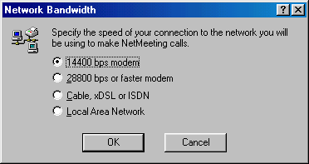
To squeeze the bandwidth to the minimal bandwidth, we can set the Network Bandwidth of NetMeeting 3.01 to,

Tools → Options → General → Bandwidth Settings .. → 14400 bps modem

Even if you are on a LAN, NetMeeting will use the minimal bandwidth CODEC to fit into 14400 bps speeds.

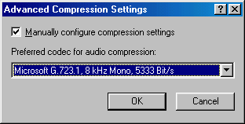
If we need to pick a specific CODEC to be used, we can select it from the Advanced Compressing Settings, i.e.,

Tools → Options → Audio → Advanced → Manually configure compression settings → Microsoft G.723.1, 8kHz mono, 5333 Bit/s.

.

PC behind Firewall / Proxy

For end users, by checking your IP address, if it begins with 192.168 or 10, it means the computer is likely to be behind a firewall or proxy server. It is fairly common in offices, schools, or campuses.

Firewall and Proxy are creating a significant number of problems in VoIP infrastructure. Most users behind Firewall do not understand that when they register directly to a gatekeeper outside the firewall, the IP address registered in the gatekeeper will be the private IP address, such as, 192.168.x.x or 10.x.x.x It creates problem when someone on the Internet wants to call the PC behind firewall as it will likely unable to reach you as 192.168.x.x or 10.x.x.x IP is unrecognized and no routing in the Internet.

To solve the problem, we need to ask the network administrator to install a gatekeeper at the proxy / firewall. The proxy gatekeeper must be configured to register to a larger gatekeeper on the Internet. If the network administrator quite cooperative and willing to set a gatekeeper at the firewall, the PC behind the firewall can then register to the proxy gatekeeper.
We may go into big trouble if the network is run on a hardware proxy / firewall. There is basically no way to insert gatekeeper software into it. Unless the network administrator willing to replace it using a PC-based firewall. Good luck.

Check the Online Users

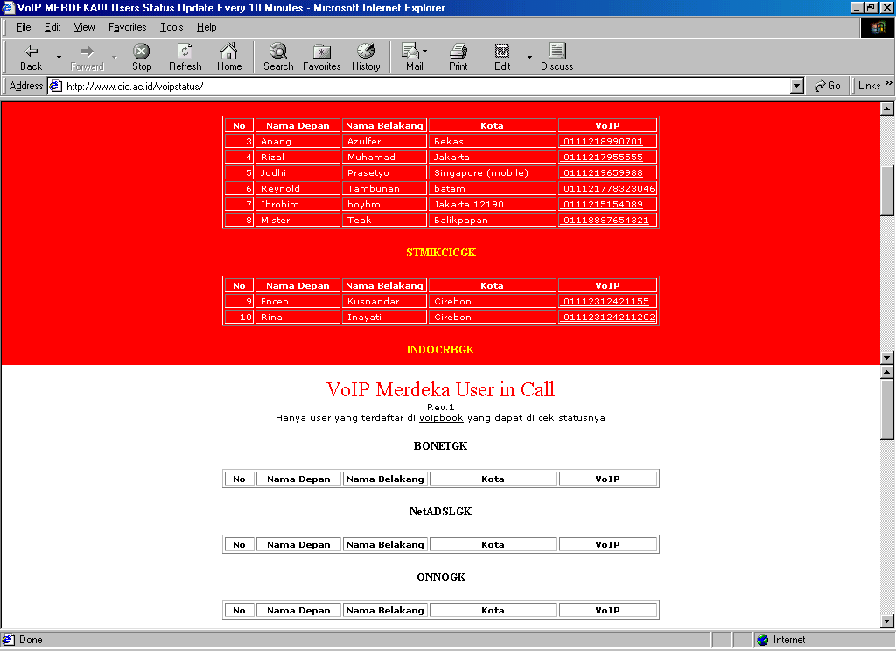
One of the most headache in a Free VoIP infrastructure is in knowing the online endpoints. It is necessary to know whose are connected to the network as only those online endpoints can communicate to each other.

The online users can be checked by telneting to port 7000 of the gatekeeper. Unfortunately, not all gatekeeper will open port 7000 to be reviewed.

Some of my friends are setting a web site that may help people to check on the online endpoints on the gatekeeper. Some of the examples are

http://www.cic.ac.id/voipstatus/
http://gk.vision.net.id/

