How To Shop For Internet Telephony Equipment

Internet Telephony equipments may be as simple as NetMeeting runs on a multimedia PC equipped with microphone. A microphone is affordably obtained at around US$ 2-3 in developing countries up to US$ 15-20 in some western countries. Such setting is the most reasonable configuration to feel Internet Telephony communication.

However, for serious office applications, such as, connecting PBX in remote / regional offices to the corporate headquarter through corporate virtual private network, a more dedicated equipment would be required. Internet Telephony Gateway (ITG) would be the important piece of equipment in the installation. Internet Telephony Gateway will act as the interface between Internet telephony and conventional analog telephony.

For enterprise or personal / home class Internet Telephony Gateway (ITG), we are normally looking at low-density gateways, i.e., gateway with small number of RJ-11 phone lines up to around 10 RJ-11 phone lines. In such low-density gateway, we are looking at around US$100-150 / RJ-11 phone lines.

Check Out the Portals
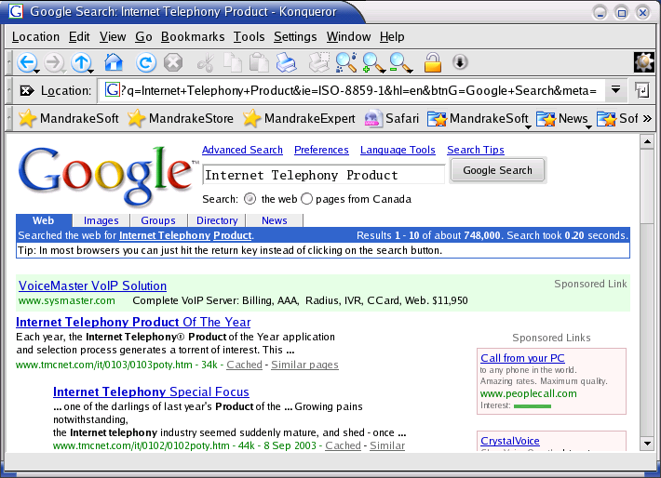
Search through Google would be the simplest way to survey for Internet Telephony or Internet Telephony Products. Selecting appropriate keywords, such as, “internet telephony”, “internet telephony gateway”, “low density gateway”.

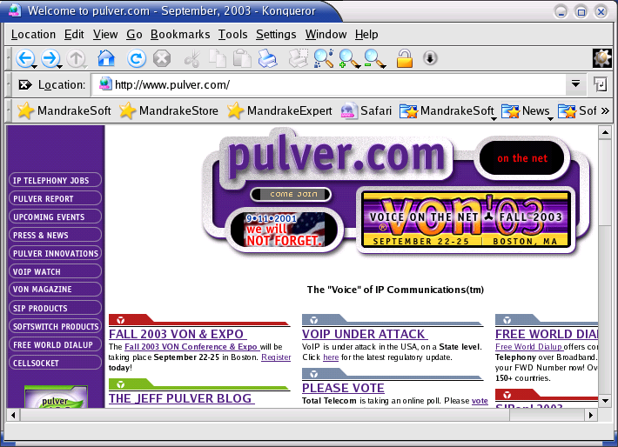
The famous Internet Telephony portal would be Pulver.Com http://www.pulver.com. It used to carry a large list of Internet Telephony equipments manufacturer. It seems the list is now more focused on a the more advanced equipments based on Session Initiation Protocol (SIP) and their remarkable Free World Dial-up movement to get free Internet Telephony calls to many places on the planet.

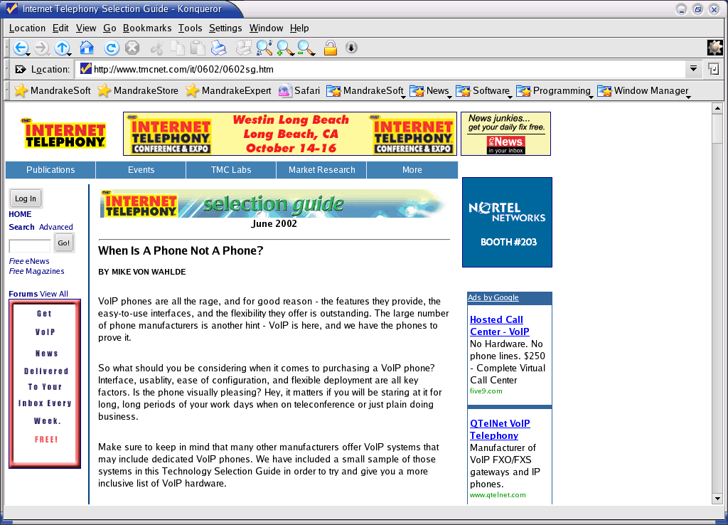
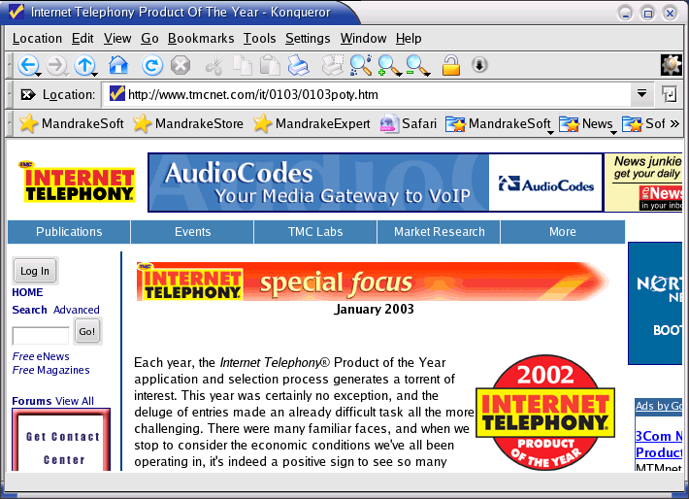
To get the review on various Internet telephony equipments would be very useful in searching for the equipments. An example of such review can be found in http://www.tmcnet.com. It has several articles useful on selecting the Internet telephony equipments, such as, the selection guide June 2002, and the special focus article, January 2003.

Examples of Enterprise Telephony Equipments

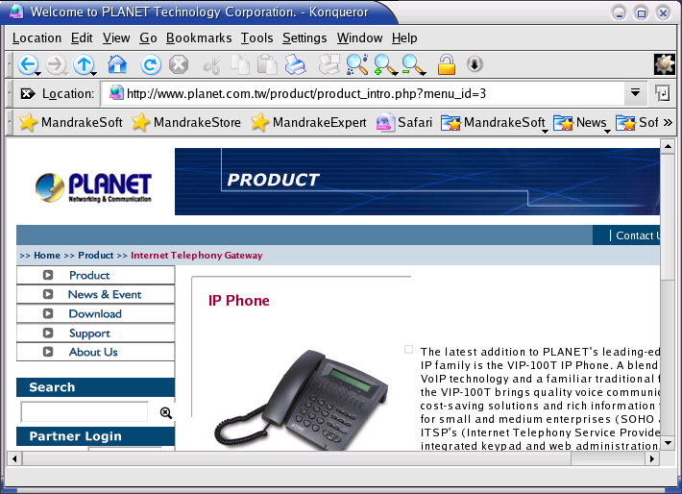
Connecting regional / branch offices to corporate headquarter would be of interest to significantly reduce the long distance and international charges. Fortunately, most of these offices currently have some sort of Internet infrastructure; some even have dedicated Internet connection with virtual private network (VPN) connection among offices.

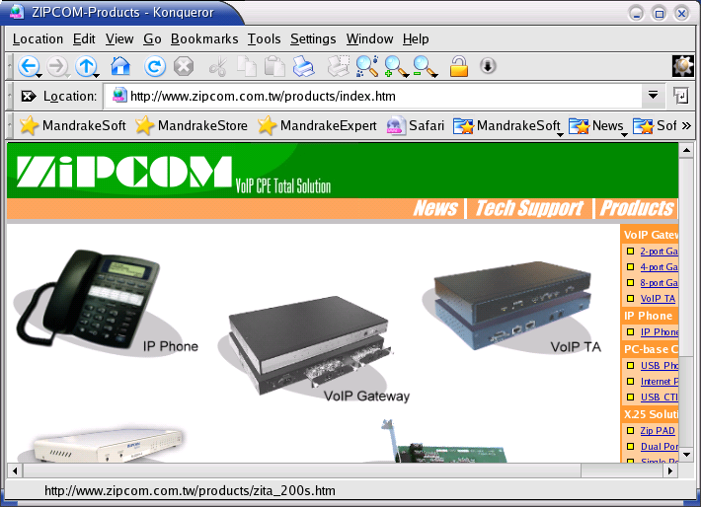
In such office installation, we might be interested in 2-10 lines dedicated Internet Telephony Gateway (ITG) or Ipphone equipment, an Internet Telephony handset with a direct Ethernet connection on the back.

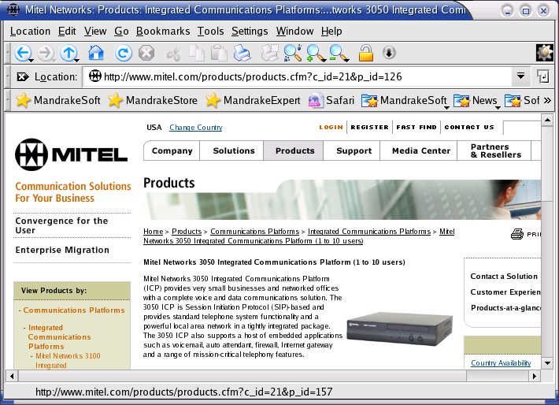
Some equipment would be able to talk using H.323 protocol. Some might be able to talk using a newer Session Initiation Protocol (SIP). H.323 based equipment might be lower in cost.

A dedicated Internet Telephony Gateway (ITG) is normally cost about US$100 / line plus taxes. More lines would be more cost effective. Taiwanese manufacturers might provide low cost solutions for dedicated Internet Telephony Gateway (ITG). Some of these manufactures are,

http://www.planet.com.tw
http://www.zipcom.com.tw
http://www.zincnetworks.com
http://www.mitel.com

Send e-mail to their sales and ask for quote on their enterprise class Internet Telephony Gateway (ITG) product to compare prices.

Example of Home / Personal Class Equipments
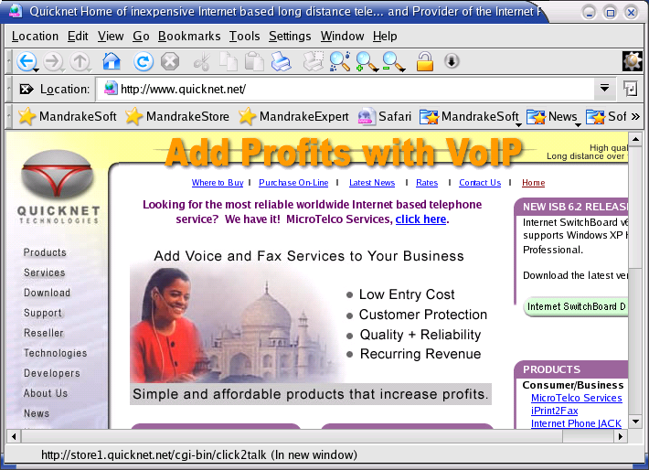
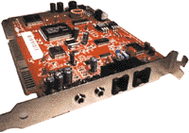
Some might be interested to have a 1-2 lines Internet Telephony Gateway (ITG) running on their PC at home or SOHO (Small Office Home Office).

There are some PC-based Internet Telephony cards. One of the most favourite PC-based cards is QuickNet InterNet LineJACK and InterNet PhoneJACK. Openh322 http://www.openh323.org even support the open Linux & Windows driver for it.
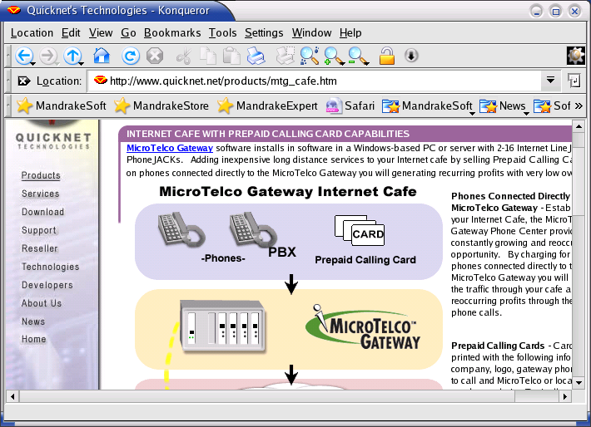
The current QuickNet products also cover for micro-Telco installation.

We normally looking at the cost around US$ 100-150 / line for a PC-based card.

Some of the home / personal class Internet Telephony equipment can be found at,

http://www.aplio.com/
http://www.innomedia.com/
http://www.quicknet.net/
http://www.shelcad.com/
http://www.users.bigpond.com/voicet/

Example of Carrier Class Equipment Examples
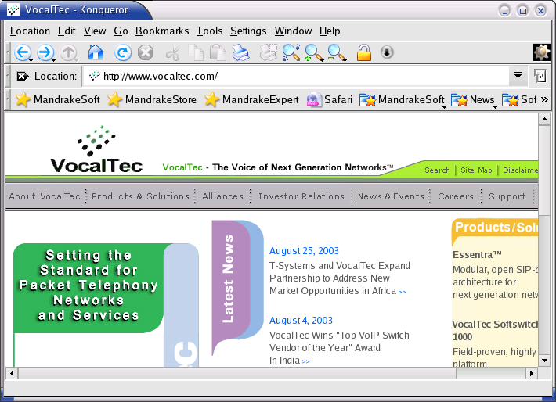
Although this book is not intended for carrier class operator, there is abundant number of carrier class Internet Telephony manufacturer. A large list of such manufacturers can be found at,

http://www.pulver.com
http://www.voipcalculator.com

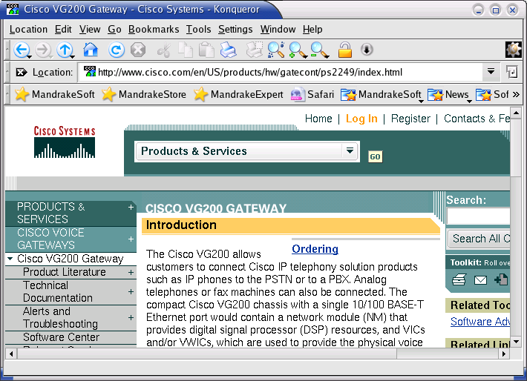
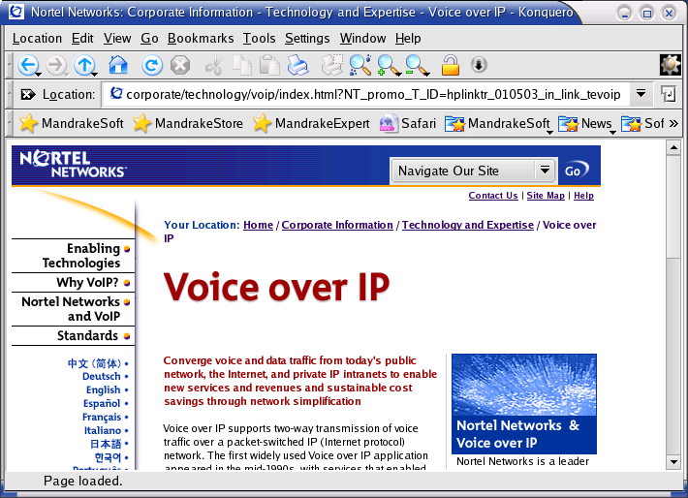
Carrier class Internet Telephony equipment may connect several T1 or E1 lines. They normally provide a complete solution with its gatekeeper and billing system. It would be the most cost effective solution to run calling card service for carrying international and some long distance traffic, hopefully the Telco quite cooperative.

